Moduldokumentation

Modul Applikationssicherheit (apsi)

Simon Wächter

2019

Inhalt

1 Einleitung 8

1.1 Einleitung 8

1.2 Lernziele 8

1.3 Prüfungen 8

2 Woche 1 9

2.1 Agenda 9

2.2 Administrative Issues 9

2.3 Who is Your Lecturer (Wagner) 9

2.4 whoami (Schläpfer) 10

2.5 Why is Application Security Important? 10

2.6 Lecture Overview (1) 11

2.7 Lecture Overview (2) 11

2.8 Lecture Overview (3) 12

2.9 Example: Buffer Overflow 12

2.10 How does a Buffer Overflow Work? 12

2.11 Buffer Overflow Demo 13

2.12 Not Really a Fix for Buffer Overflow: Stack Protection 13

2.13 Fix for Buffer Overflow: Checked Buffers 13

2.14 Example: Taint Checking in Perl (1) 14

2.15 Example: Taint Checking (2) 14

2.16 Example: Taint Checking (3) 15

2.17 Example: Taint Checking (4) 15

2.18 Example: Data Leakage by Behavior (1) 15

2.19 Example: Data Leakage by Behavior (2) 16

2.20 Example: Data Leakage by Error Output 16

2.21 Human Factors 17

2.22 Exercises and Preparation for Next Week 17

2.23 Reserve 17

3 Woche 2 18

3.1 Agenda 18

3.2 Recap: What do Attackers Want? 18

3.3 Buffer Overflow II 18

3.4 Buffer Overflow II 19

3.5 Buffer Overflow II 19

3.6 Buffer Overflow II 20

3.7 Buffer Overflow II 20

3.8 Attack Technique: Fuzzing 21

3.9 Error Handling 21

3.10 Case study – Handling too long input 22

3.11 Case-study: Compression Bomb 22

3.12 Error Handling 23

3.13 Algorithmic Complexity Attacks 24

3.14 Algorithmic Complexity: Sorting 24

3.15 Algorithmic Complexity: Hashing 25

3.16 Algorithmic Complexity: Regular Expressions 25

4 Woche 3 26

4.1 Agenda 26

4.2 Secure Coding Principle: Test-before-use 26

4.3 Input Validation 26

4.4 Input Normalization 27

4.5 Unix Permission Model (simplified) 27

4.6 Chroot 28

4.7 Mandatory Access Control (MAC) 28

4.8 MAC Example: SELinux 29

4.9 MAC Example: AppArmor 29

4.10 Secure Coding Principle: Defense in Depth 30

4.11 Privilege Separation 30

4.12 Overall Idea 31

4.13 Form of the Modules 31

4.14 Example: OpenSSH 32

4.15 OpenSSH: Privilege Separation Approach 32

4.16 Example: Postfix MTA (Email Server) 32

4.17 Postfix System View 33

4.18 Postfix: Example Data-Flow 33

5 Woche 4 34

5.1 Agenda 34

5.2 Security Testing (for Software) 34

5.3 Pen-Test 34

5.4 How does a Pen-Test fail? 35

5.5 Code Inspection and Review 35

5.6 Code Scanners 36

5.7 Execution Emulators 36

5.8 Patching 37

5.9 How to Patch 37

5.10 Problems with Patching 38

5.11 Problems with not Patching 38

5.12 Problems with Unavailability of Patches 38

5.13 Economic Aspects of Security 39

5.14 Case Study: DDoS on Brian Krebs (20.9.2016) 39

5.15 What can Perform Such an Attack? 39

5.16 IoT: Internet of insecure Things 40

5.17 Why are These IoT Devices so Insecure? 40

5.18 Possible Solutions 41

5.19 Does it Pay to make Software Secure? 41

5.20 So, what to do? 42

6 Woche 5 43

6.1 Agenda 43

6.2 Generating Cryptographic Keys 43

6.3 Information-Theoretical Entropy 44

6.4 Estimating Entropy is Tricky 44

6.5 Seeding a CPRNG 45

6.6 Bad Seeding Examples 45

6.7 Storing Cryptographic Keys Securely 45

6.8 Storing Passwords 46

6.9 Rainbow Table 46

6.10 Storing Passwords 47

6.11 So What is Wrong with PBKDF2? 47

6.12 Hardware RNGs 48

6.13 Example 1: Via C3 Hardware CPRNG Schematic 48

6.14 Example 2: Intel RDRAND Schematic 49

6.15 Compromise on Design-Level 49

6.16 Storing Private Data (as a Service Provider) 50

6.17 Disk/Storage Encryption 50

6.18 Disk Encryption Protects Against What? 50

6.19 Decryption Only With User Logged In 51

6.20 Encryption in the Cloud 51

6.21 JavaScript Client-Side Encryption in Web-Apps 52

7 Woche 6 53

7.1 Agenda 53

7.2 Virtualization vs. Security 53

7.3 DoS on Application Layer 54

7.4 DoS on Application Layer 54

7.5 Code Analysis for Security 55

7.6 Backdoors in Code 55

7.7 Backdoor Hiding Techniques 56

7.8 Finding Backdoors 56

7.9 Backdoors in Cryptography 57

7.10 Example 1: ECC 57

7.11 Example 2: Specially selected Primes for Discreet Logarithms 58

7.12 Fuzz-Testing: The Idea 58

7.13 Possibilities and Limitations 59

7.14 Structured Fuzzing vs. Random Fuzzing 59

7.15 Fuzzing for Regular Tests 60

7.16 Useful Fuzzing Tools 60

8 Woche 7 61

8.1 Agenda 61

8.2 Example Request in the TCP/IP Model 61

8.3 HTTP 61

8.4 HTTP Request Example: GET 62

8.5 HTTP Request Example: POST 62

8.6 HTTP Response Example 63

8.7 Exotic Requests: PUT, DELETE, ... 63

8.8 HTTP Authentication 64

8.9 HTTP Authentication 64

8.10 Cookies 65

8.11 Cookie Options 65

8.12 Cookies: Access via JavaScript 66

8.13 Session Management 66

8.14 Security Problems with Session Management 67

8.15 Keeping State Securely on Client-Side 67

8.16 Remark: Cookies and Application Paths vs. Proxies 68

8.17 SSL/TLS 68

8.18 SSL/TLS 69

8.19 CGI: General Idea 69

8.20 CGI Scripts in Different Languages 70

8.21 CGI in BASH 71

8.22 CGI in BASH: Output 71

8.23 CGI in Perl 72

8.24 CGI in Perl: Output 72

8.25 CGI in C 73

8.26 CGI in C: Output 73

8.27 CGI in Java 74

8.28 CGI Security 74

9 Woche 8 75

9.1 Dates 75

9.2 11.11.19: Guest Speaker about WAF 75

9.3 Agenda 75

9.4 OWASP – Open Web Application Security Project 76

9.5 OWASP Top Ten 76

9.6 OWASP Top Ten 77

9.7 Cross-Site Scripting (XSS): Cookie Theft 77

9.8 Stored XSS Countermeasures 78

9.9 Reflected XSS 78

9.10 Defense Against Reflected XSS 79

9.11 Cross Site Request Forgery (CRSF) 79

9.12 CRSF Example 2 79

9.13 CRSF Countermeasures 80

9.14 Same-Origin Policy 80

9.15 Cookies and Same Origin 81

9.16 Same Origin Policy (SOP) and its Limits 81

9.17 CORS Overview 82

9.18 CORS Preflight Requests 82

9.19 CORS Example (slightly abbreviated) 83

9.20 CORS for Multiple Domains 83

9.21 Content Security Policy (CSP) Headers 84

9.22 Overview of Common CSP Options 84

9.23 Exercise: U08 85

10 Woche 9 86

10.1 Agenda 86

10.2 Coding Style Guides / Coding Standards 86

10.3 Linux Kernel Coding Style: Introduction 86

10.4 Linux Kernel Coding Style: Examples (1) 87

10.5 Linux Kernel Coding Style: Examples (2) 87

10.6 Linux Kernel Coding Style: Examples (3) 88

10.7 Linux Kernel Coding Style: Examples (4) 88

10.8 CERT/SEI Rules and Recommendations 88

10.9 What do Coding Style Guides Accomplish in Reality? 89

10.10 Problems with Restrictive Coding Environments 89

10.11 What About Interfaces and Naming in Them? 90

10.12 So use a Style Guide or not? 90

11 Woche 10 91

11.1 Agenda 91

11.2 Authentication 91

11.3 Authorization 91

11.4 Access to a Resource 92

11.5 Recap: Public Key Cryptography 92

11.6 JSON Object Signing and Encryption (JOSE) 93

11.7 JSON Web Signatures (JWS) 93

11.8 JSON Web Encryption (JWE) 94

11.9 JSON Web Token (JWT) 94

11.10 Nested JWT 95

11.11 JOSE Implementation Details 95

11.12 OAuth 2.0 96

11.13 OAuth Access Flow 96

11.14 Identity Federation 97

11.15 OpenID Connect 97

11.16 OAuth vs. OpenID 98

11.17 OpenID Connect 98

11.18 Recent OAuth 2.0 Flaws 98

11.19 SAML 2.0 99

11.20 SAML 2.0 99

12 Woche 11 100

13 Woche 12 101

13.1 Agenda 101

13.2 Why use a Security Framework? 101

13.3 Bad Reasons to use a (Security-) Framework 101

13.4 Problems of Using a Security Framework 102

13.5 What if the Framework will not let you go? 102

13.6 The Spring Security Framework 103

13.7 Project Integration: Maven 103

13.8 Project Integration: Gradle 103

13.9 Characteristics of the External Dependency 104

13.10 Attacks Via External Dependency 104

13.11 Attacks Via External Dependency 105

13.12 Security Track-Record of Spring Security 105

13.13 Security Architecture of a Web Application 106

13.14 Security Architecture of a Web Application 106

13.15 User States 107

13.16 State Transitions 107

13.17 Content-Based Attacks 108

13.18 How to Protect Against User-Generated Content? 108

14 Woche 13 109

14.1 Agenda 109

14.2 Example Enterprise Access Control Architecture (simplified) 109

14.3 Decentralized Access Gateways 109

14.4 Federated Authentication and Authorization 110

14.5 Central Authentication and Authorization 110

14.6 Externalized Authorization Management 111

14.7 XACML Architecture and Sample Authorization Flow 111

14.8 Unified Hybrid Multi-Cloud Application Deployment 112

14.9 Access Gateway based on the Sidecar Pattern 112

14.10 Central Access Control Summary 113

14.11 OWASP WebGoat 113

14.12 Setup WebGoat the Simple Way 113

14.13 Setup OWASP Zed Attack Proxy (ZAP) 114

14.14 Using OWASP WebGoat 114

14.15 Homework 114

15 Woche 14 115

# Einleitung

## Einleitung

Dieses Dokument stellt die Moduldokumentation für das Modul apsi dar. Allfällige Unterlagen sind im Modulordner zu finden.

## Lernziele

Das Modul beinhaltet folgende Lernziele:

* Kennen typische Bedrohungen von Applikationen sowie ihren Daten und können abschätzen, wieweit diese für durch sie zu entwickelnde Software ein Sicherheitsrisiko darstellen
* Kennen typische Sicherheitsprobleme und können sie vermeiden
* Sind in der Lage, einschlägige Quellen zu konsultieren, um neu veröffentlichte Sicherheitsprobleme zu erfassen und zu verstehen, wie diese zu vermeiden sind
* Verfügen über Konzeptwissen, nicht nur Produktwissen, um das Gelernte auch in anderen Umfeldern und mit anderen Programmiersprachen anwenden zu können

## Prüfungen

Die Modulnote setzt sich zu 100% aus einer Semesterprüfung und einer Modulschlussprüfung zu je 50% zusammen.

# Woche 1

## Agenda

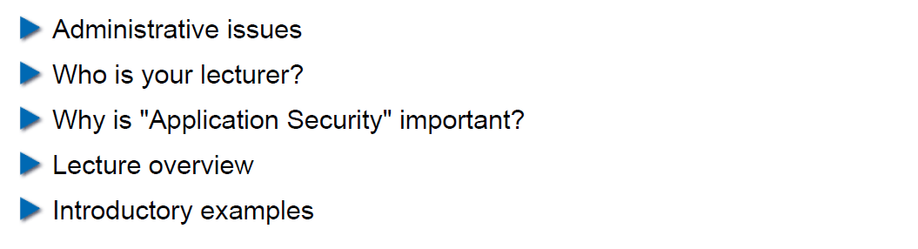

## Administrative Issues

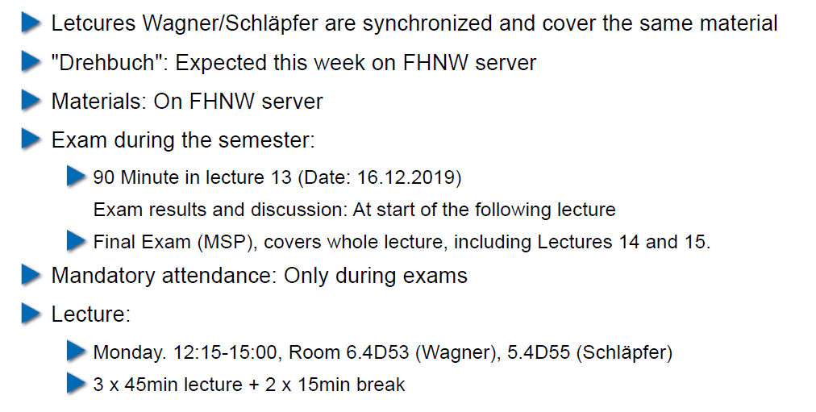

## Who is Your Lecturer (Wagner)

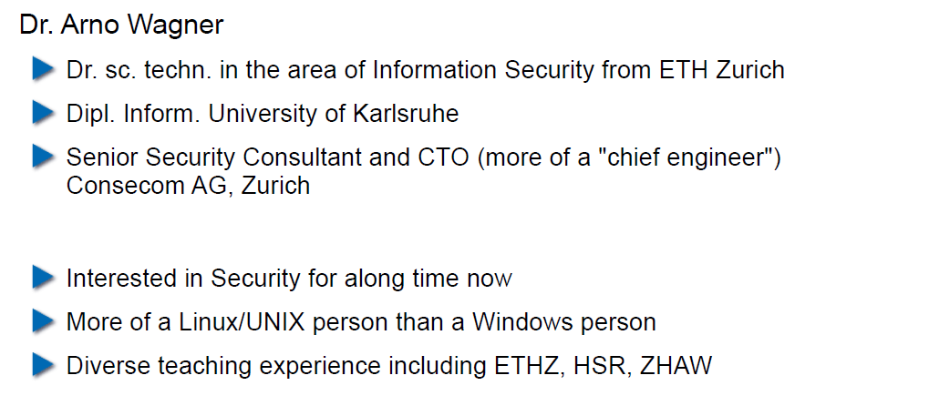

## whoami (Schläpfer)

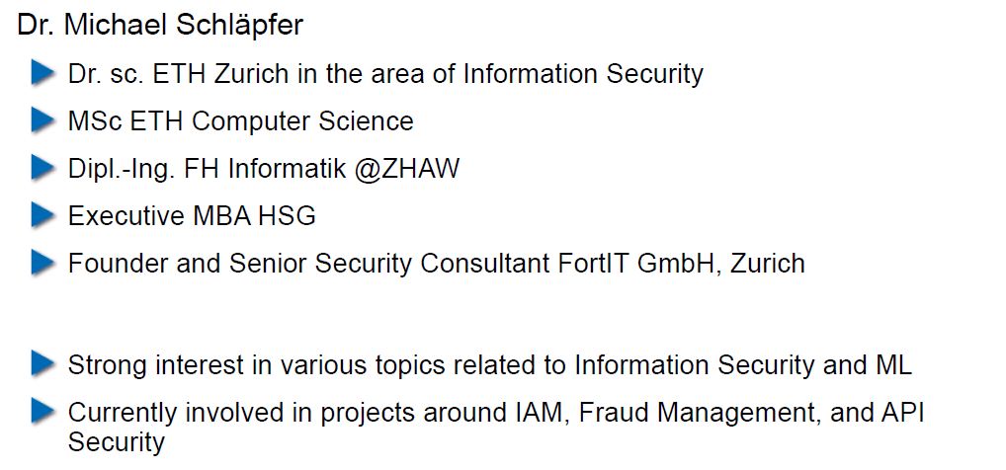

## Why is Application Security Important?

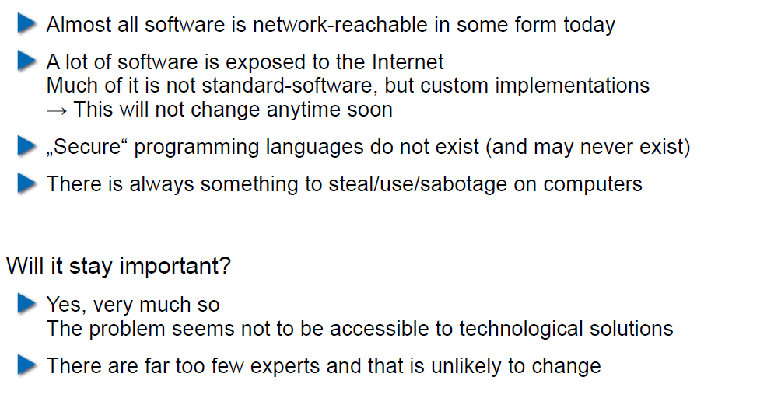

## Lecture Overview (1)

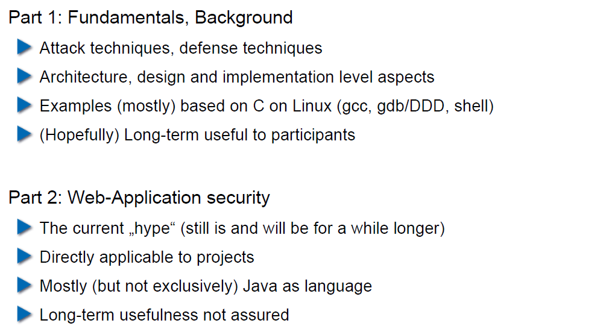

## Lecture Overview (2)

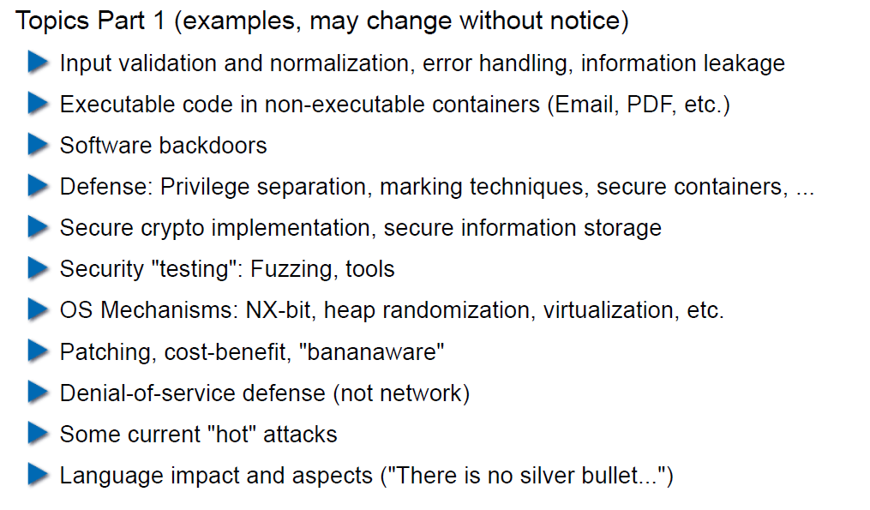

## Lecture Overview (3)

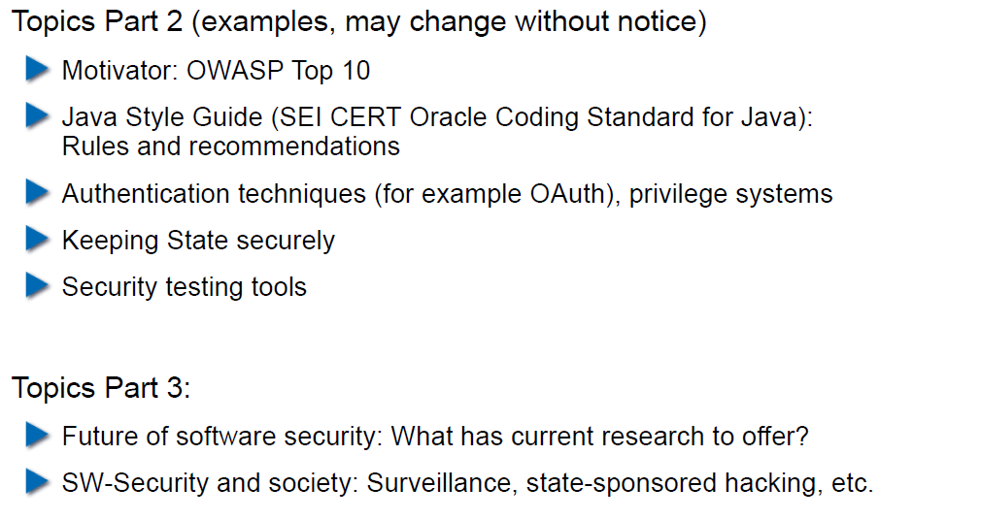

## Example: Buffer Overflow

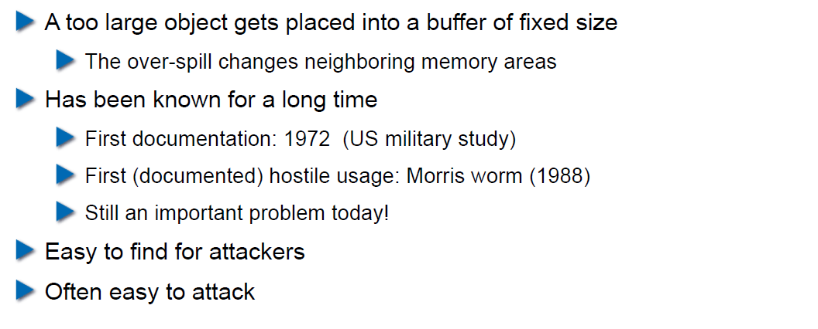

## How does a Buffer Overflow Work?

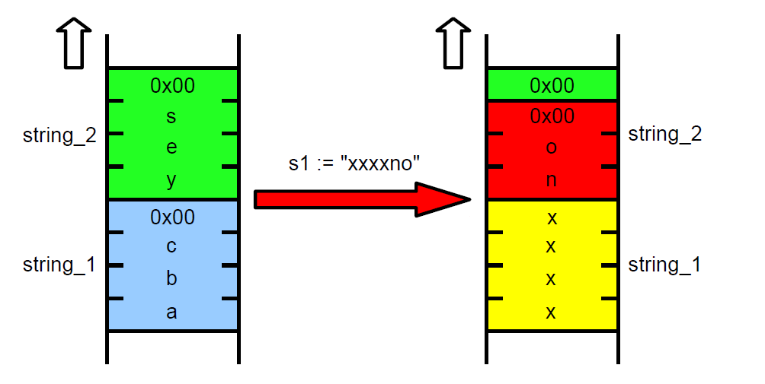

## Buffer Overflow Demo

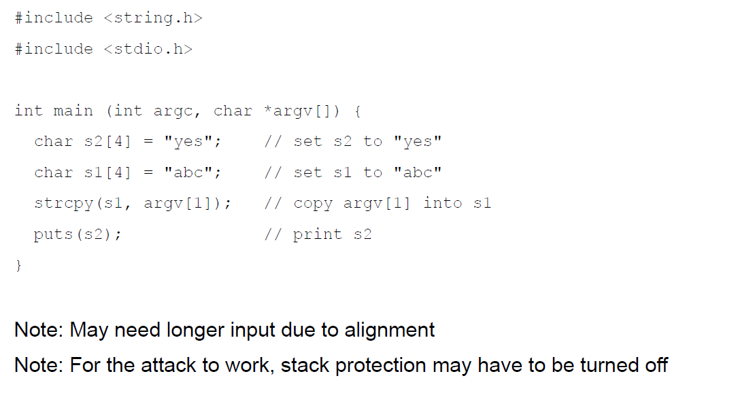

## Not Really a Fix for Buffer Overflow: Stack Protection

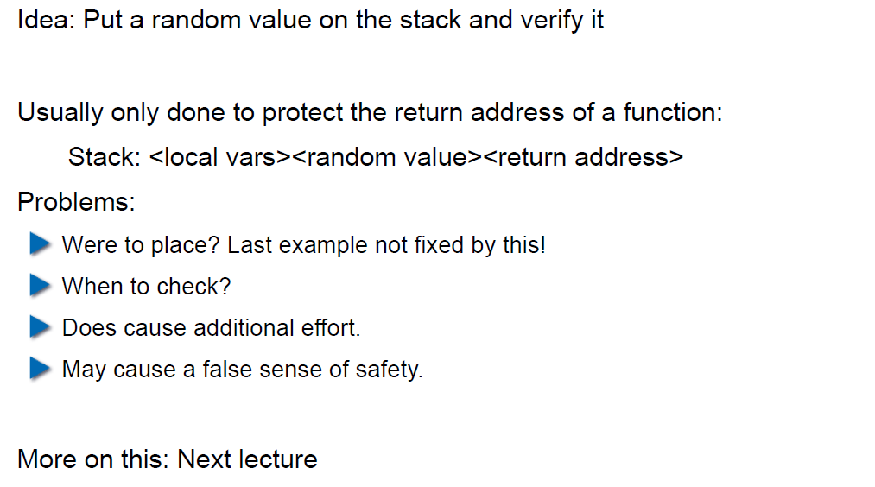

## Fix for Buffer Overflow: Checked Buffers

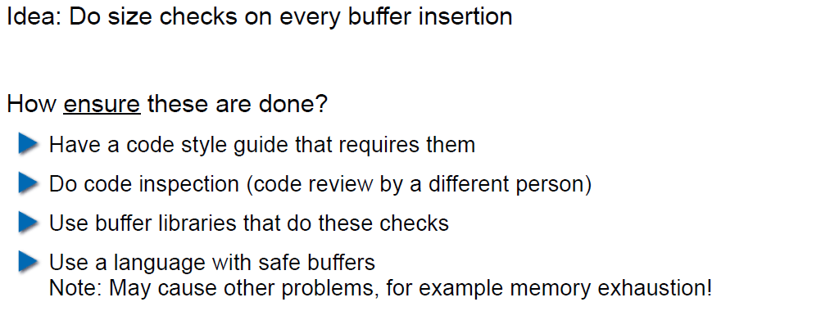

## Example: Taint Checking in Perl (1)

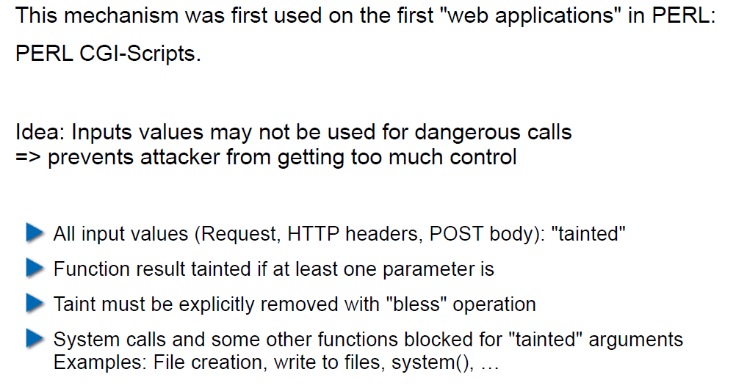

## Example: Taint Checking (2)

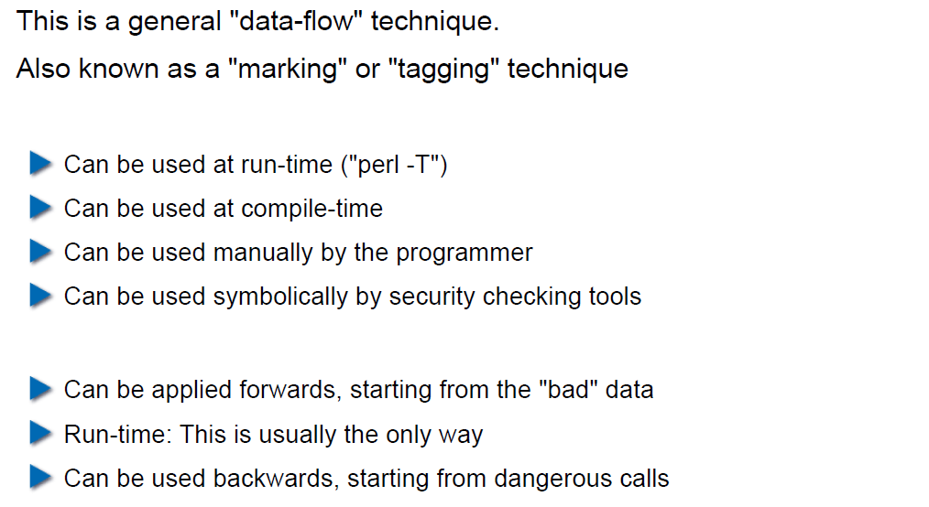

## Example: Taint Checking (3)

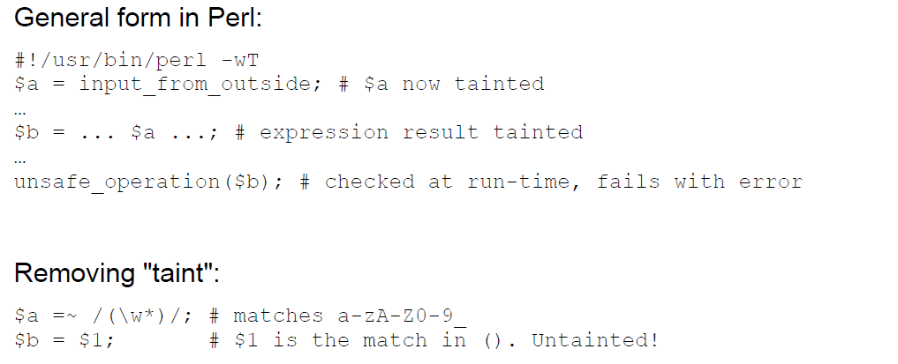

## Example: Taint Checking (4)

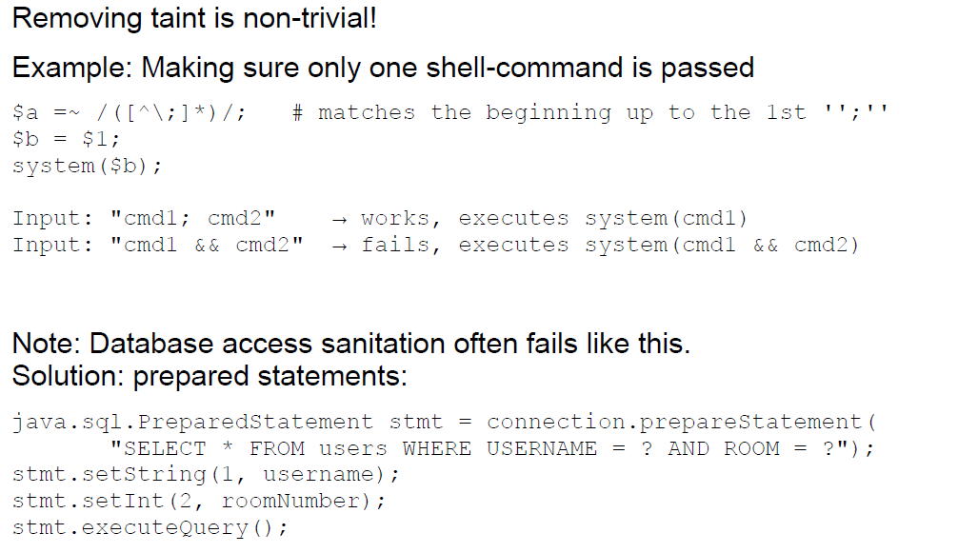

## Example: Data Leakage by Behavior (1)

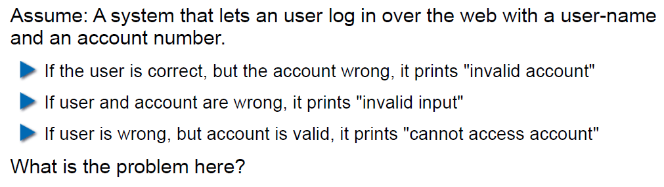

## Example: Data Leakage by Behavior (2)

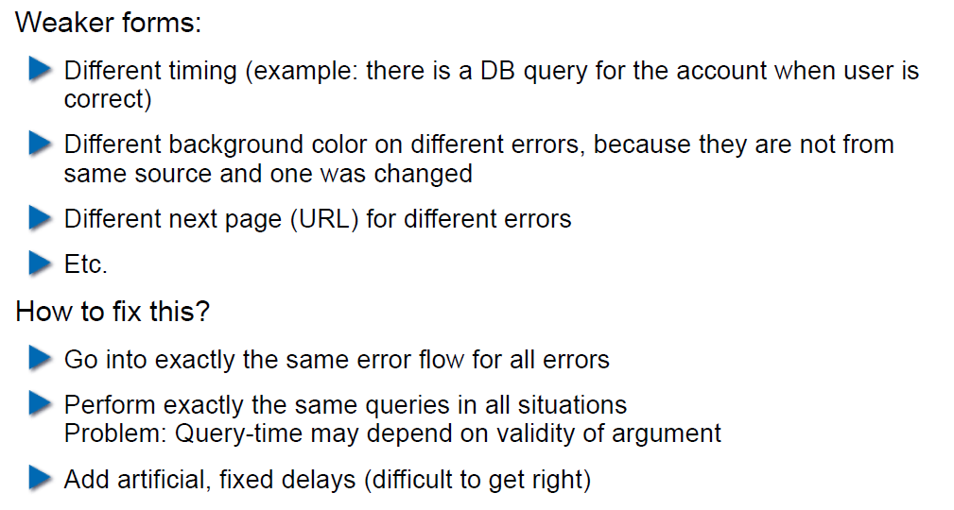

## Example: Data Leakage by Error Output

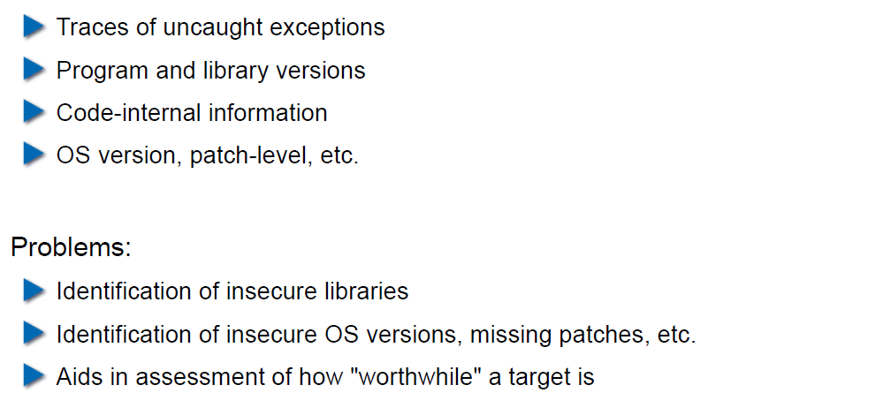

## Human Factors

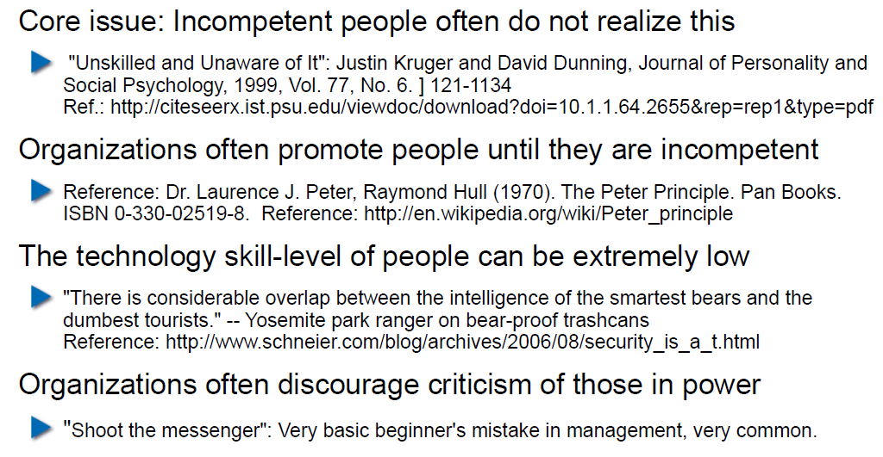

## Exercises and Preparation for Next Week

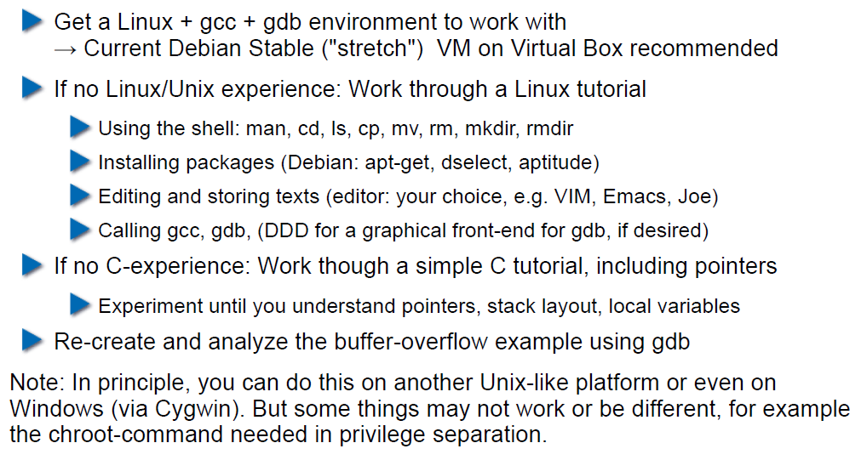

## Reserve

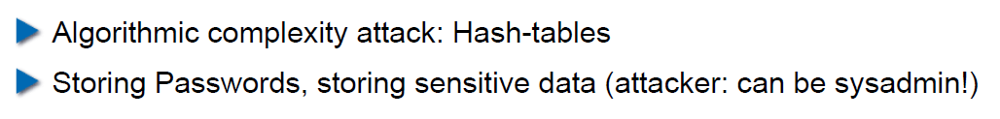

# Woche 2

## Agenda

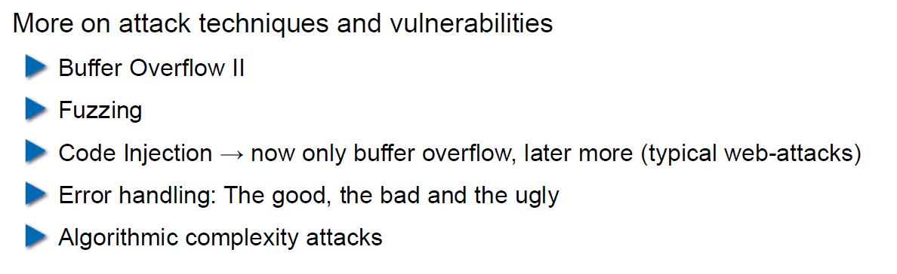

## Recap: What do Attackers Want?

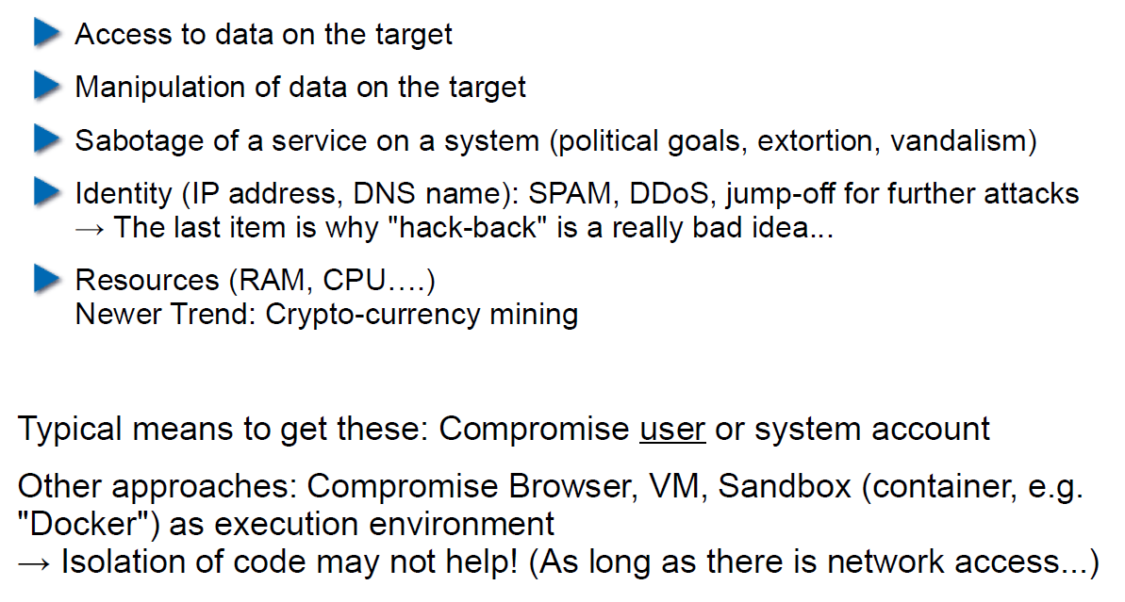

## Buffer Overflow II

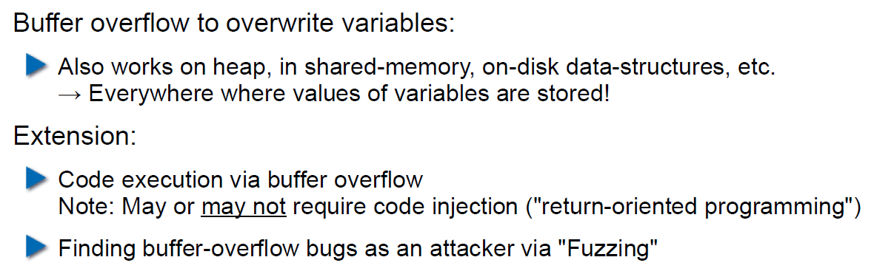

## Buffer Overflow II

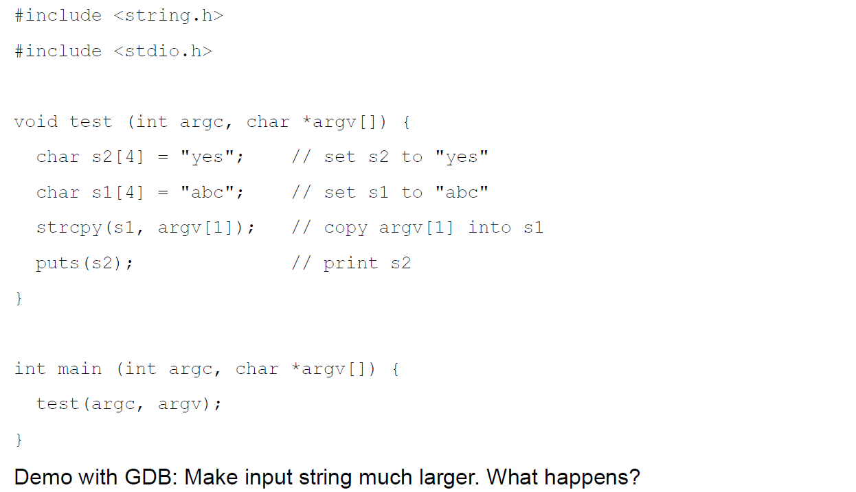

## Buffer Overflow II

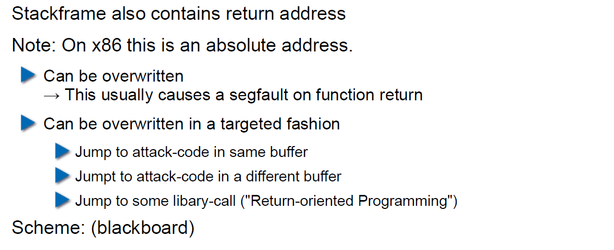

## Buffer Overflow II

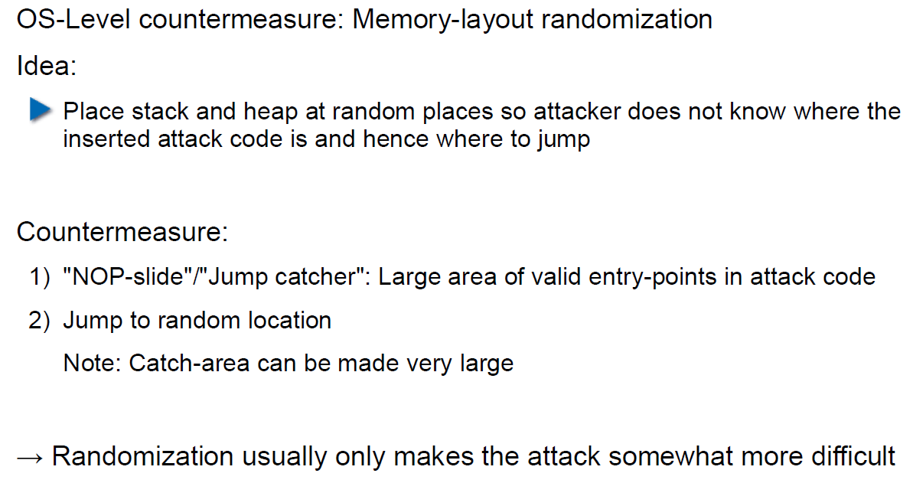

## Buffer Overflow II

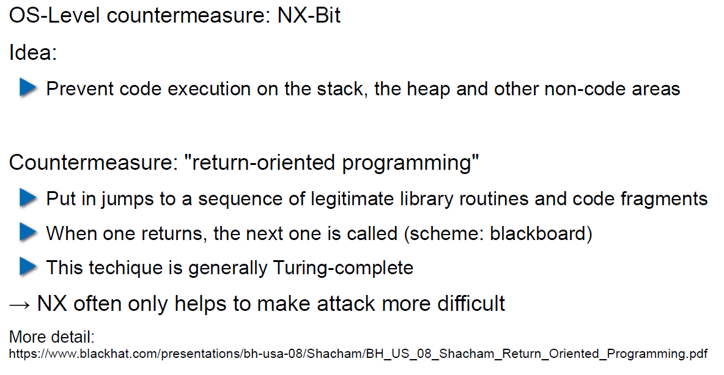

## Attack Technique: Fuzzing

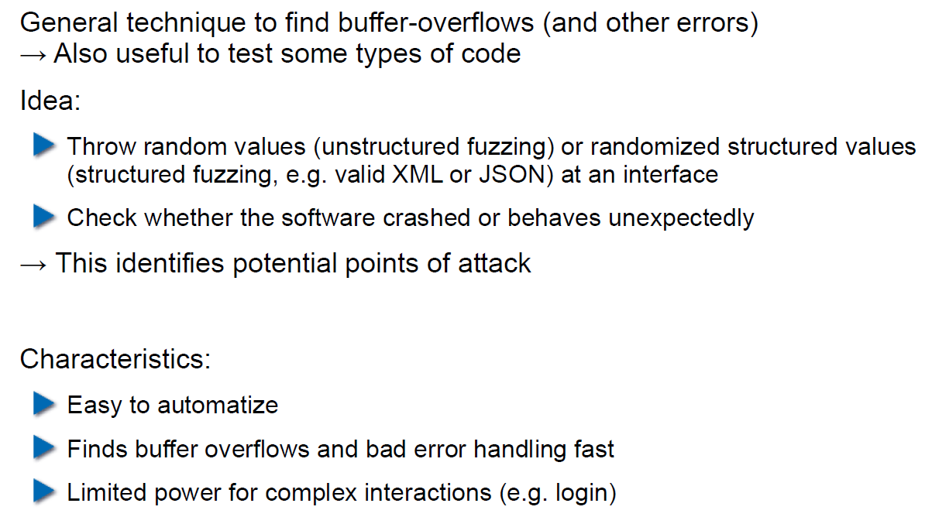

## Error Handling

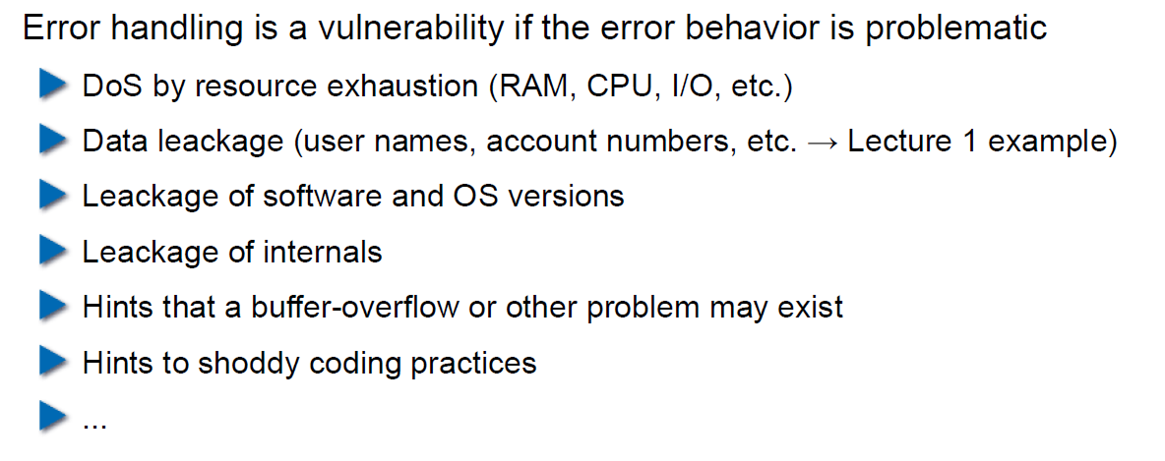

## Case study – Handling too long input

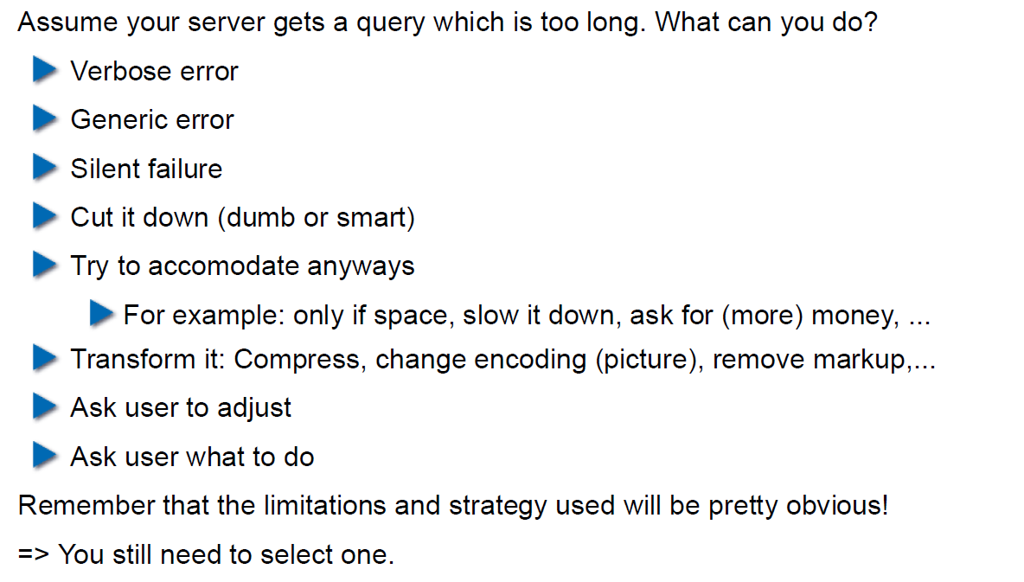

## Case-study: Compression Bomb

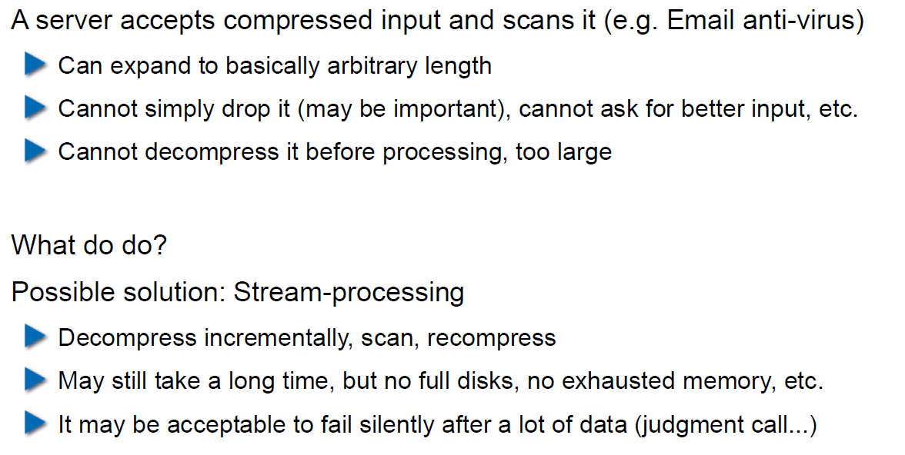

## Error Handling

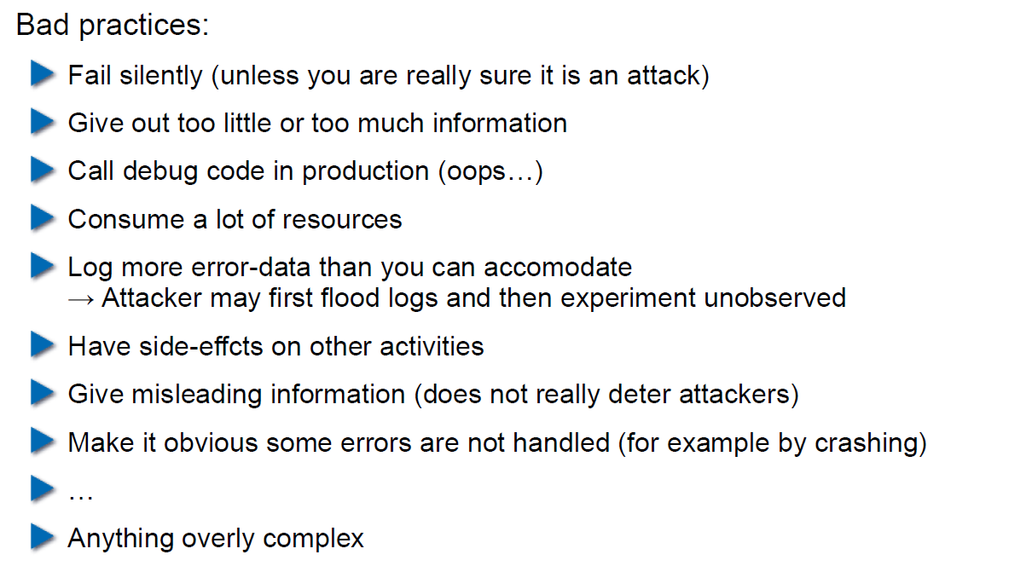

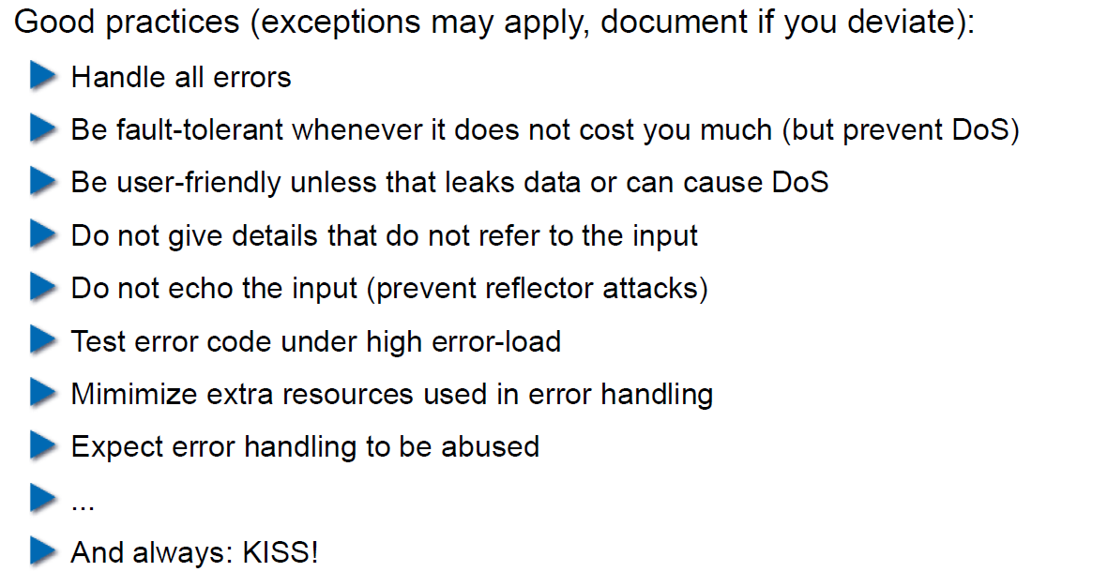

## Algorithmic Complexity Attacks

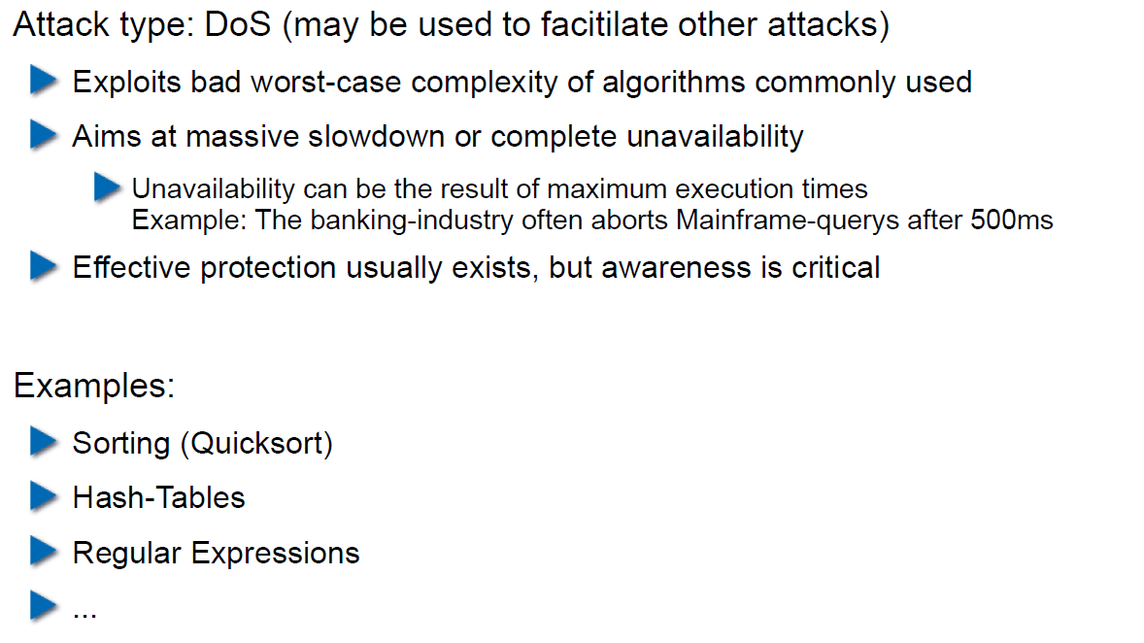

## Algorithmic Complexity: Sorting

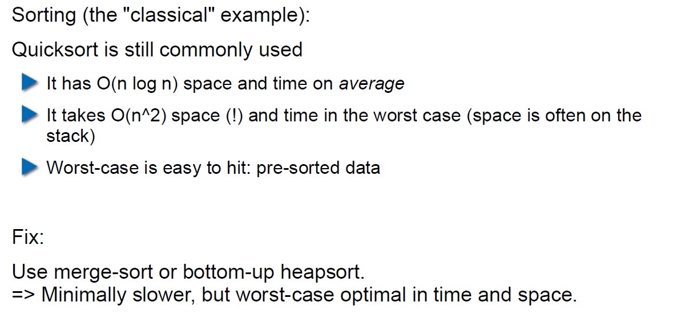

## Algorithmic Complexity: Hashing

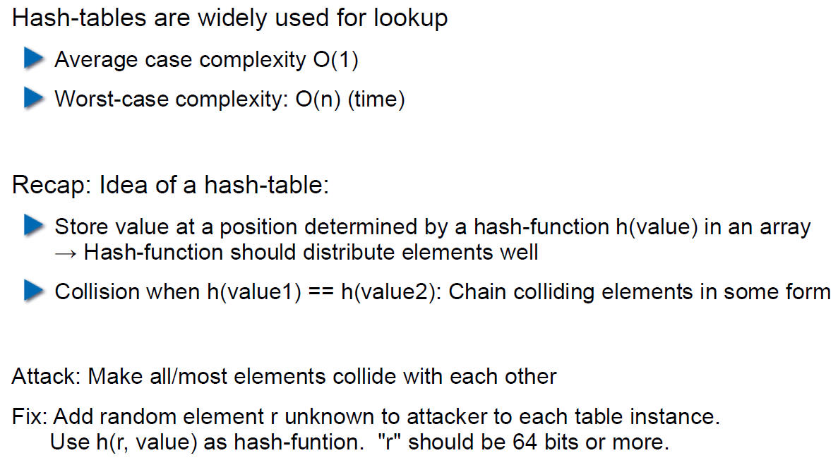

## Algorithmic Complexity: Regular Expressions

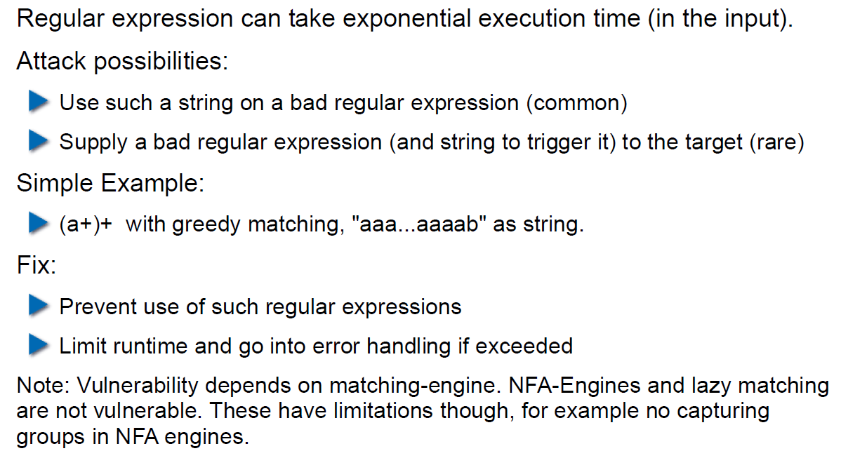

# Woche 3

## Agenda

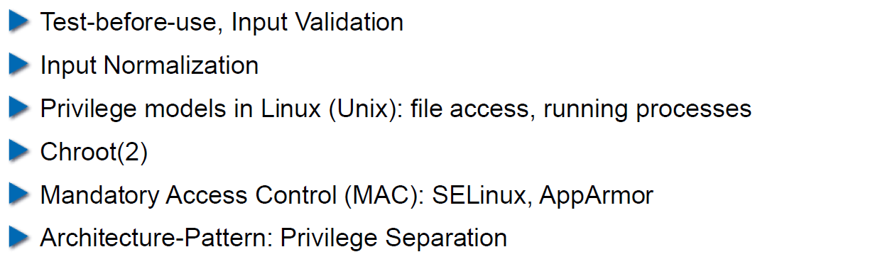

## Secure Coding Principle: Test-before-use

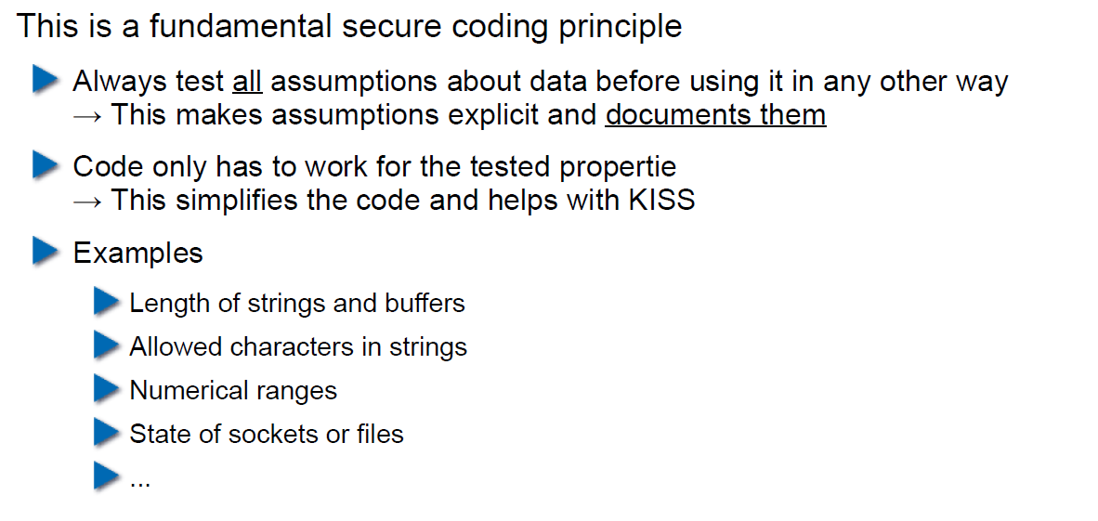

## Input Validation

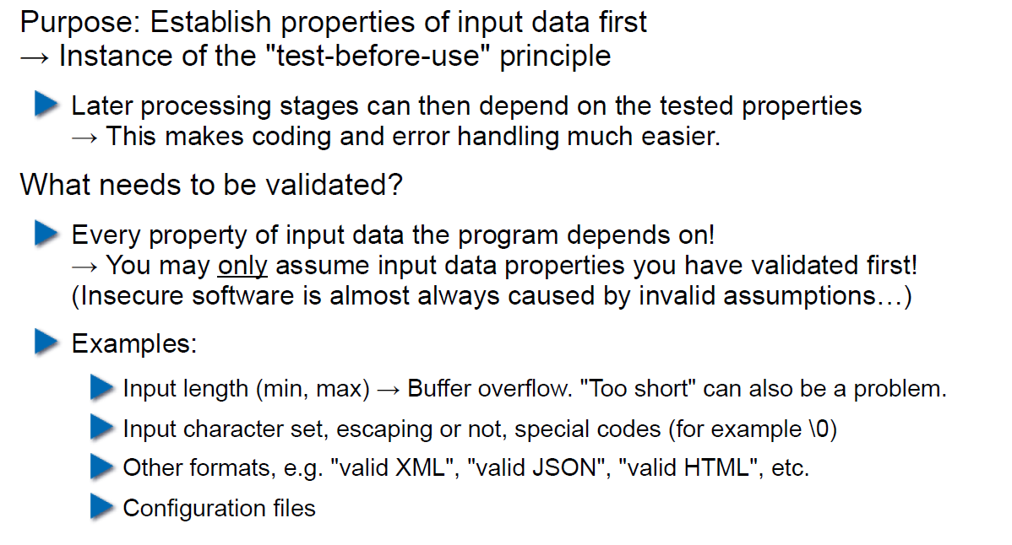

## Input Normalization

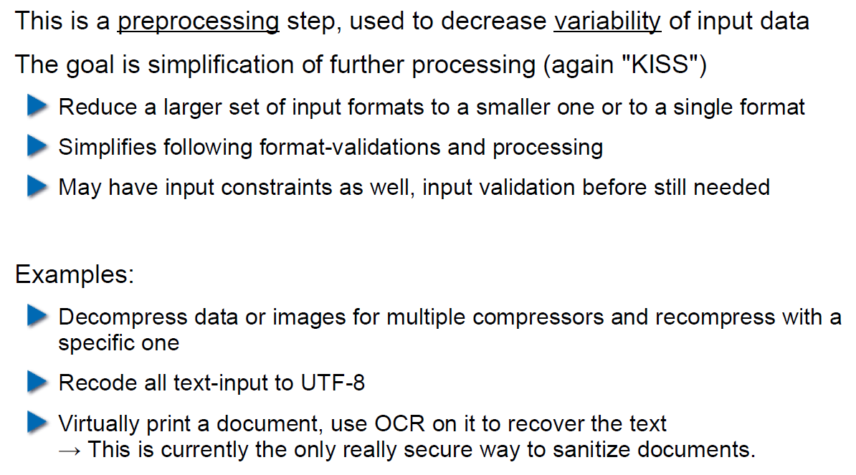

## Unix Permission Model (simplified)

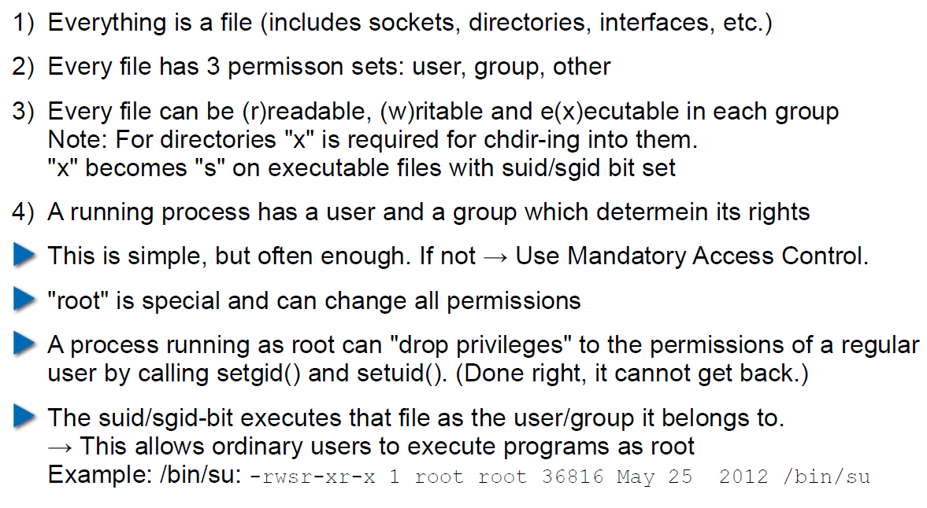

## Chroot

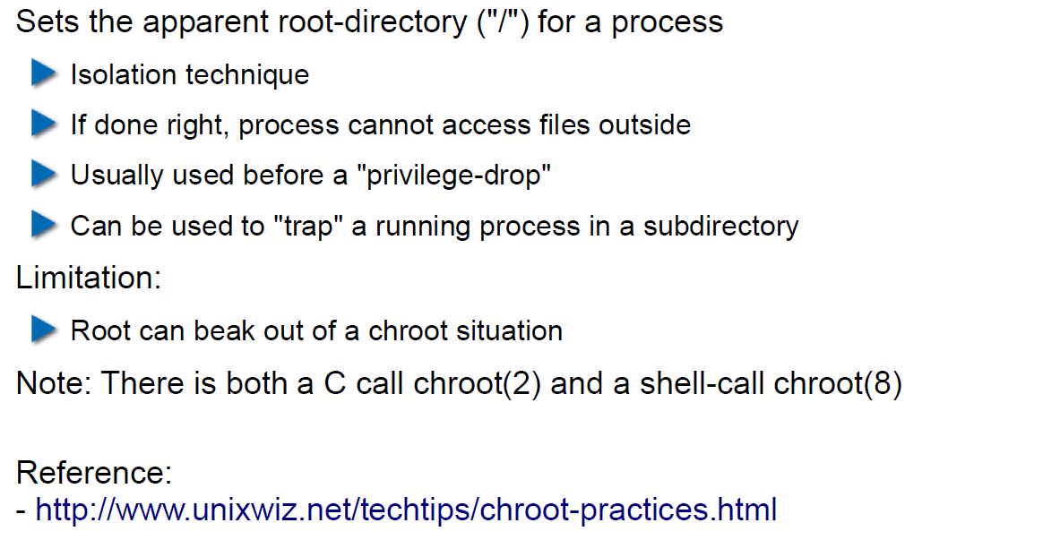

## Mandatory Access Control (MAC)

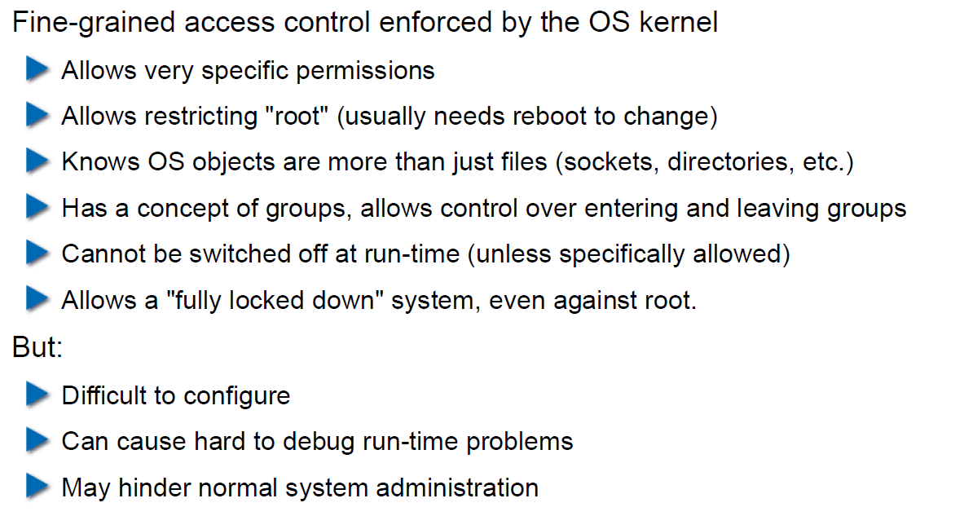

## MAC Example: SELinux

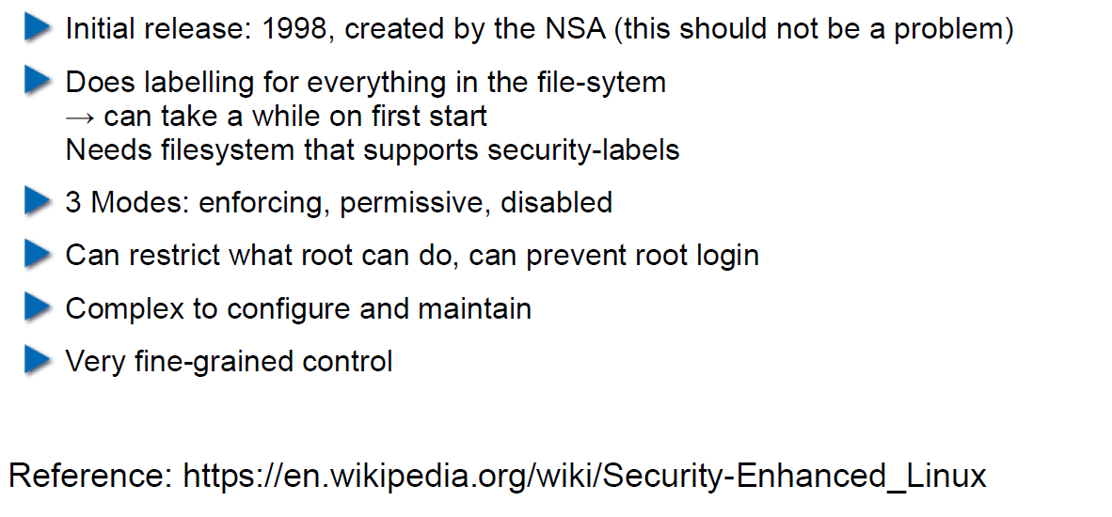

## MAC Example: AppArmor

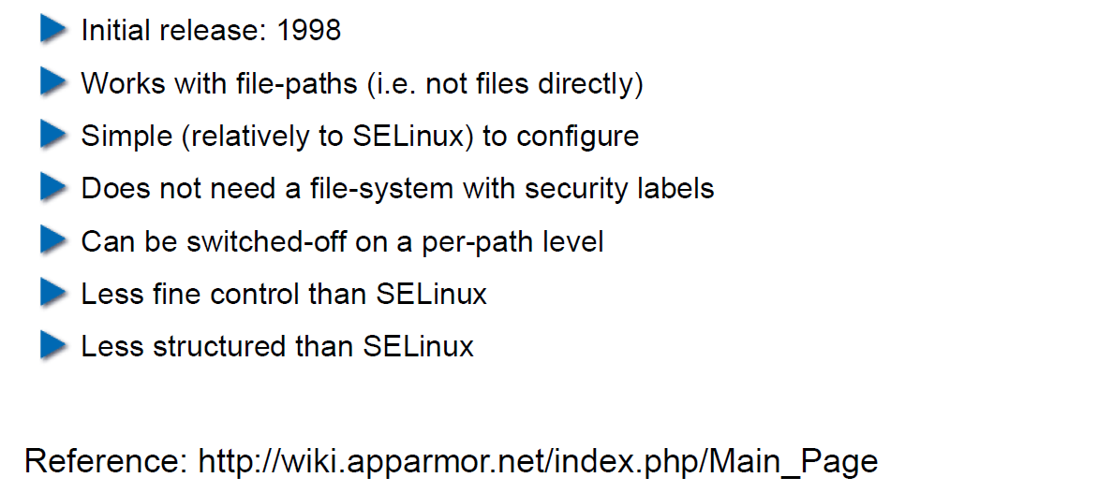

## Secure Coding Principle: Defense in Depth

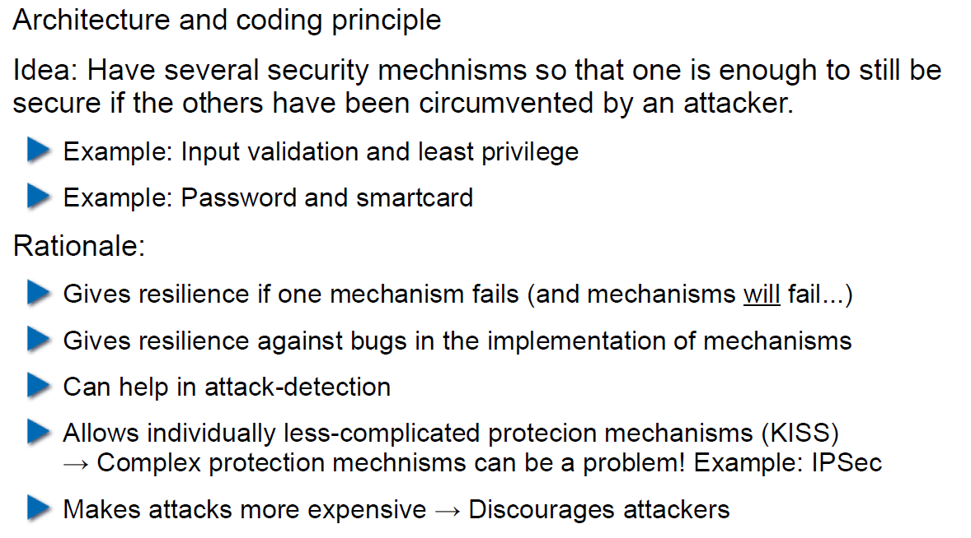

## Privilege Separation

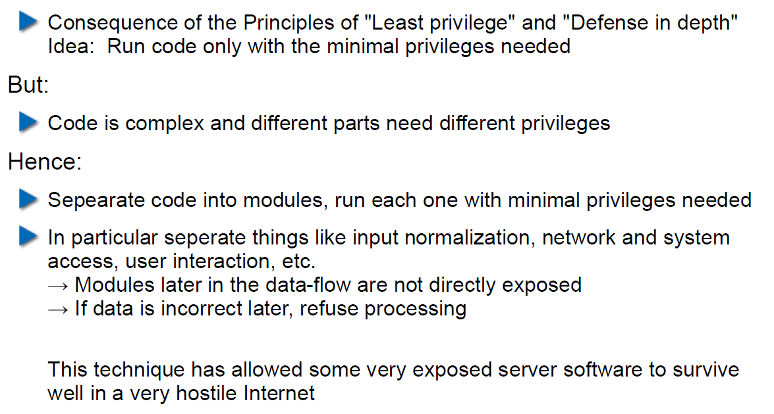

## Overall Idea

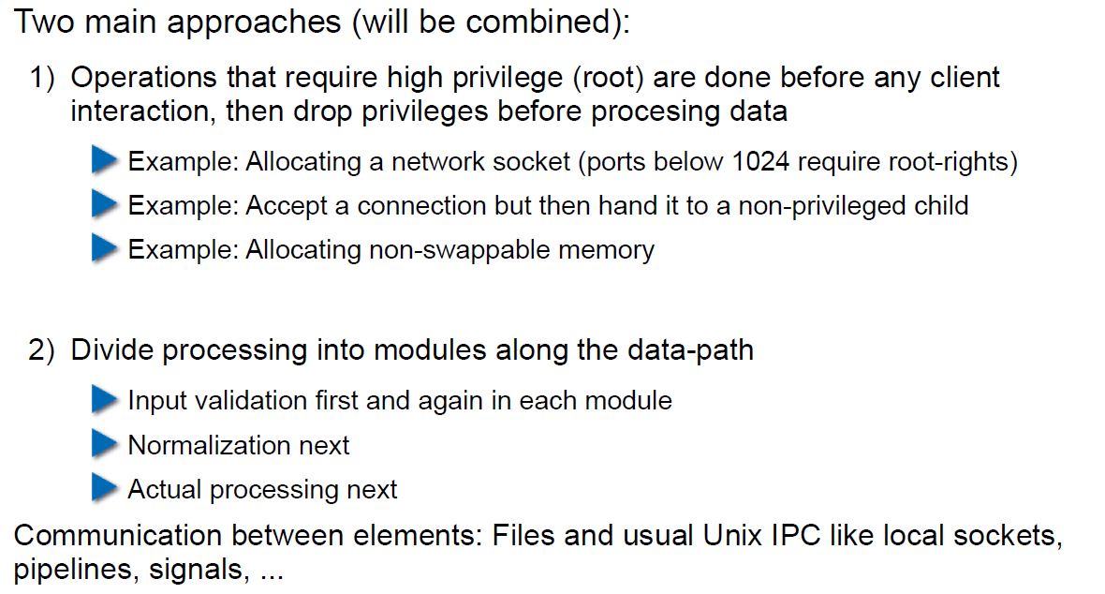

## Form of the Modules

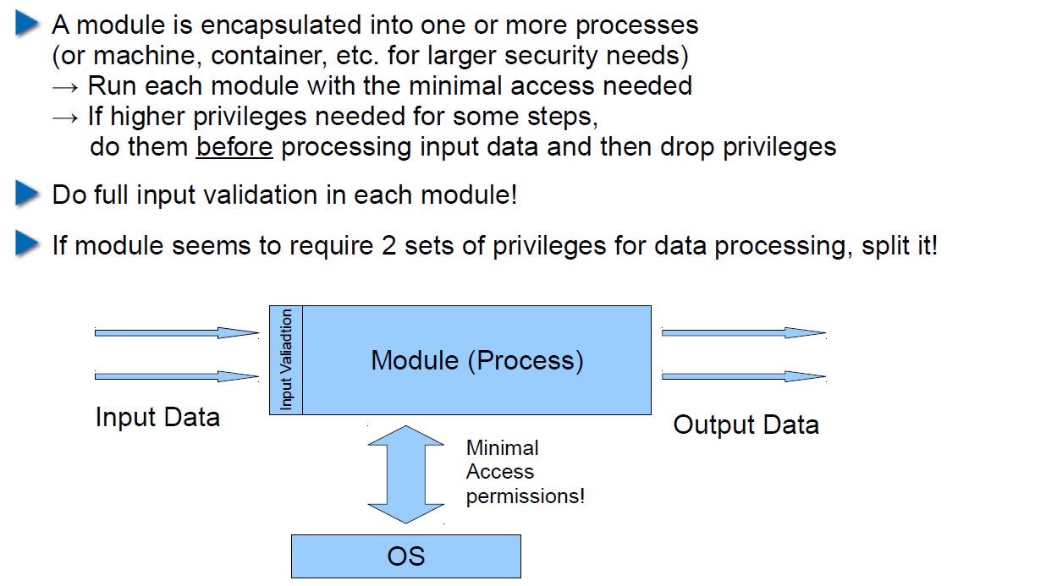

## Example: OpenSSH

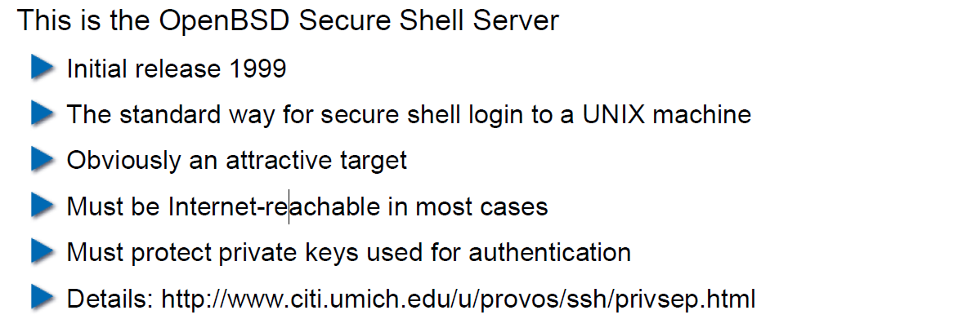

## OpenSSH: Privilege Separation Approach

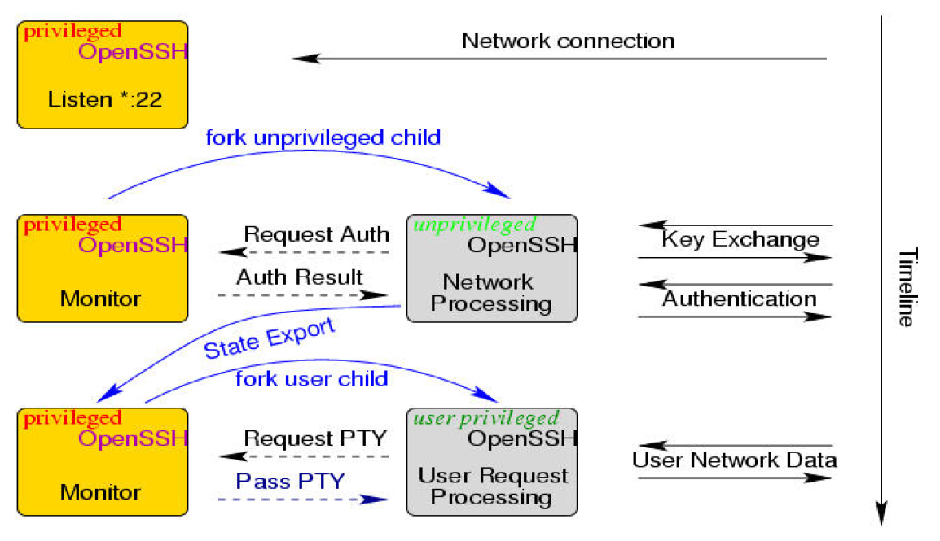

## Example: Postfix MTA (Email Server)

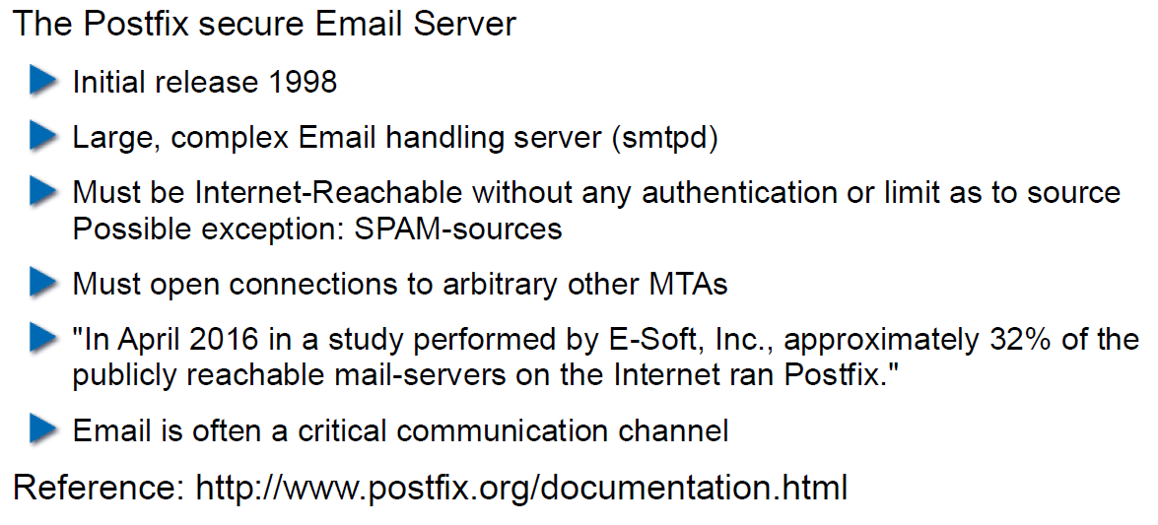

## Postfix System View

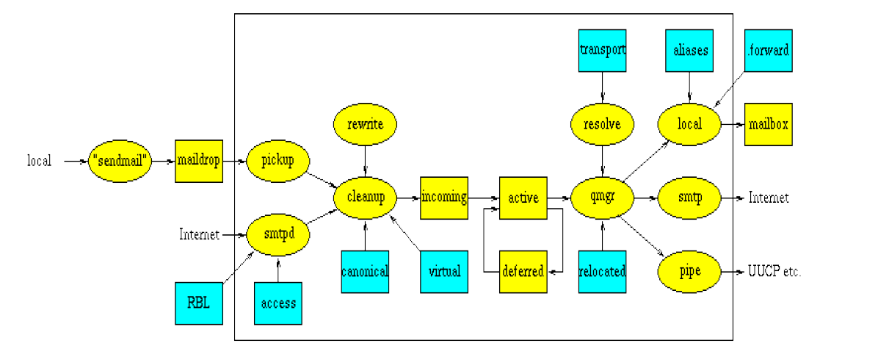

## Postfix: Example Data-Flow

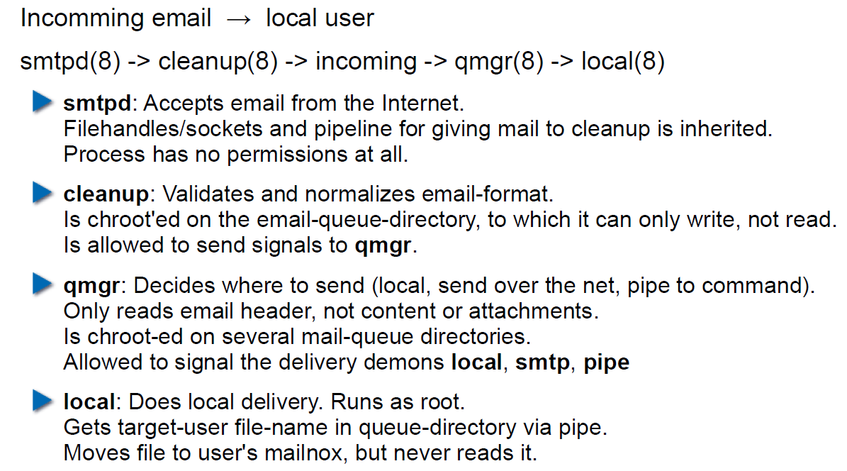

# Woche 4

## Agenda

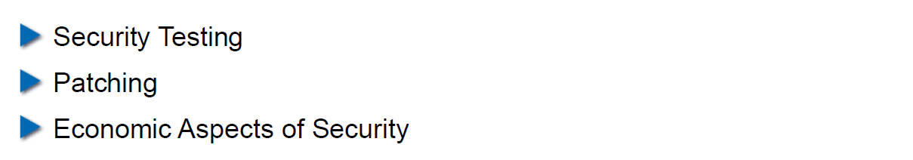

## Security Testing (for Software)

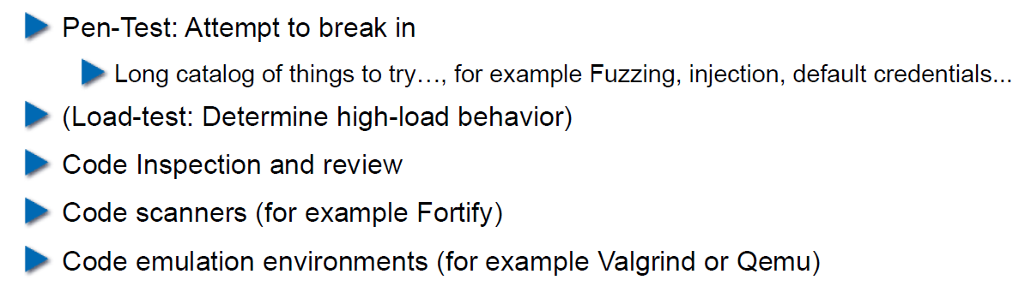

## Pen-Test

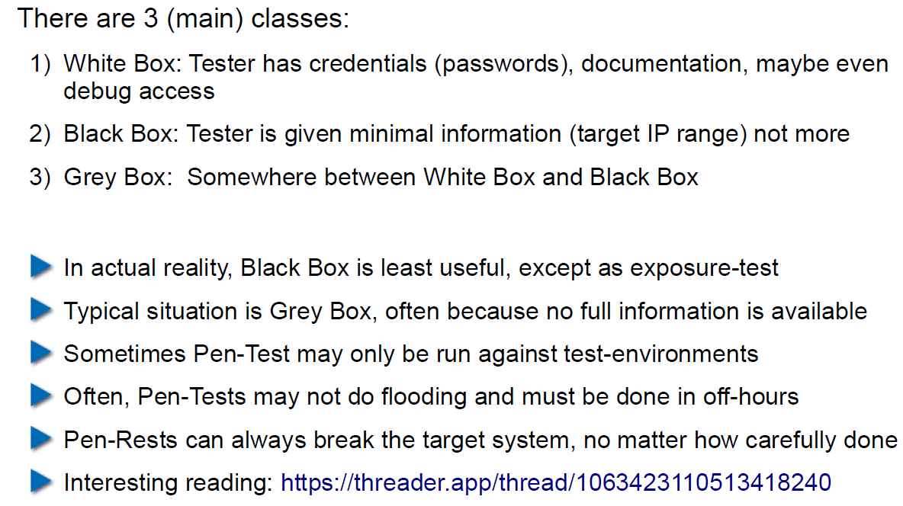

## How does a Pen-Test fail?

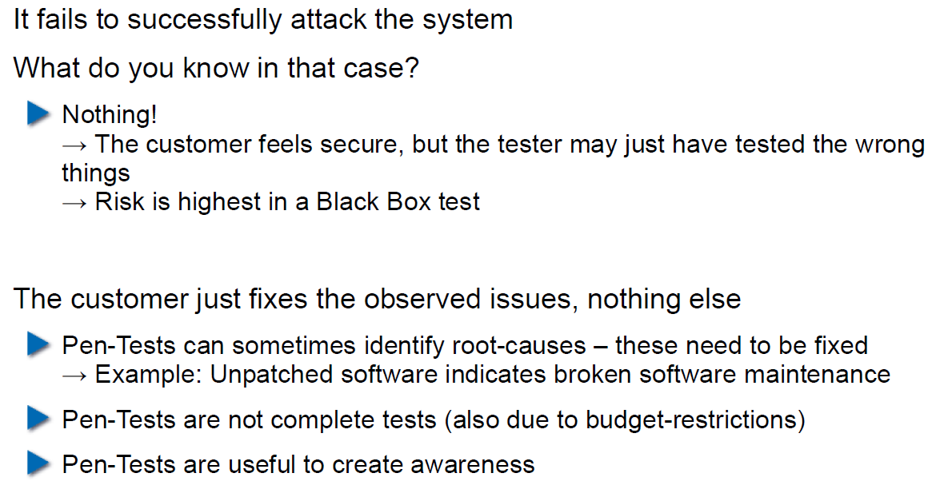

## Code Inspection and Review

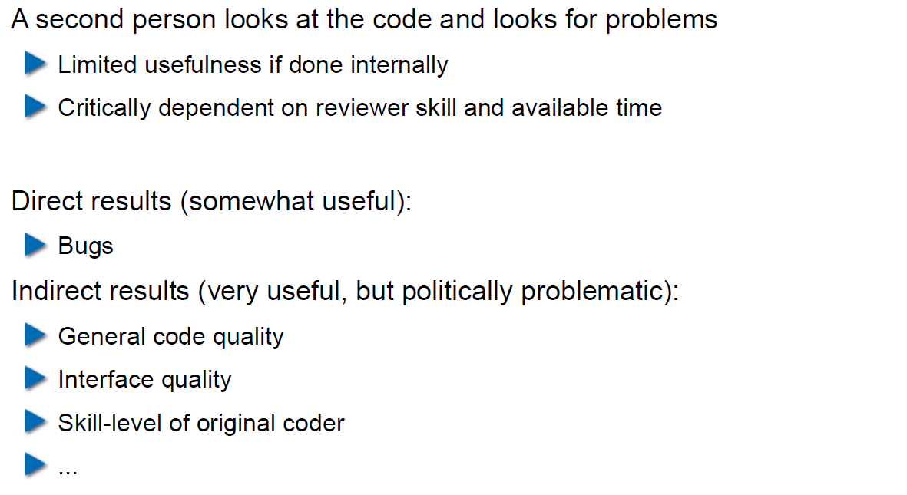

## Code Scanners

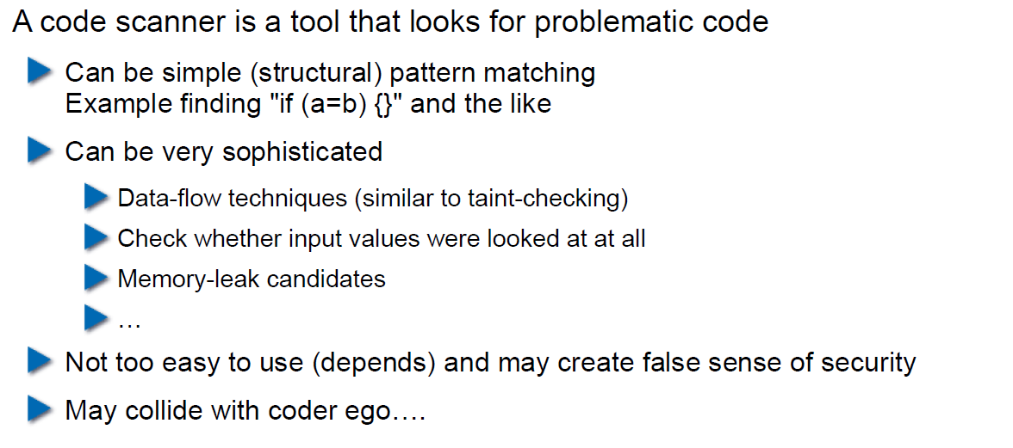

## Execution Emulators

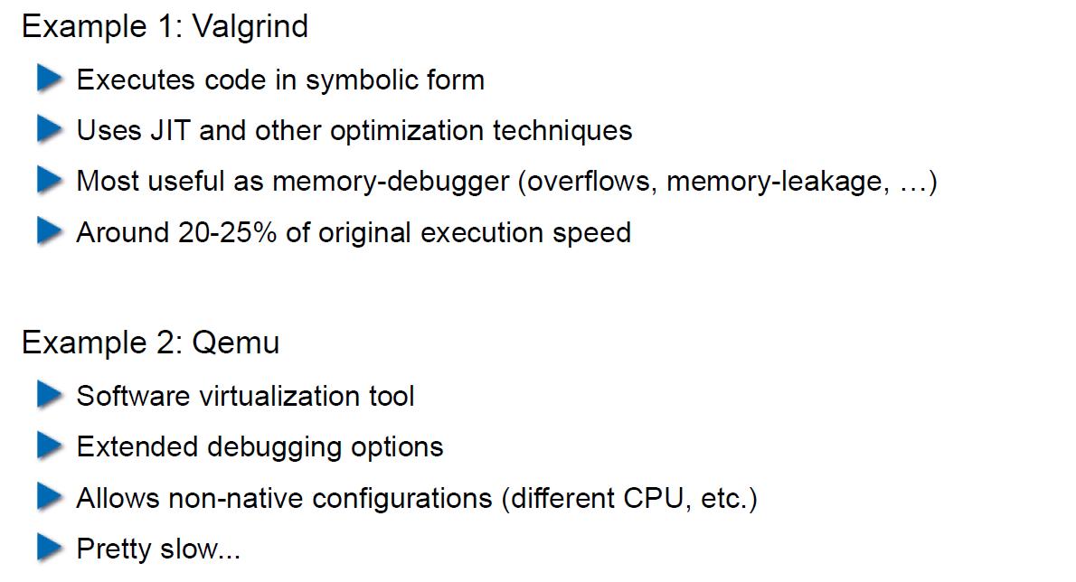

## Patching

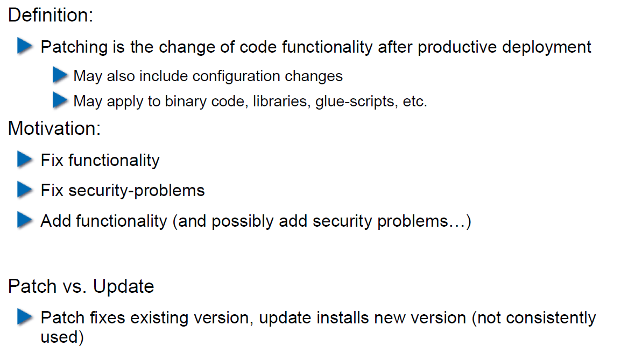

## How to Patch

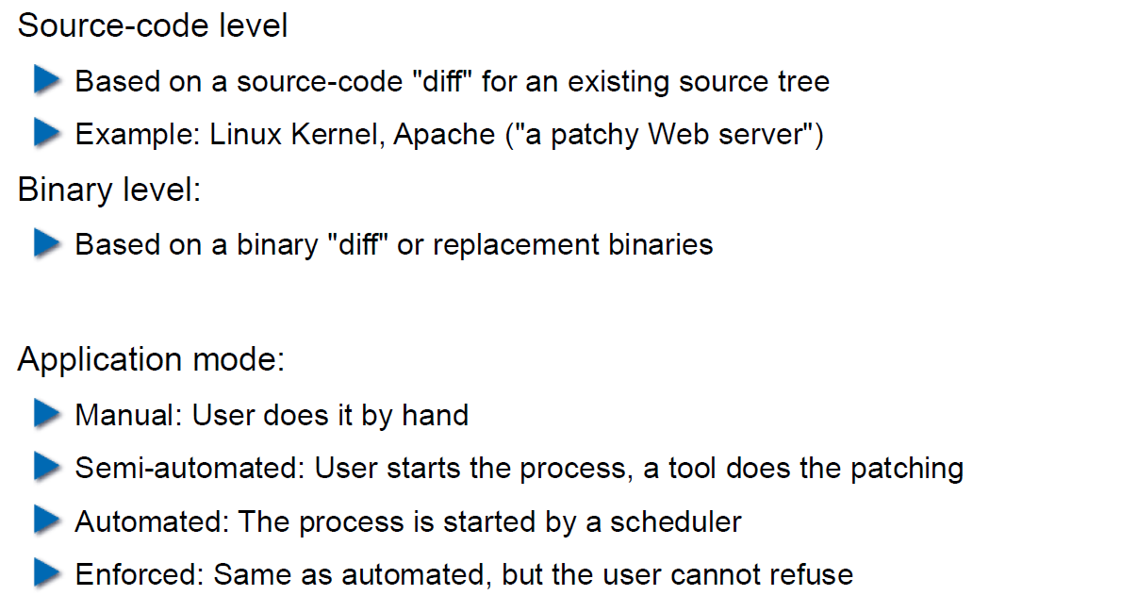

## Problems with Patching

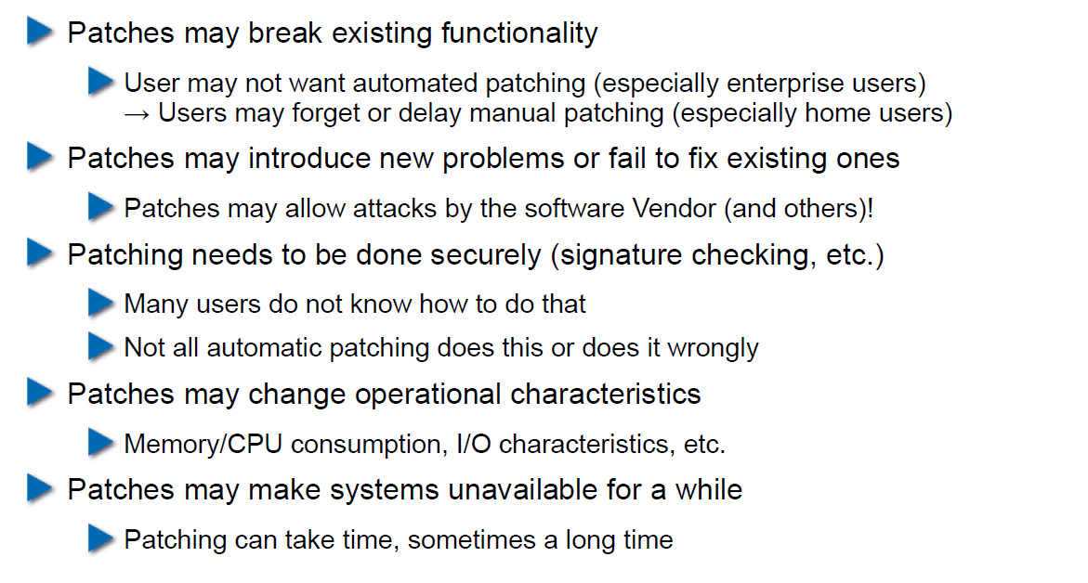

## Problems with not Patching

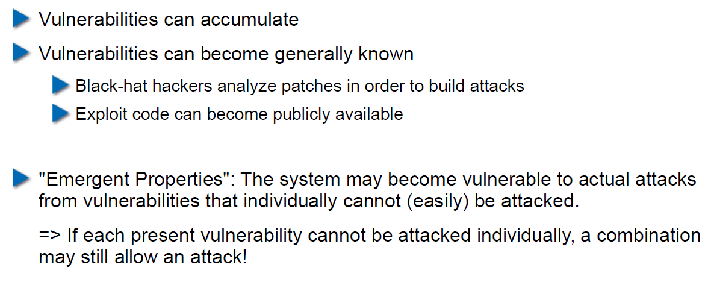

## Problems with Unavailability of Patches

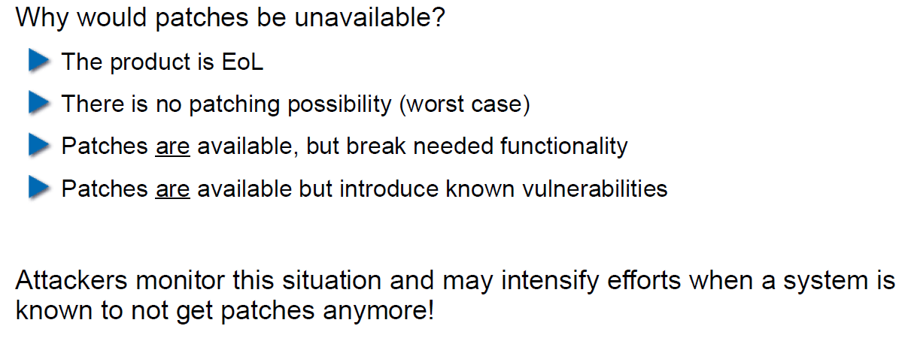

## Economic Aspects of Security

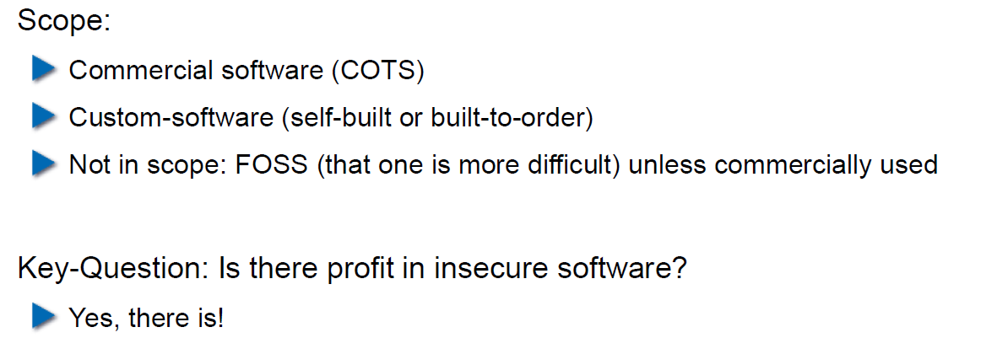

## Case Study: DDoS on Brian Krebs (20.9.2016)

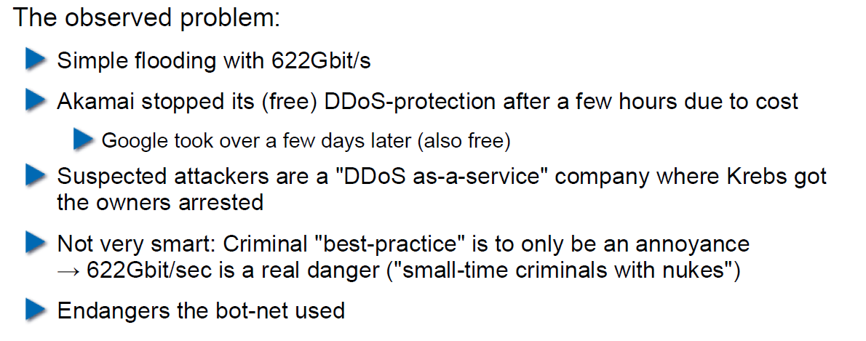

## What can Perform Such an Attack?

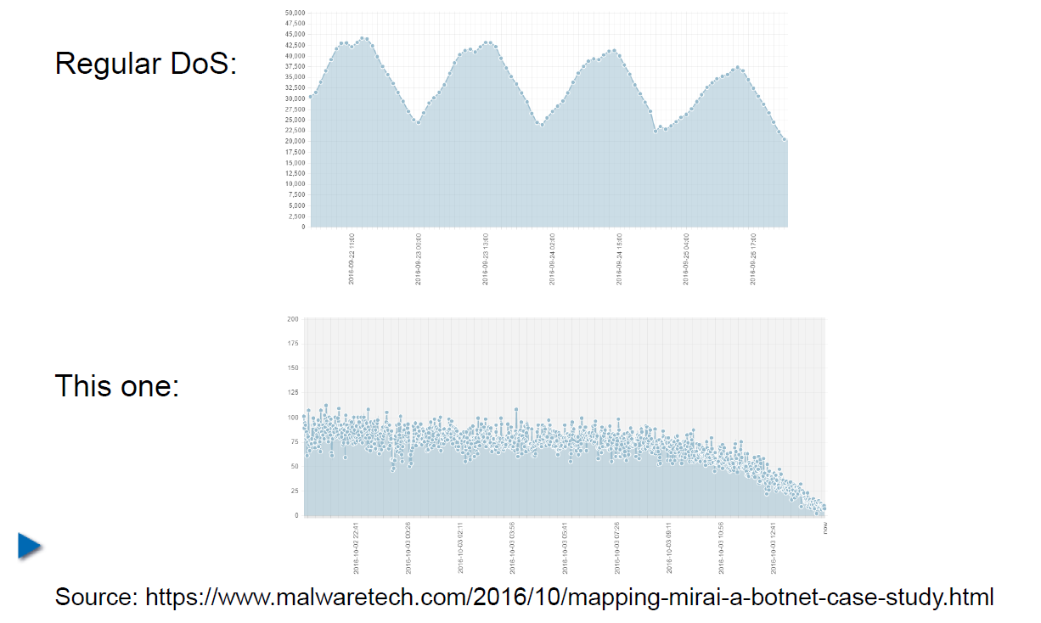

## IoT: Internet of insecure Things

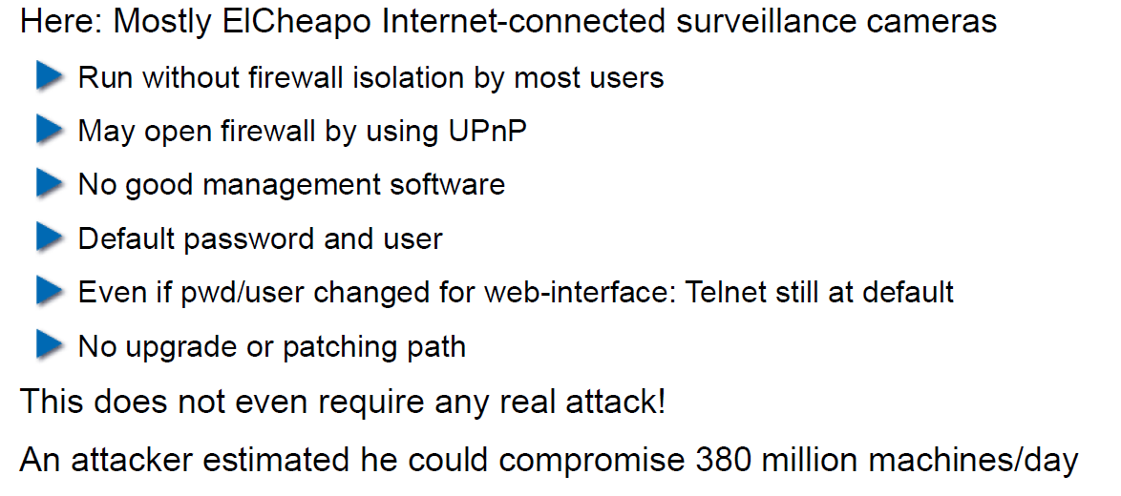

## Why are These IoT Devices so Insecure?

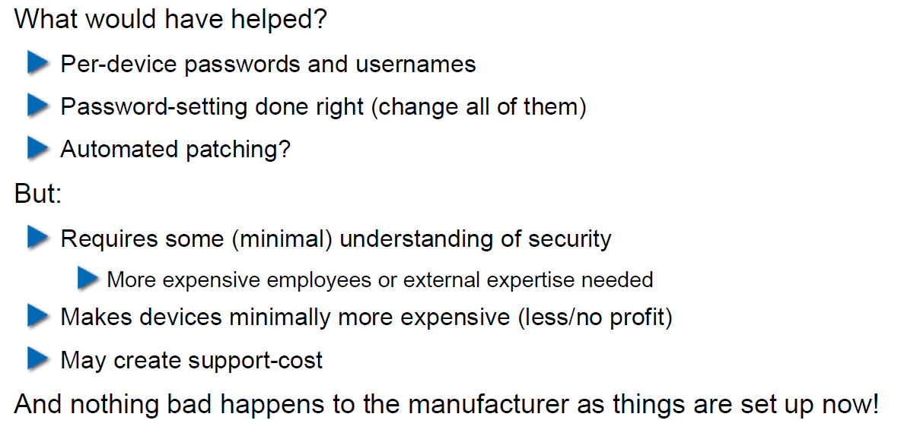

## Possible Solutions

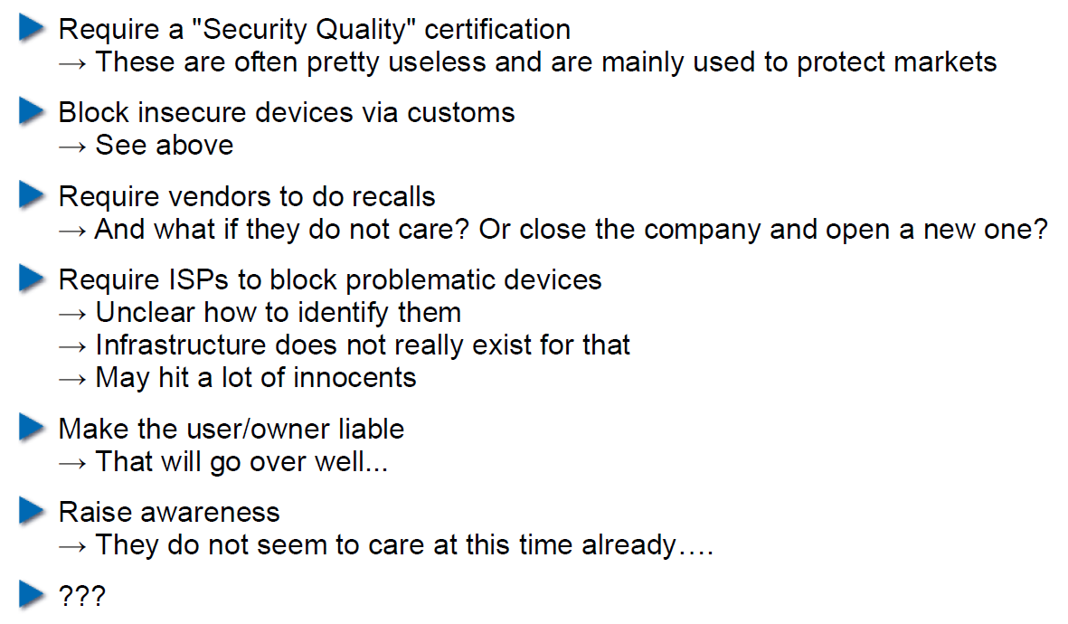

## Does it Pay to make Software Secure?

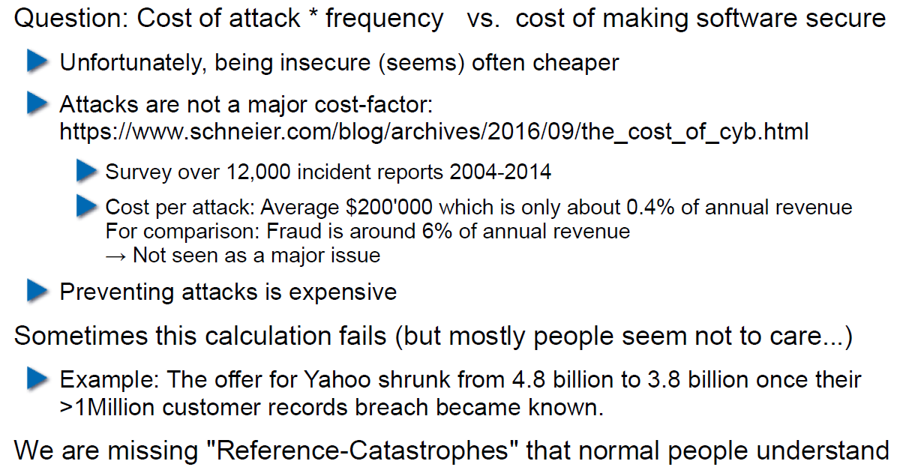

## So, what to do?

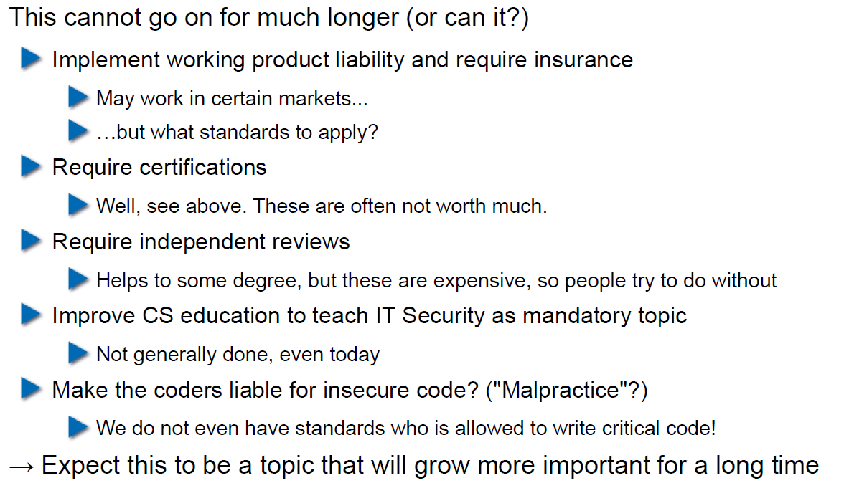

# Woche 5

## Agenda

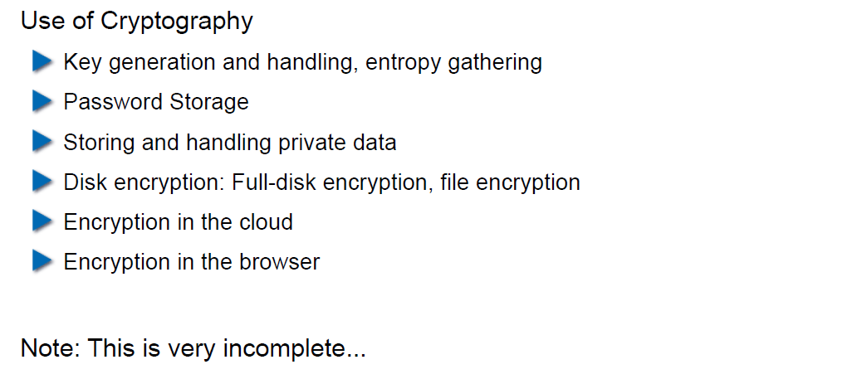

## Generating Cryptographic Keys

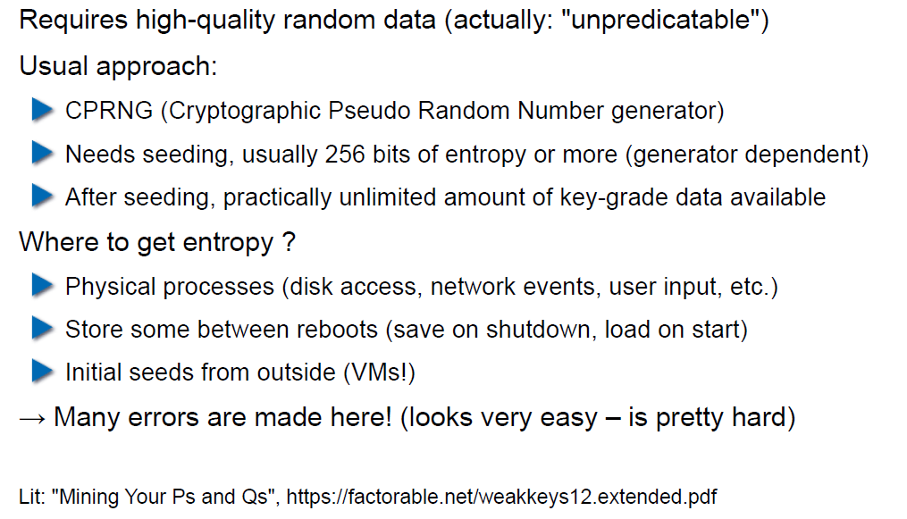

## Information-Theoretical Entropy

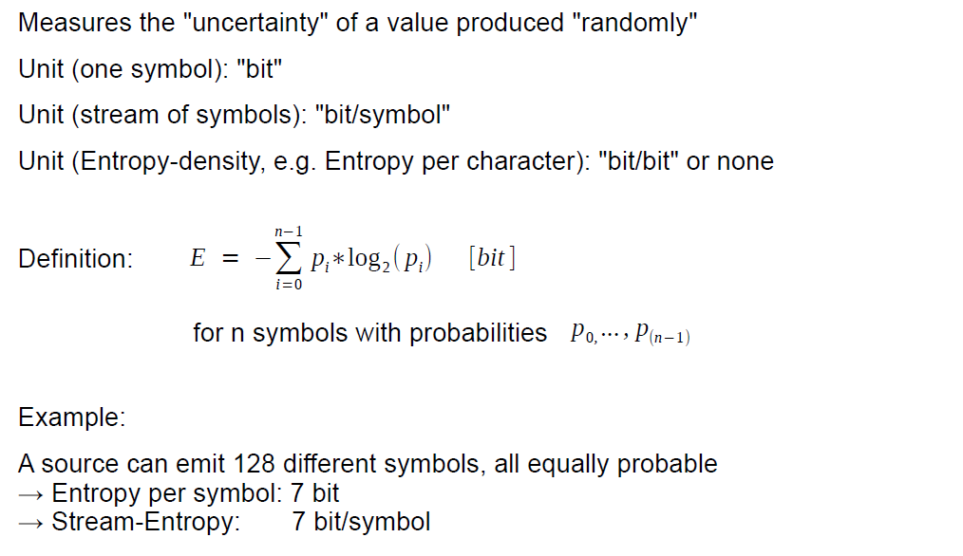

## Estimating Entropy is Tricky

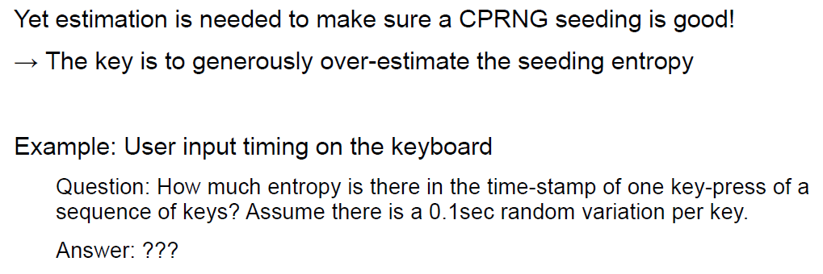

## Seeding a CPRNG

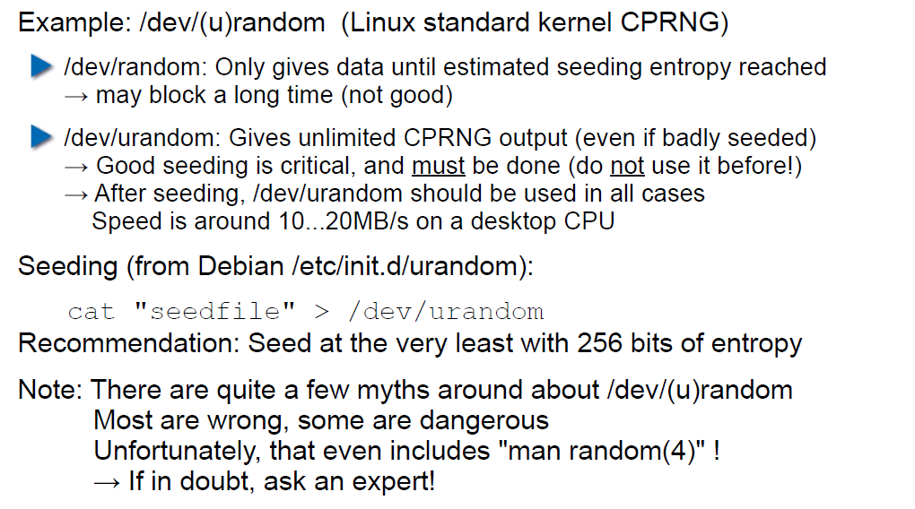

## Bad Seeding Examples

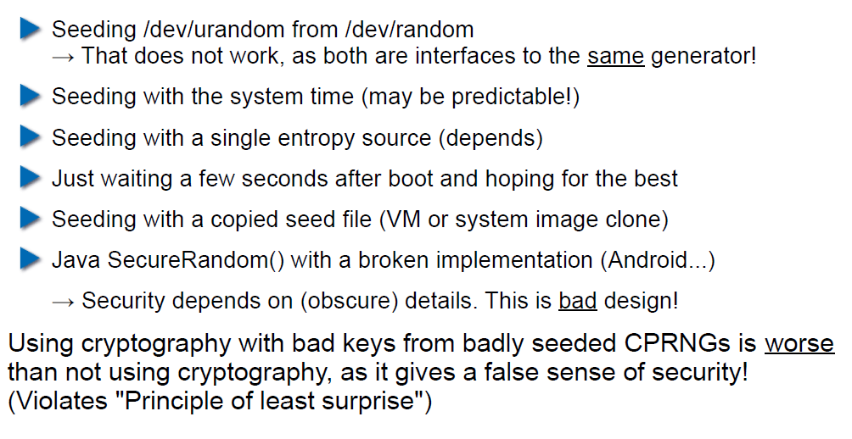

## Storing Cryptographic Keys Securely

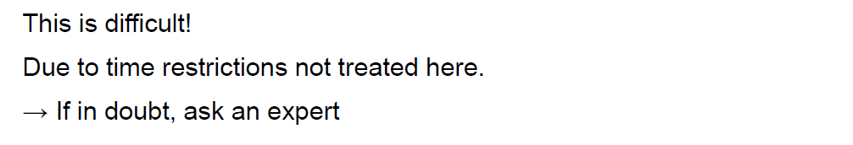

## Storing Passwords

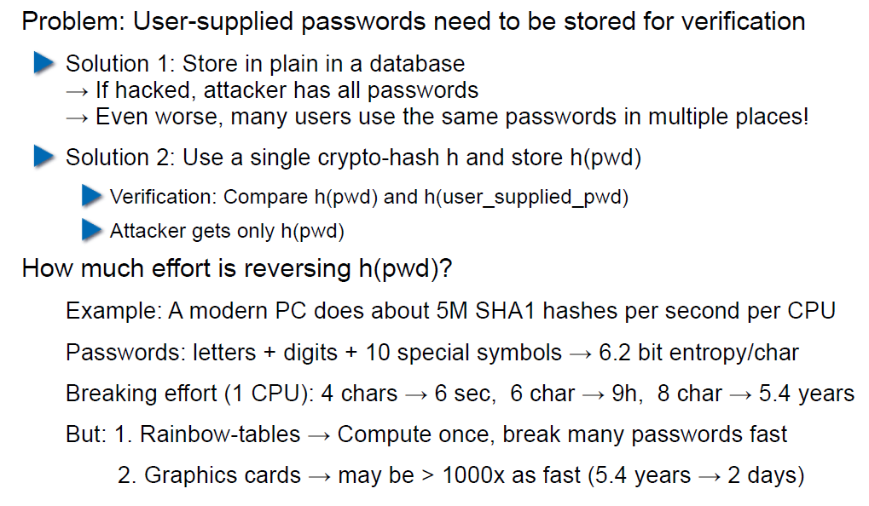

## Rainbow Table

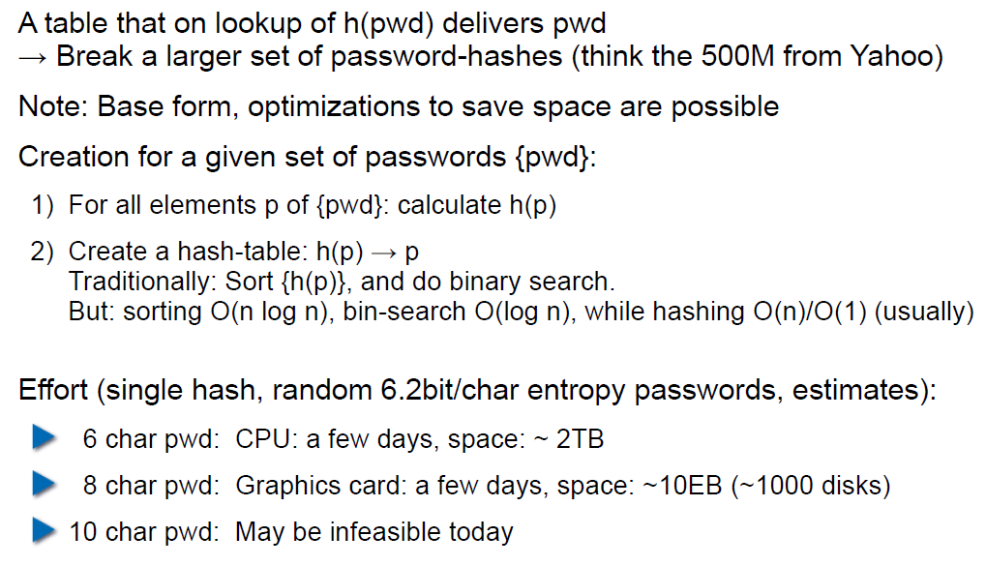

## Storing Passwords

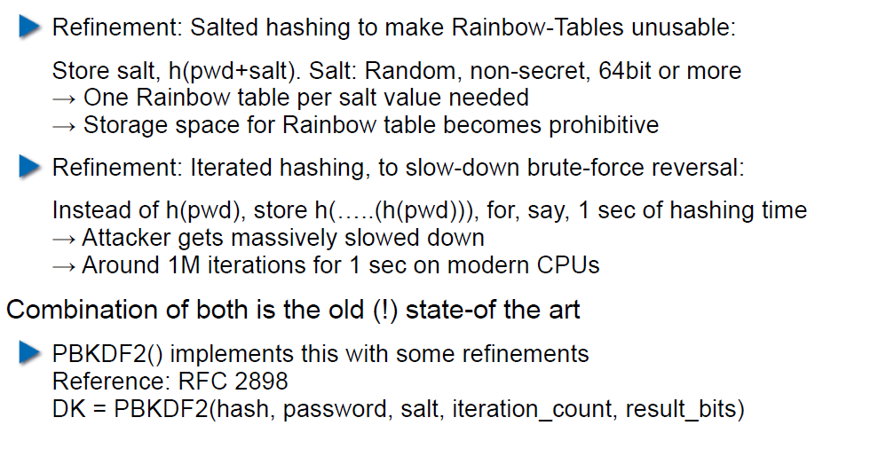

## So What is Wrong with PBKDF2?

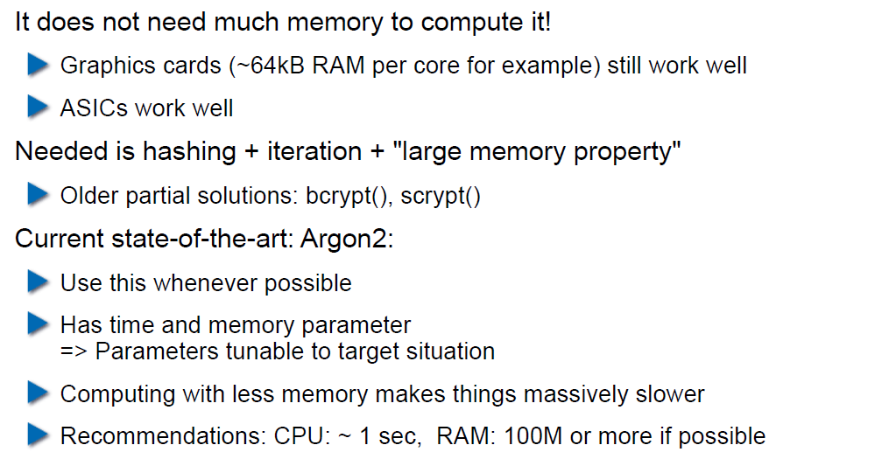

## Hardware RNGs

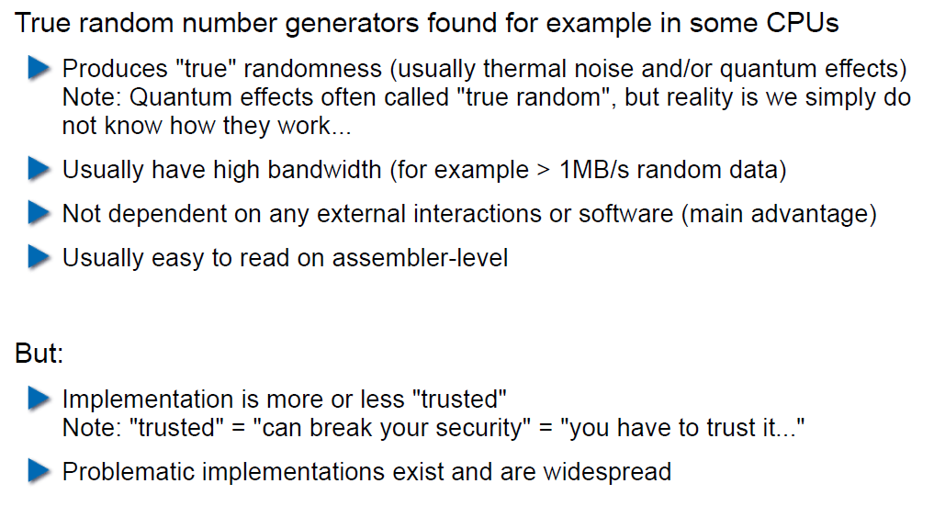

## Example 1: Via C3 Hardware CPRNG Schematic

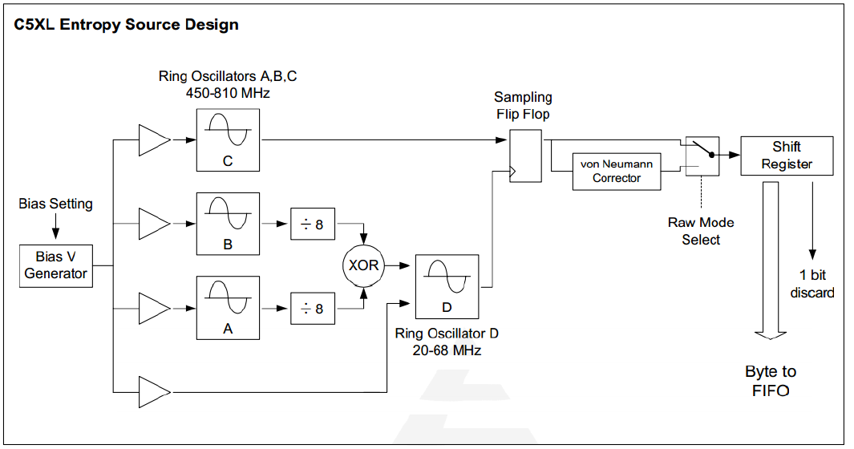

## Example 2: Intel RDRAND Schematic

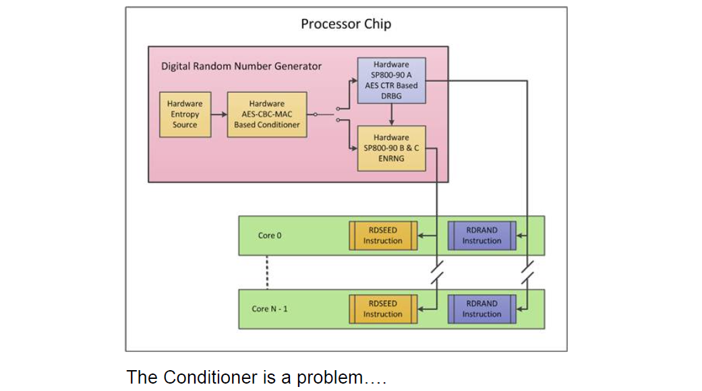

## Compromise on Design-Level

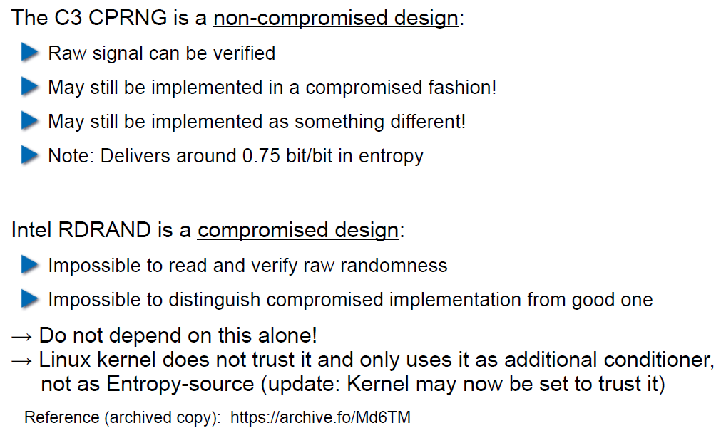

## Storing Private Data (as a Service Provider)

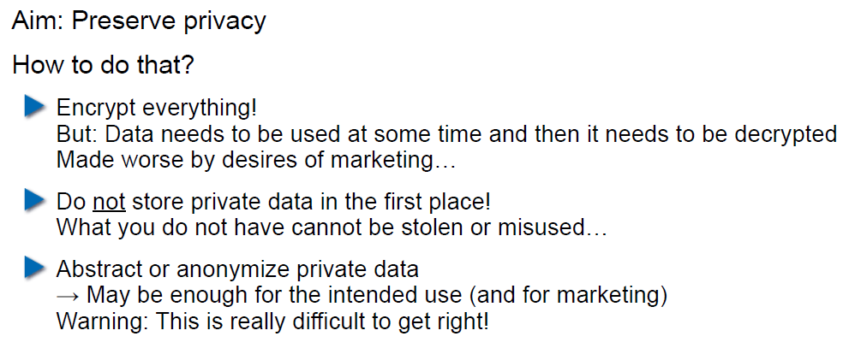

## Disk/Storage Encryption

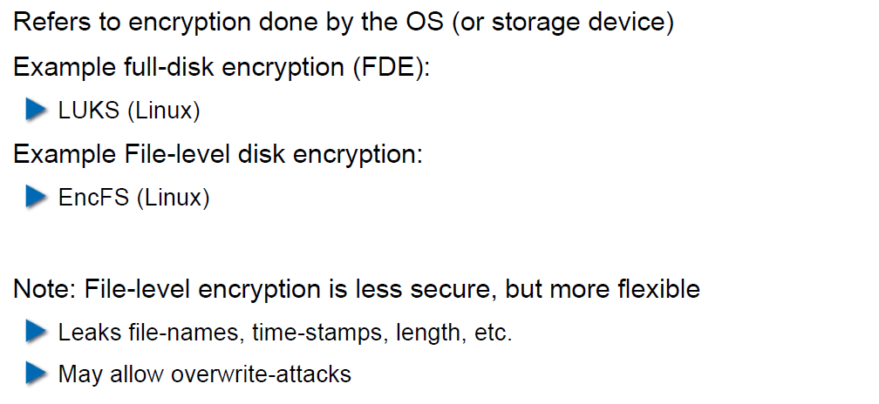

## Disk Encryption Protects Against What?

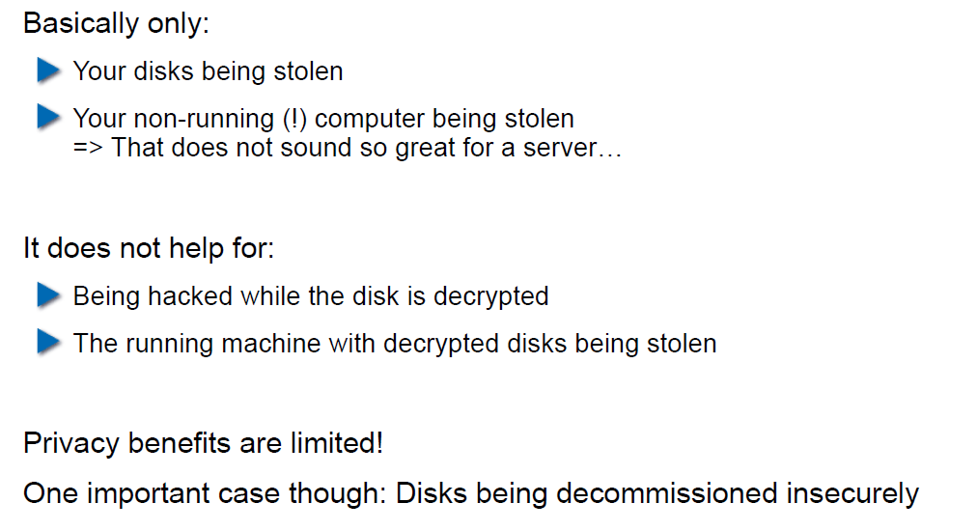

## Decryption Only With User Logged In

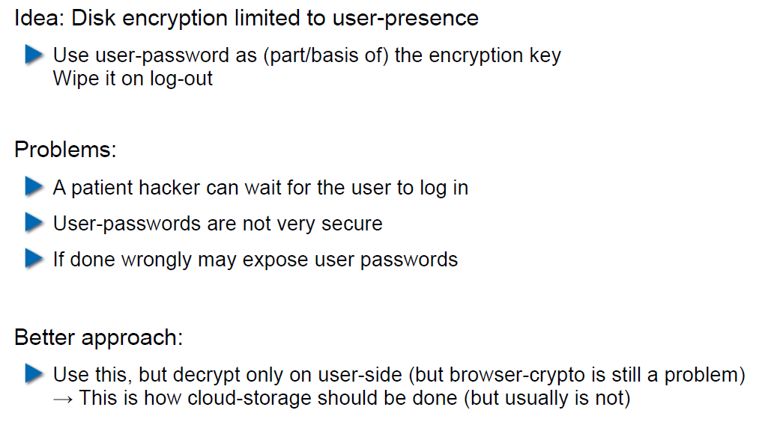

## Encryption in the Cloud

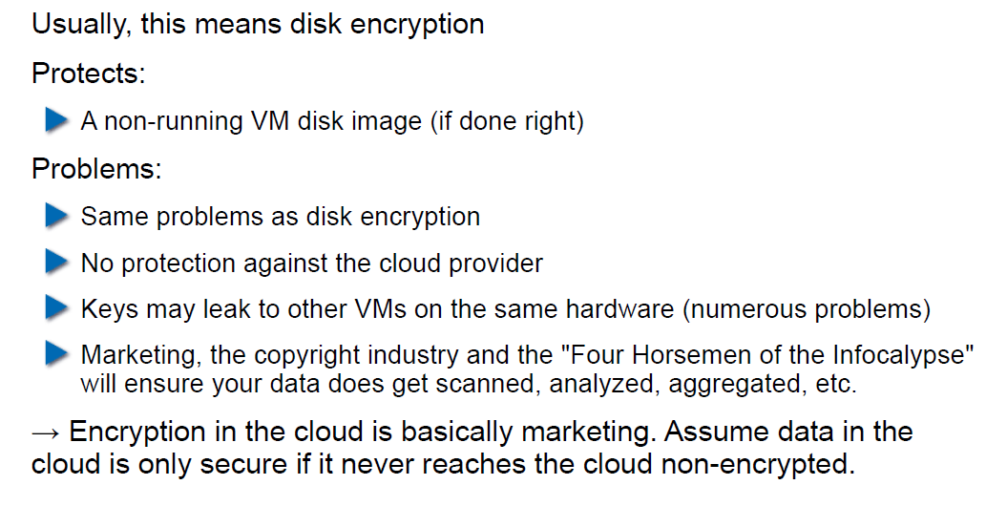

## JavaScript Client-Side Encryption in Web-Apps

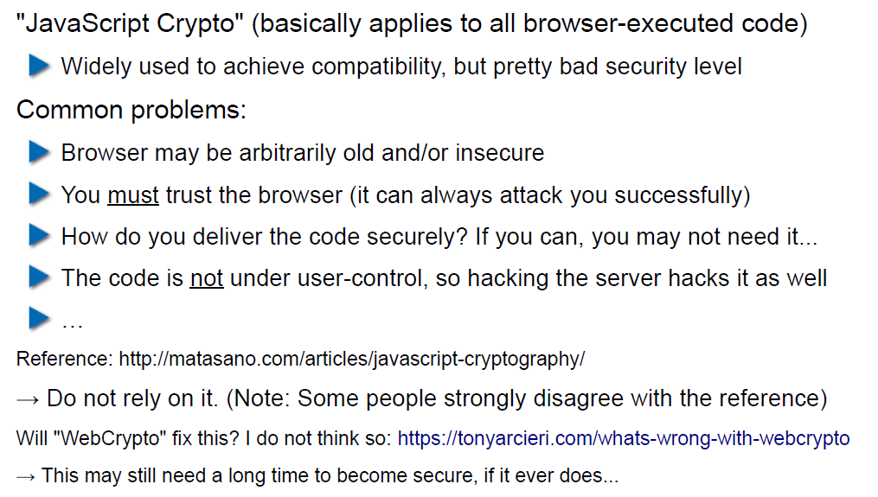

# Woche 6

## Agenda

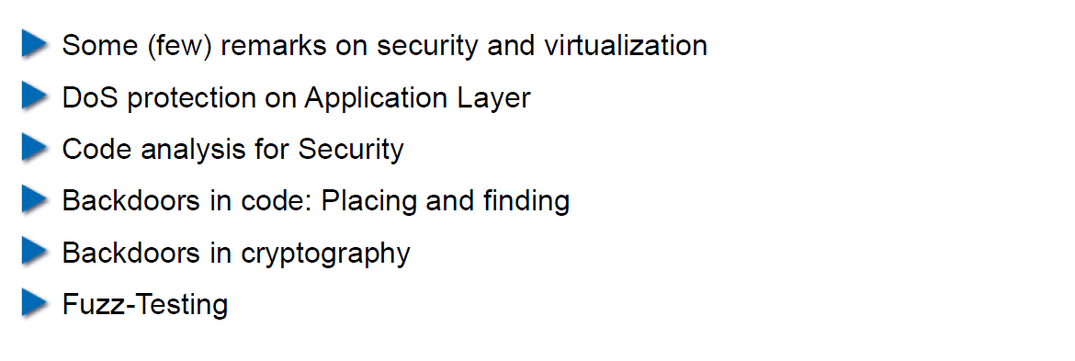

## Virtualization vs. Security

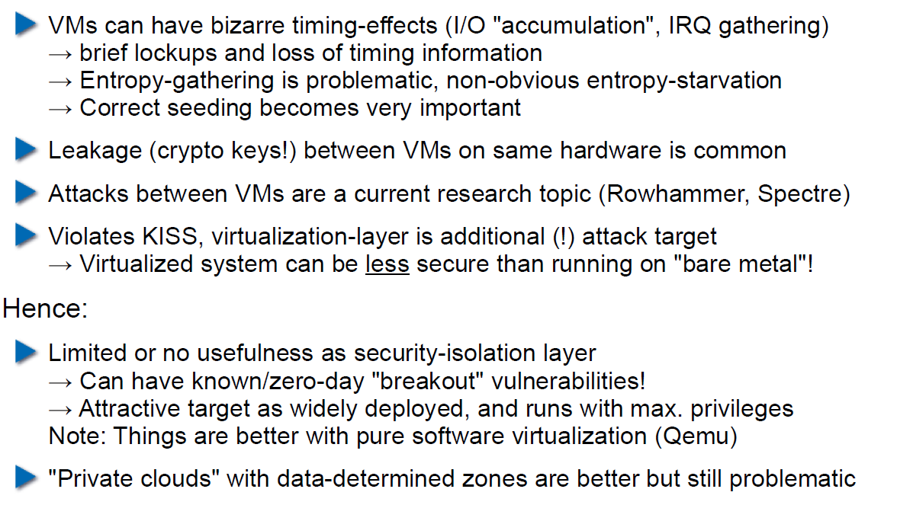

## DoS on Application Layer

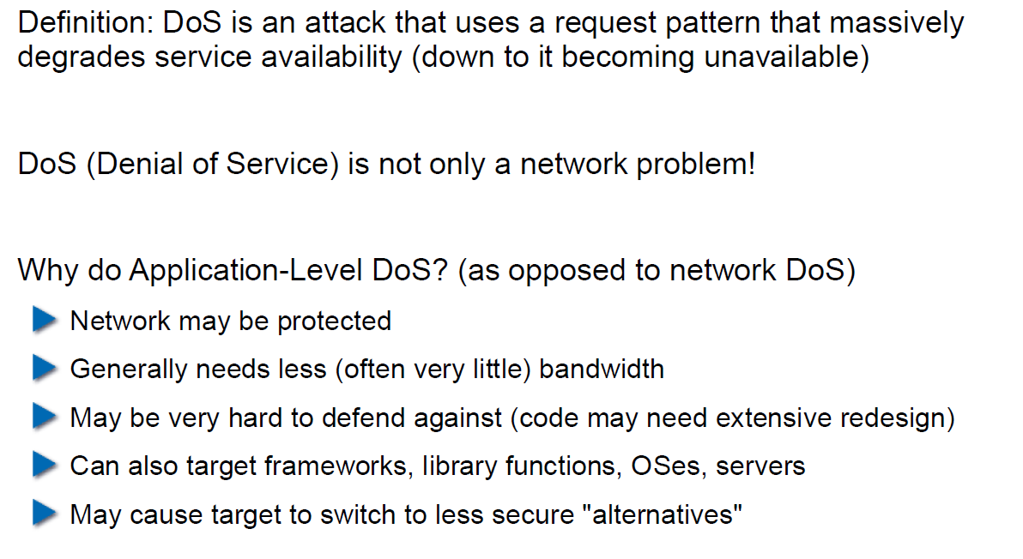

## DoS on Application Layer

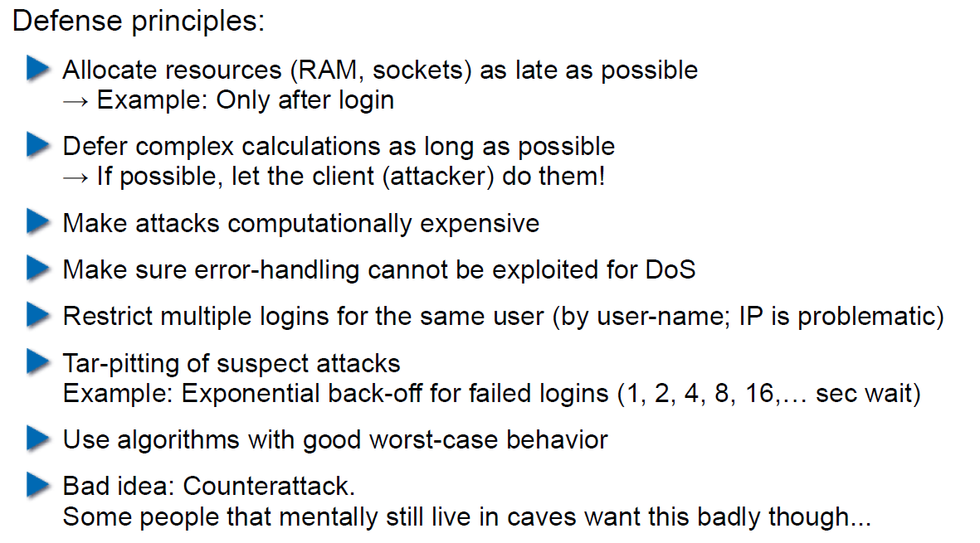

## Code Analysis for Security

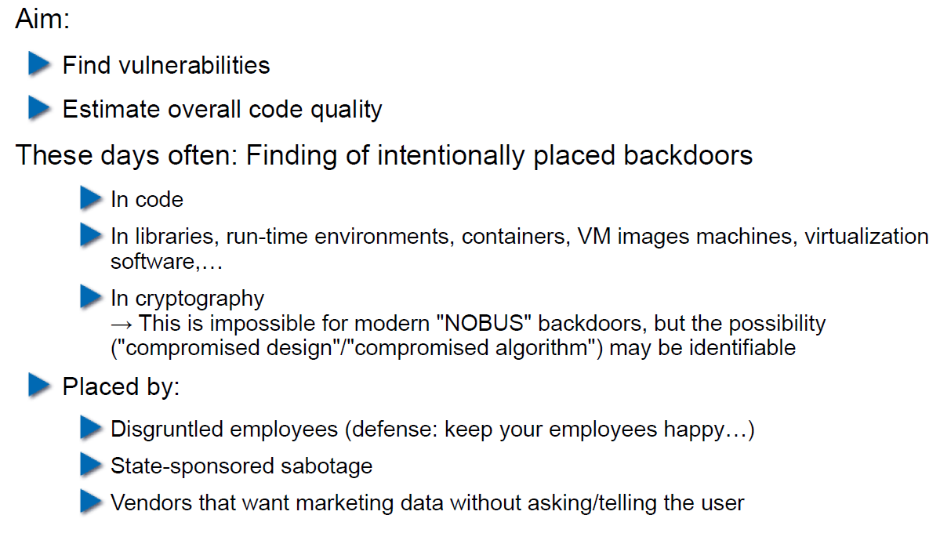

## Backdoors in Code

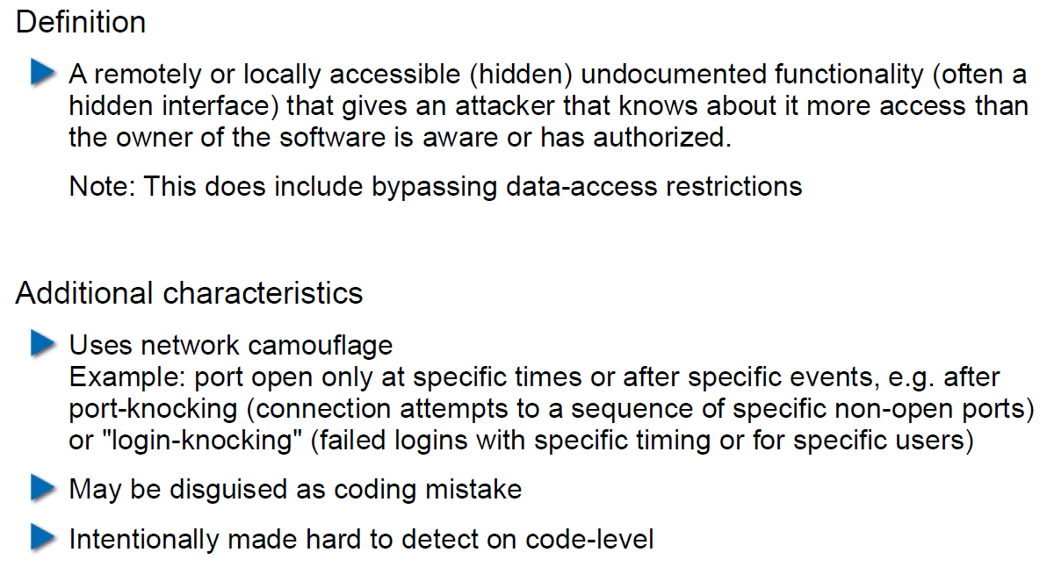

## Backdoor Hiding Techniques

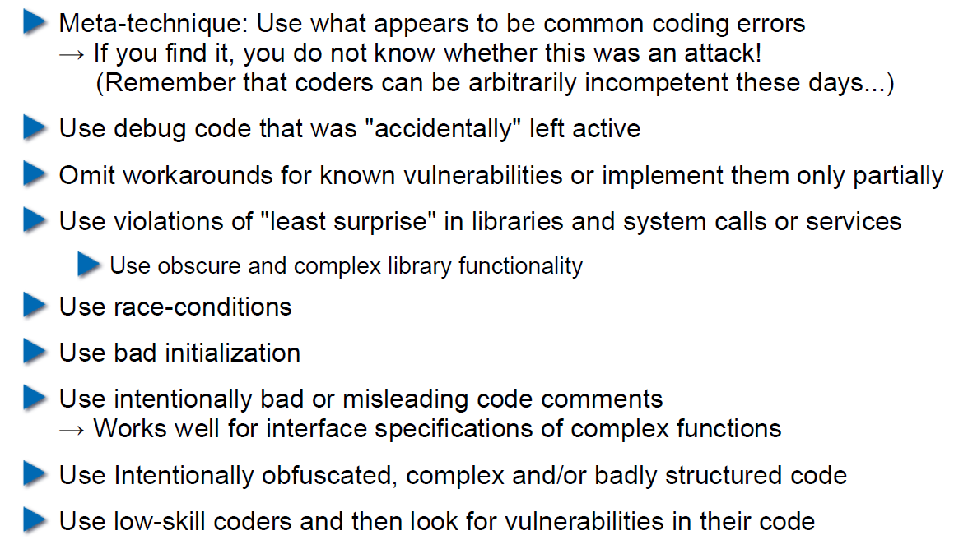

## Finding Backdoors

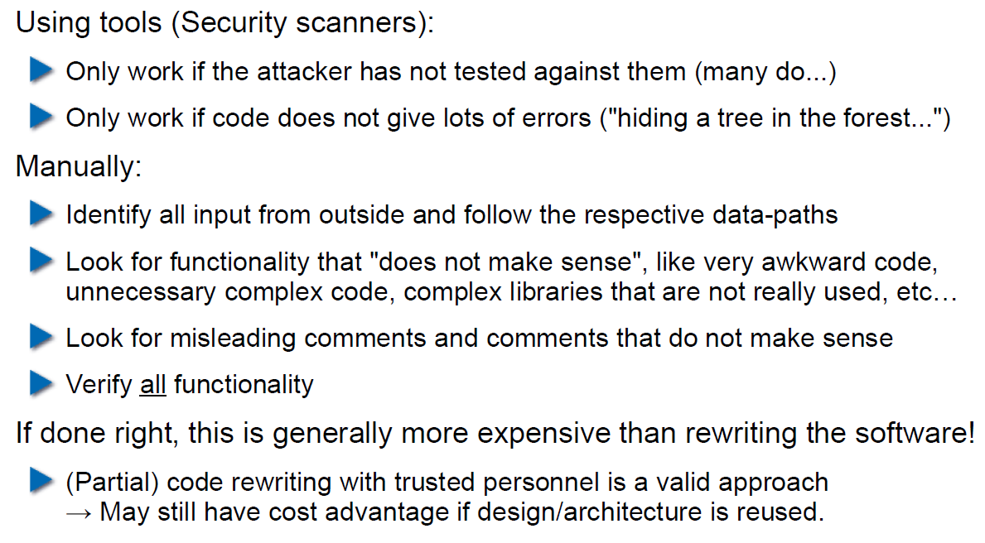

## Backdoors in Cryptography

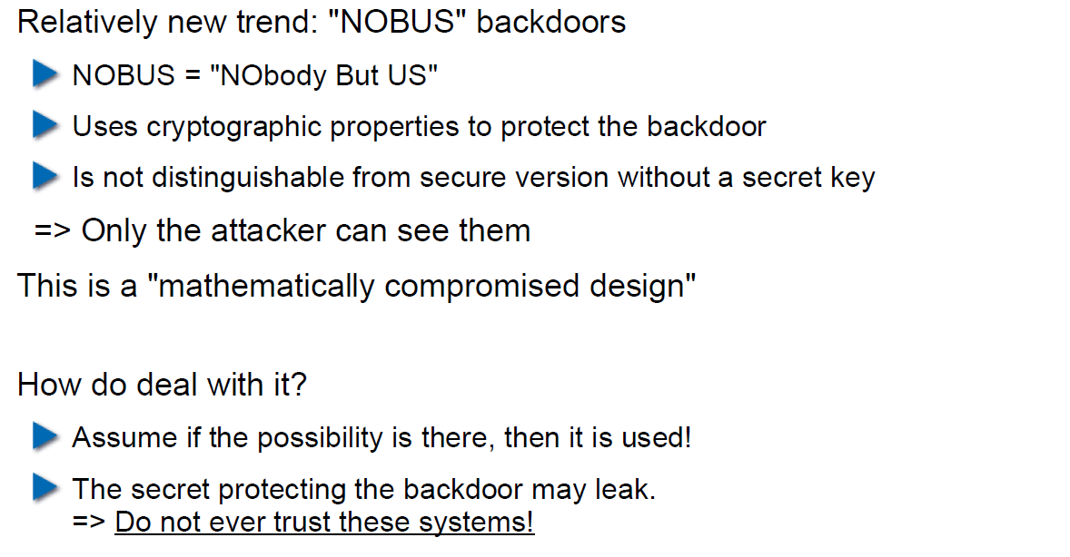

## Example 1: ECC

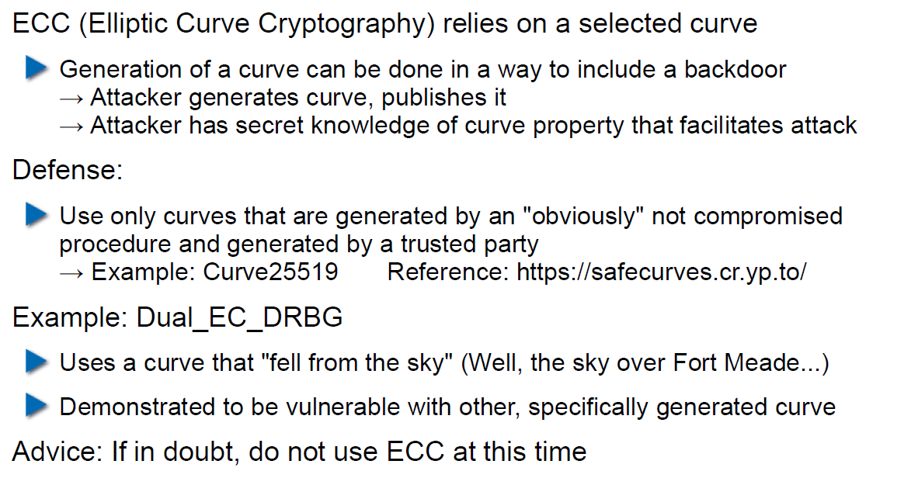

## Example 2: Specially selected Primes for Discreet Logarithms

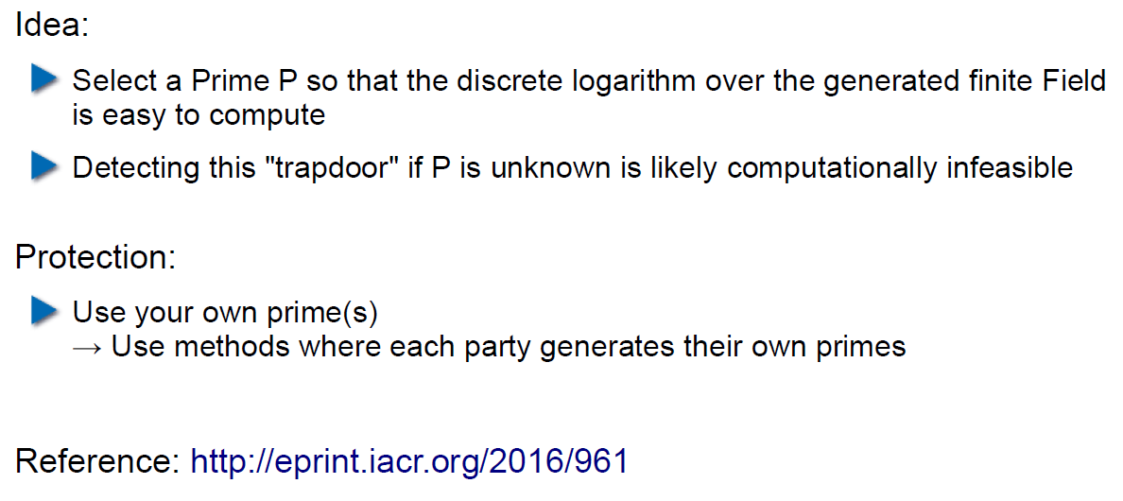

## Fuzz-Testing: The Idea

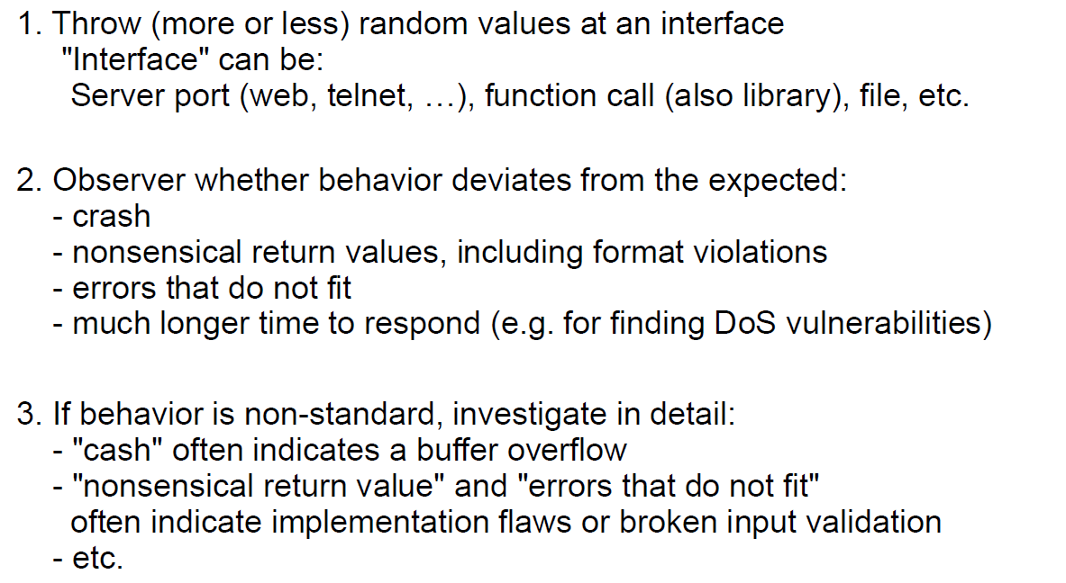

## Possibilities and Limitations

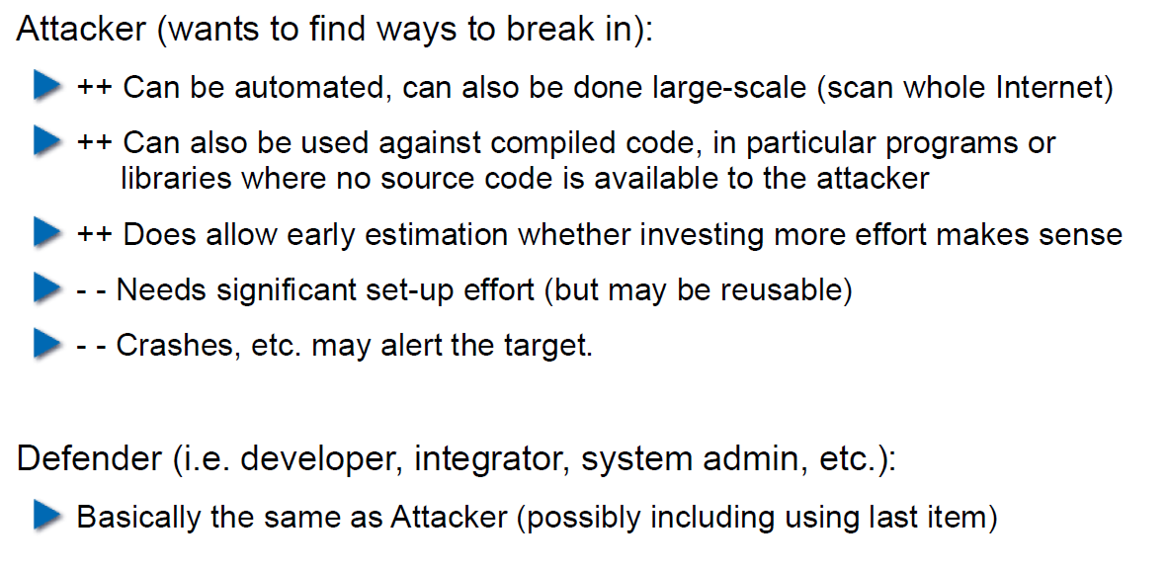

## Structured Fuzzing vs. Random Fuzzing

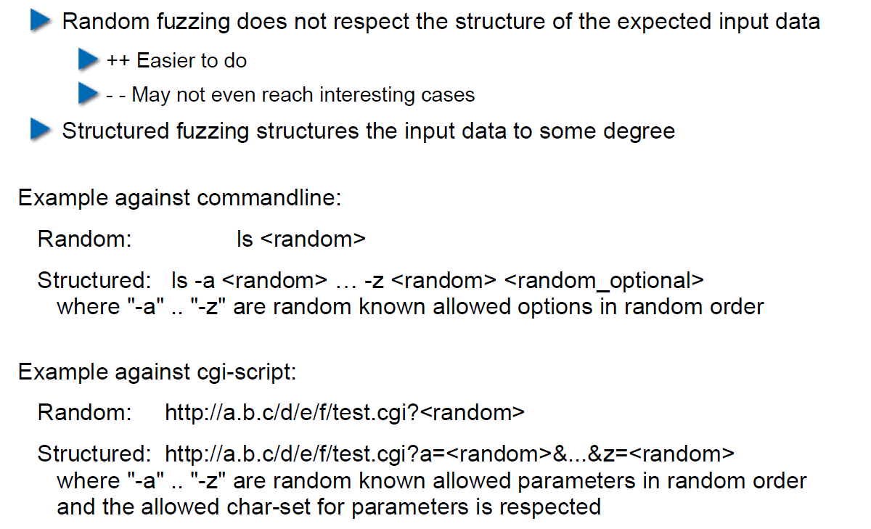

## Fuzzing for Regular Tests

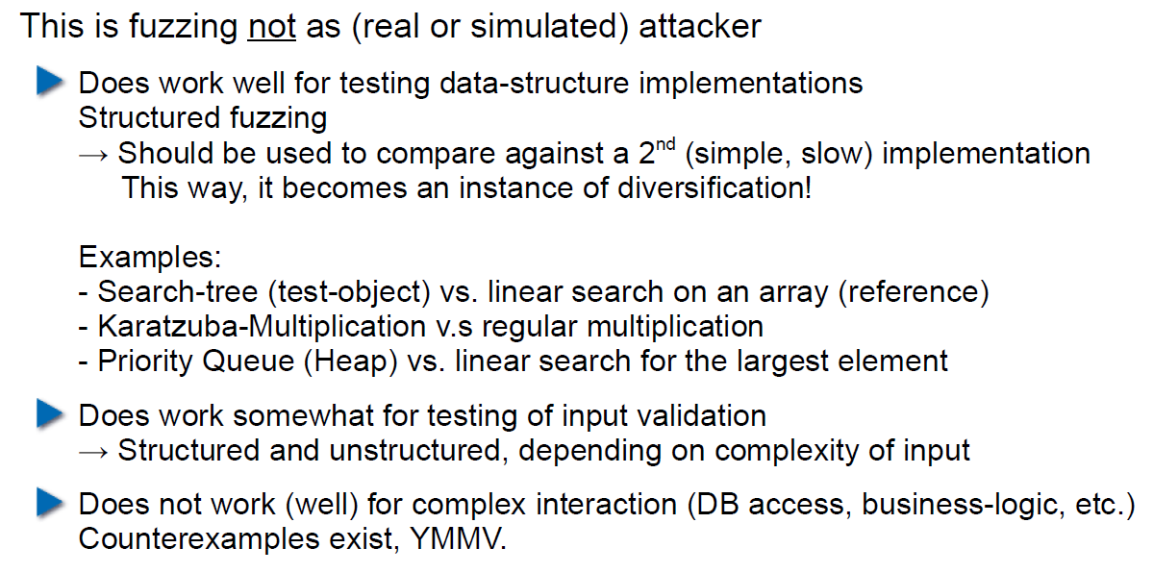

## Useful Fuzzing Tools

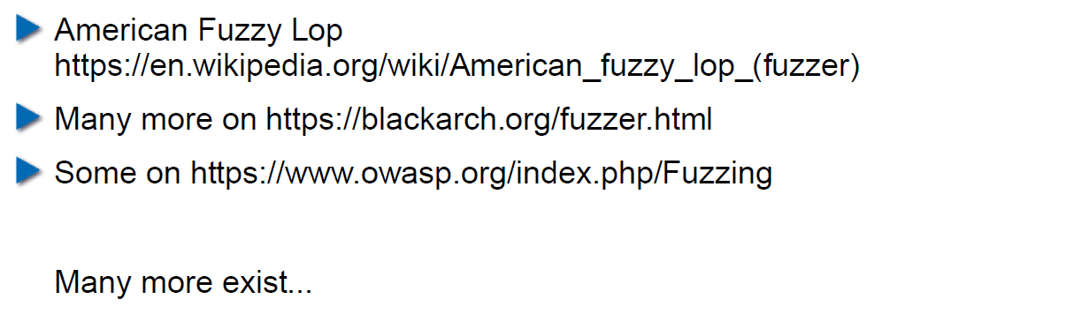

# Woche 7

## Agenda

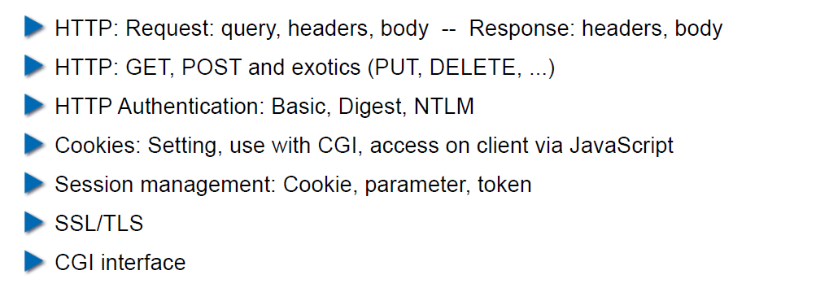

## Example Request in the TCP/IP Model

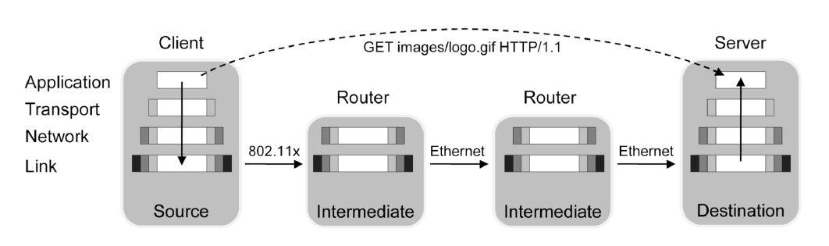

## HTTP

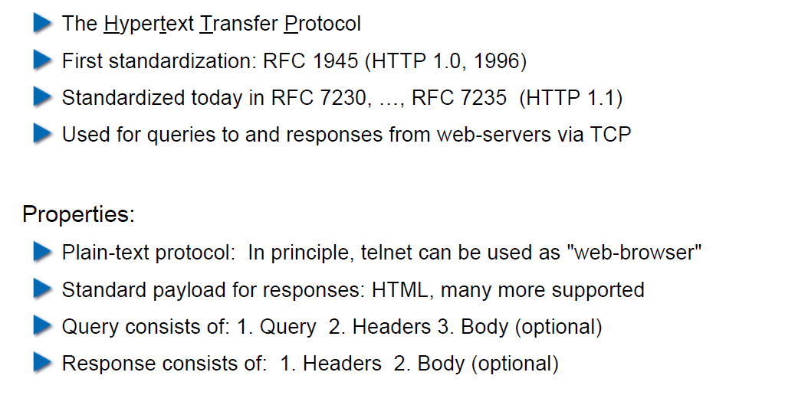

## HTTP Request Example: GET

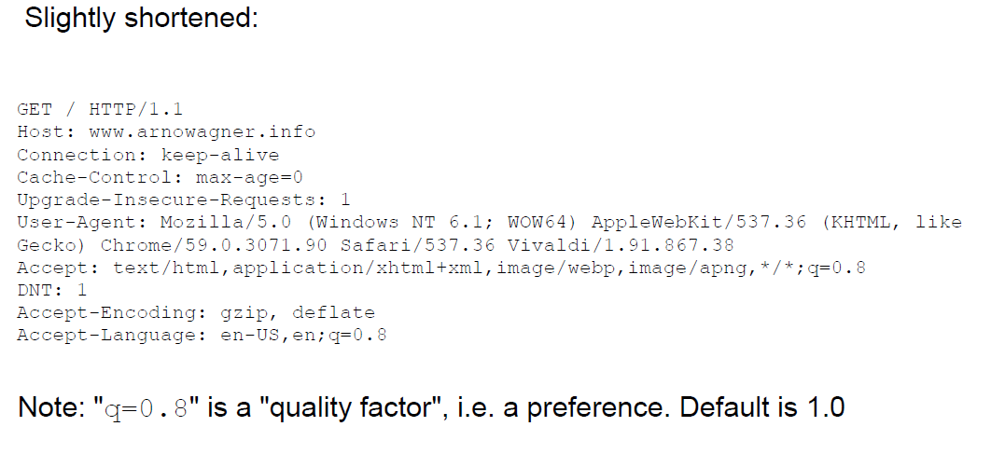

## HTTP Request Example: POST

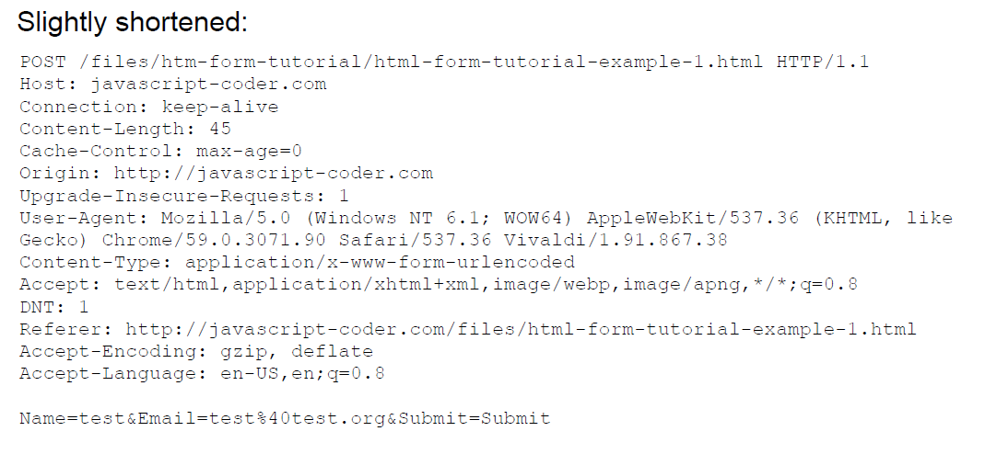

## HTTP Response Example

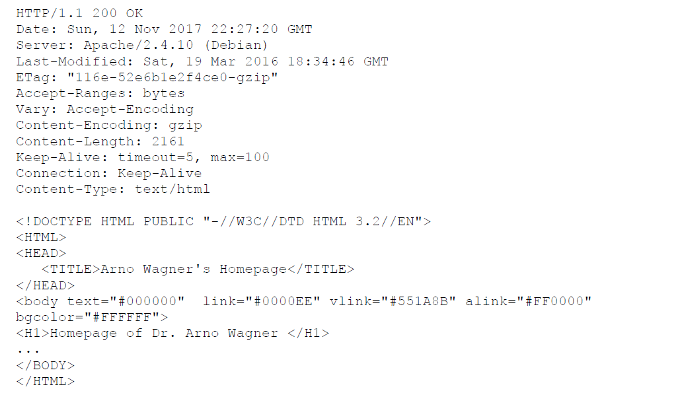

## Exotic Requests: PUT, DELETE, ...

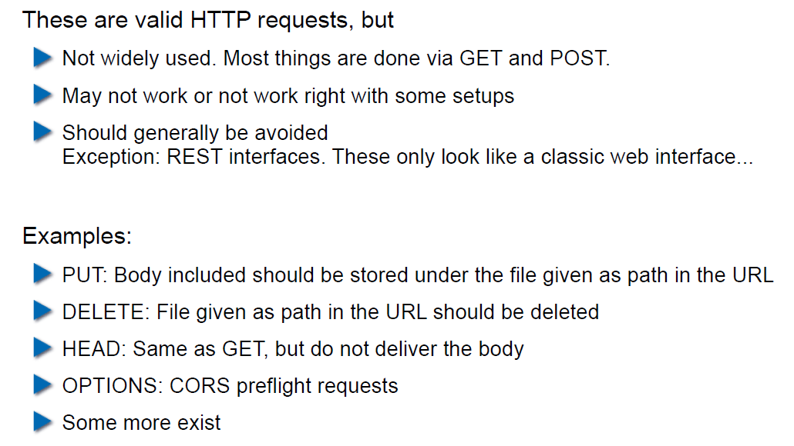

## HTTP Authentication

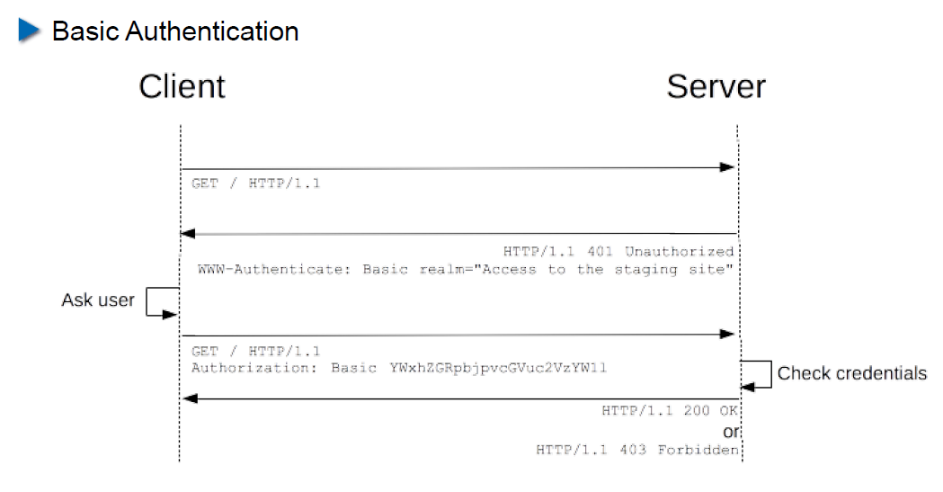

## HTTP Authentication

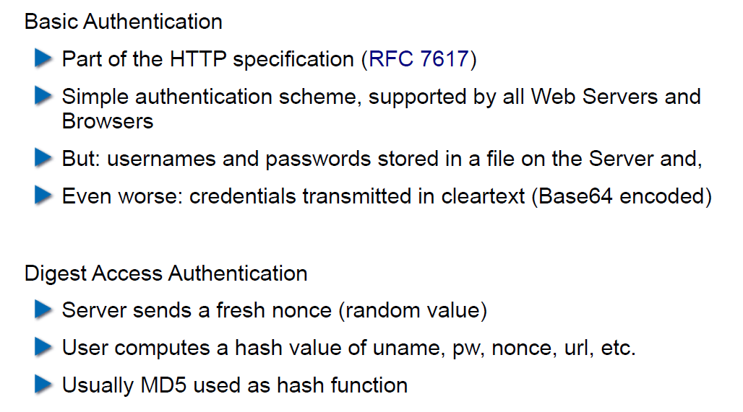

## Cookies

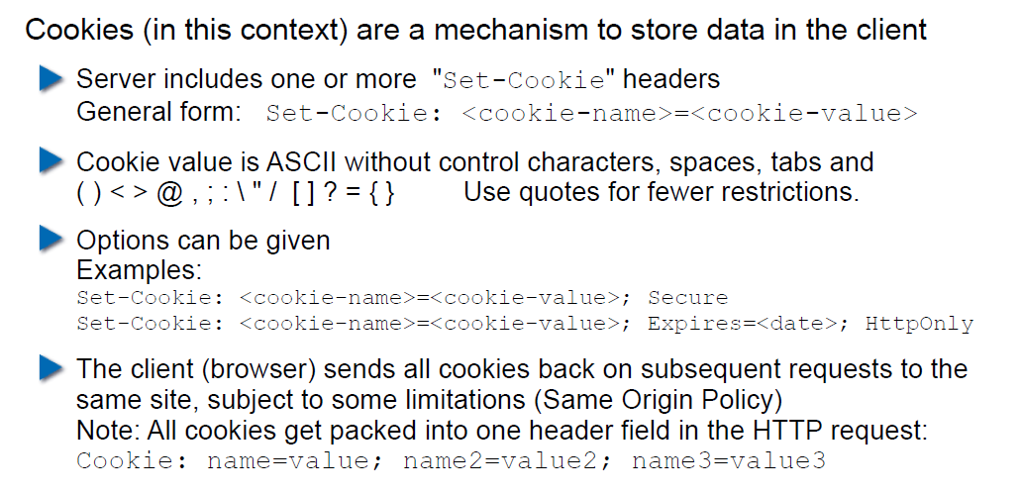

## Cookie Options

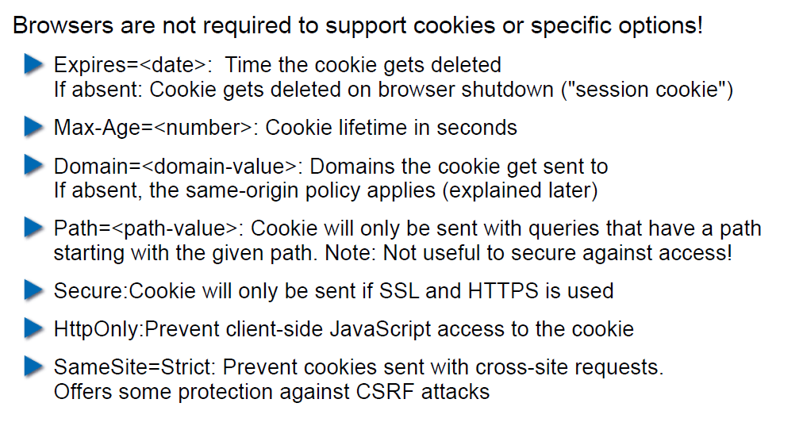

## Cookies: Access via JavaScript

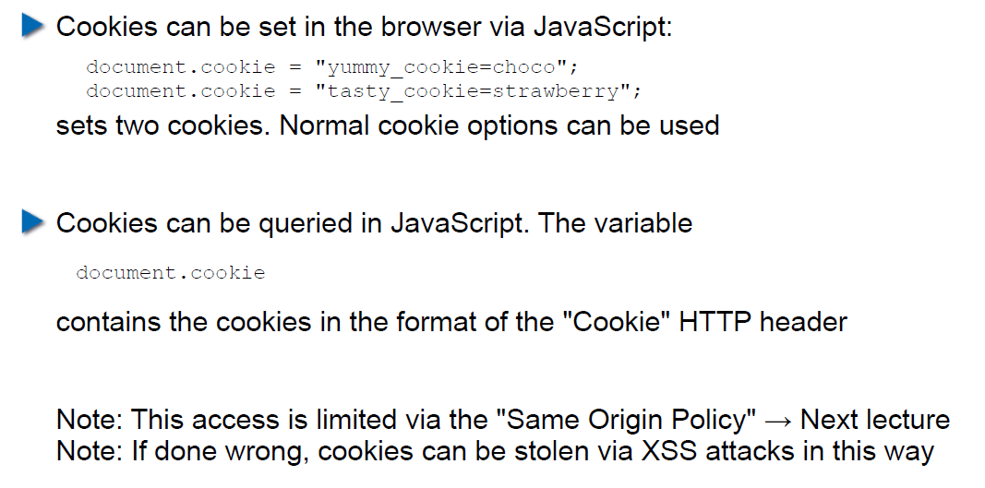

## Session Management

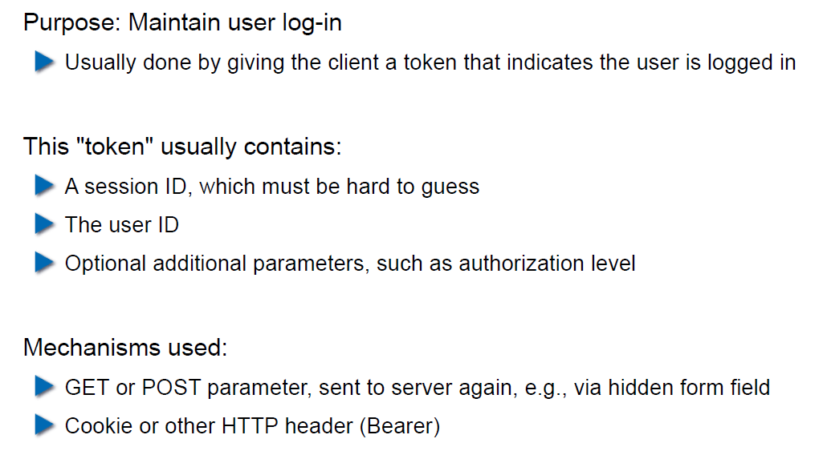

## Security Problems with Session Management

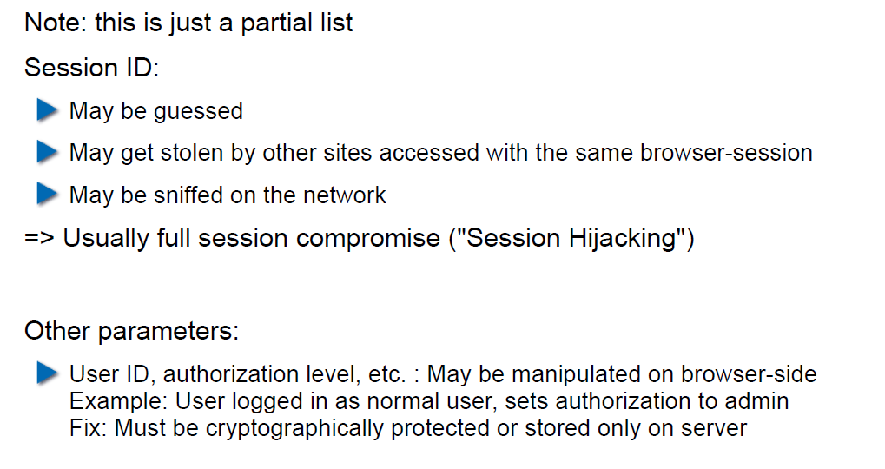

## Keeping State Securely on Client-Side

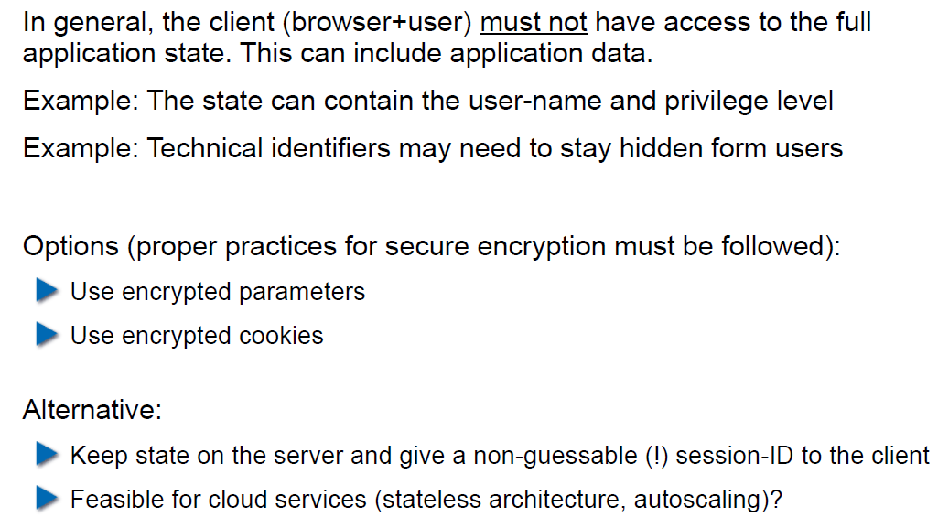

## Remark: Cookies and Application Paths vs. Proxies

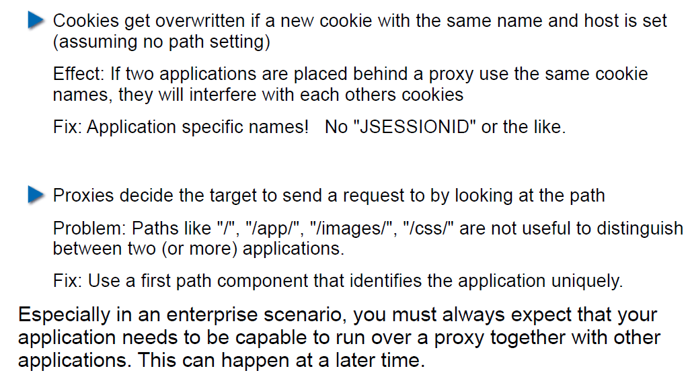

## SSL/TLS

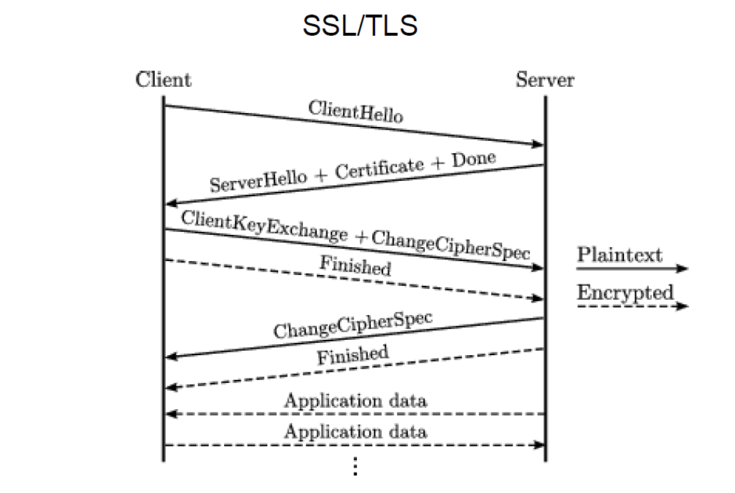

## SSL/TLS

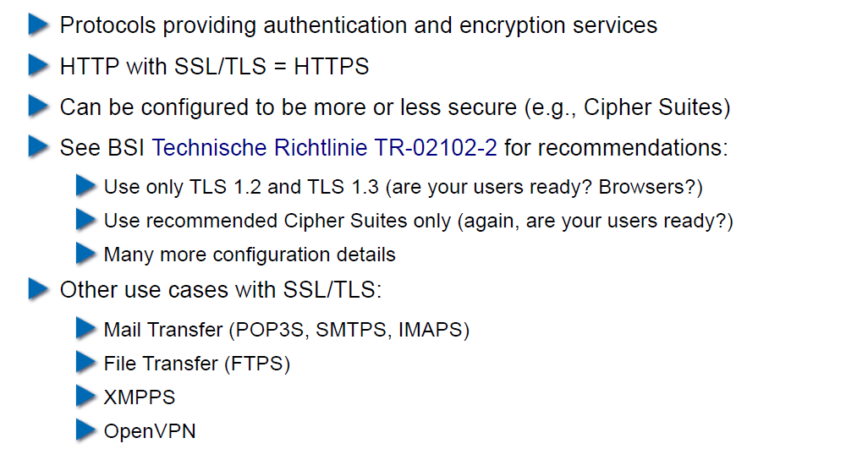

## CGI: General Idea

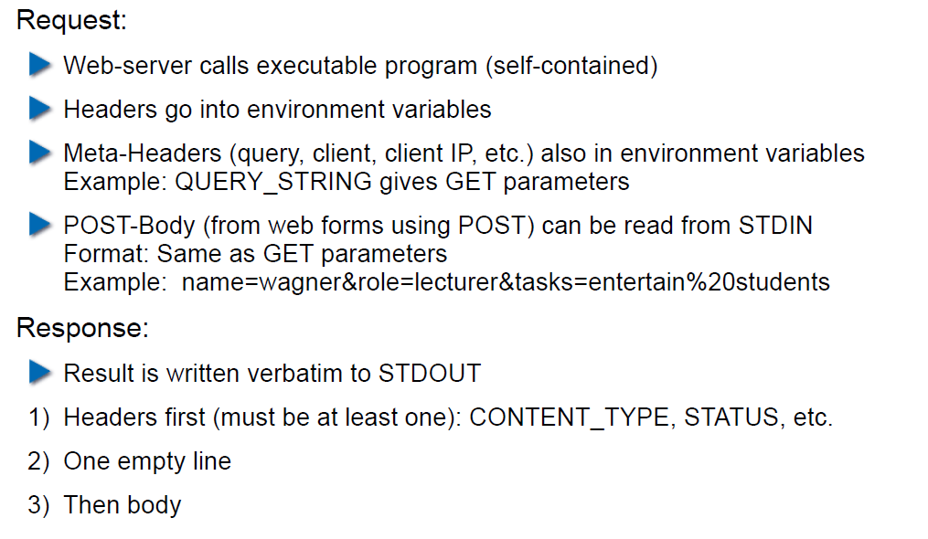

## CGI Scripts in Different Languages

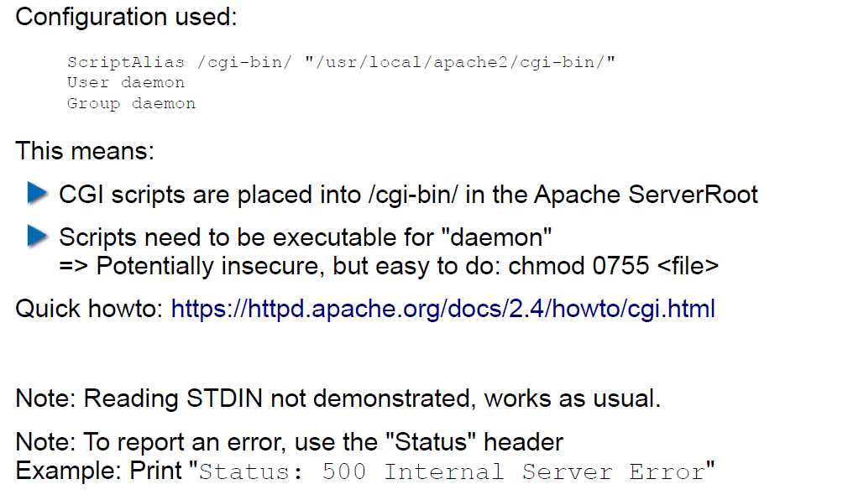

## CGI in BASH

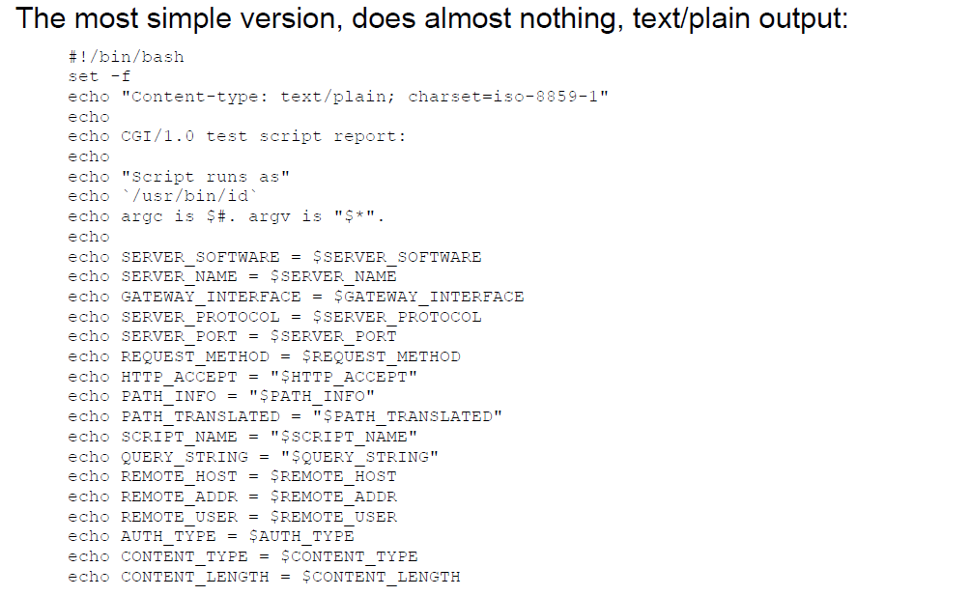

## CGI in BASH: Output

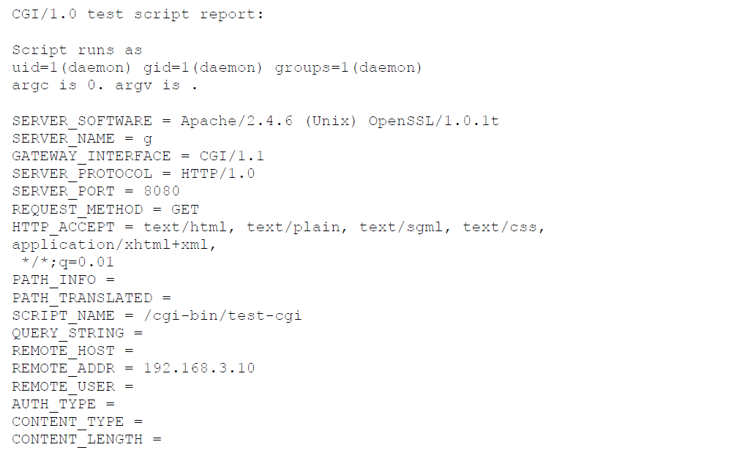

## CGI in Perl

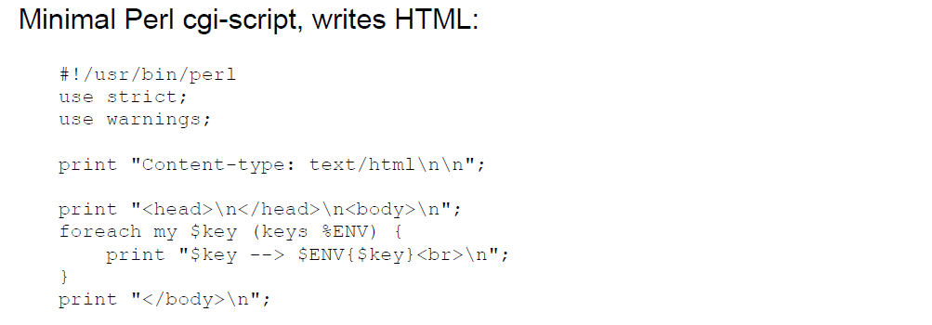

## CGI in Perl: Output

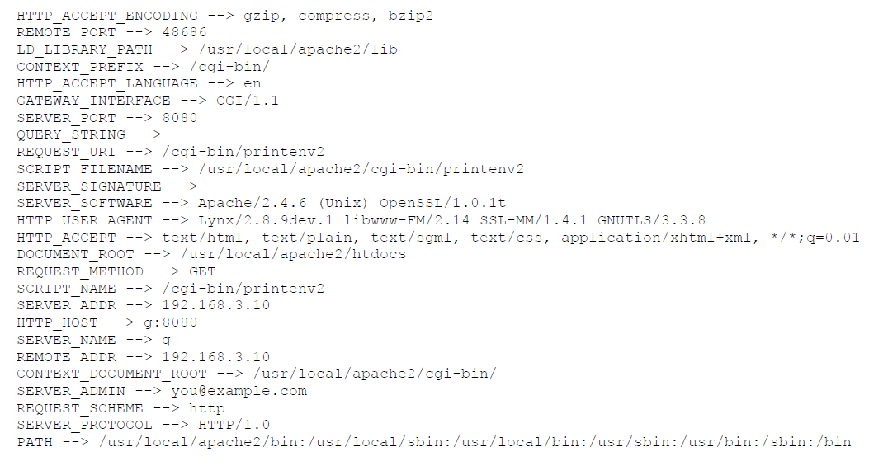

## CGI in C

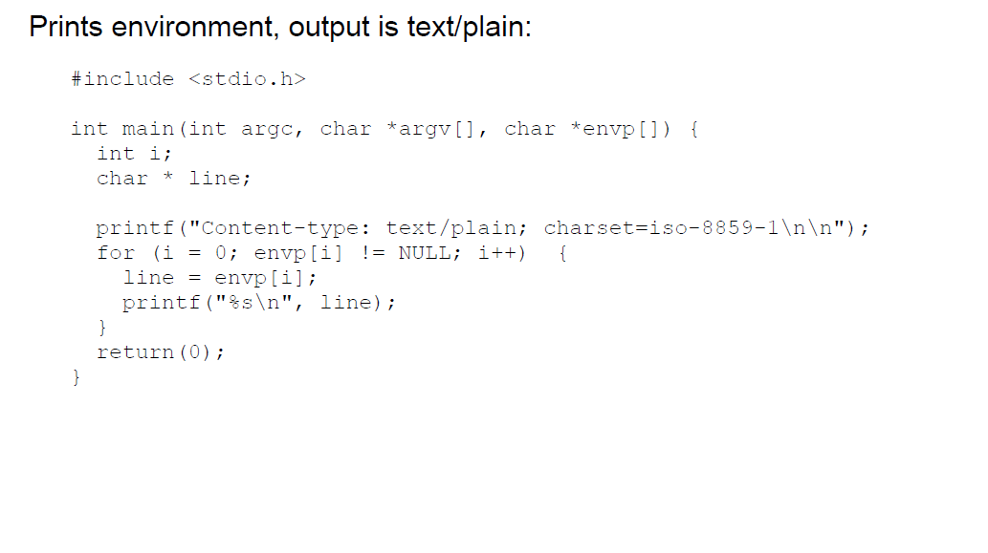

## CGI in C: Output

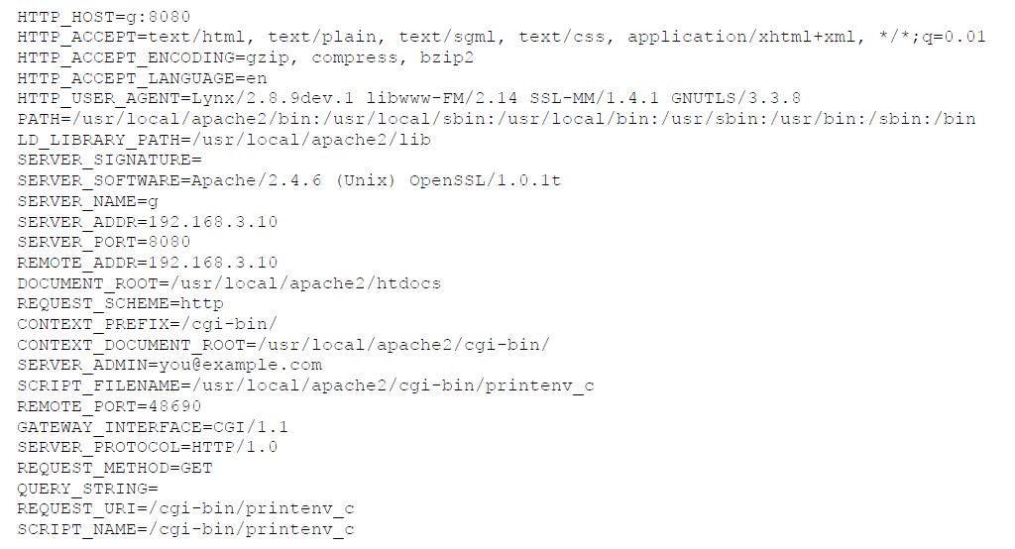

## CGI in Java

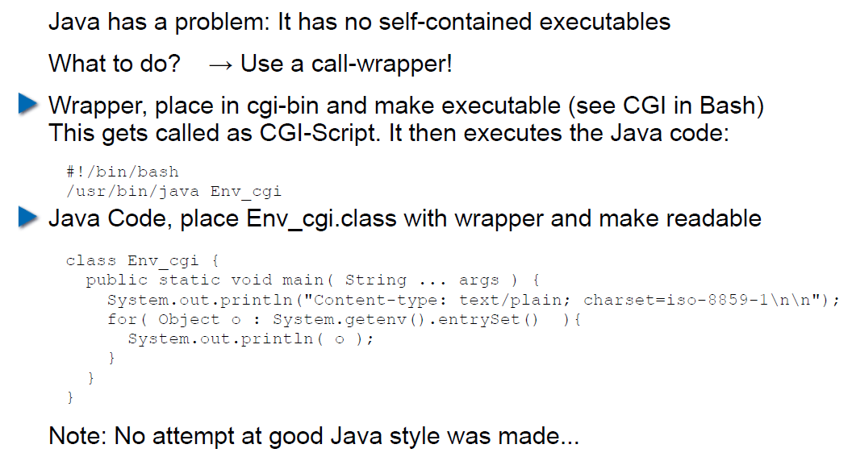

## CGI Security

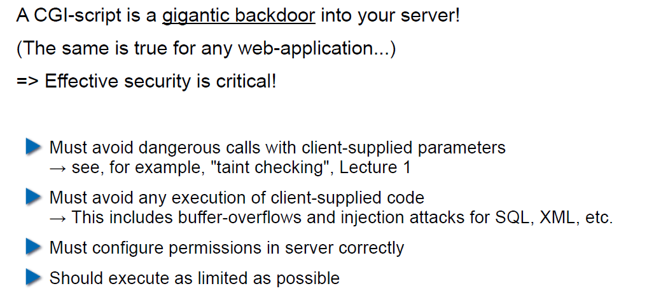

# Woche 8

## Dates

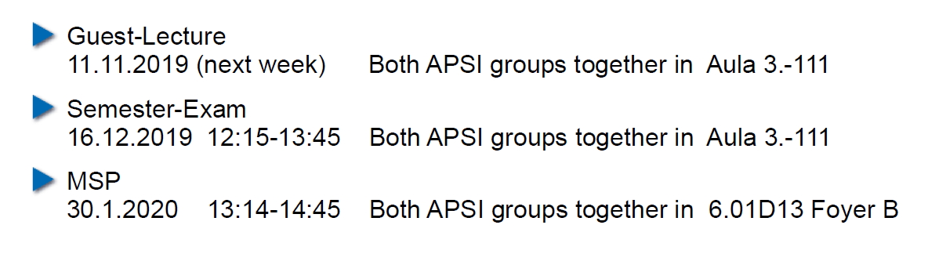

## 11.11.19: Guest Speaker about WAF

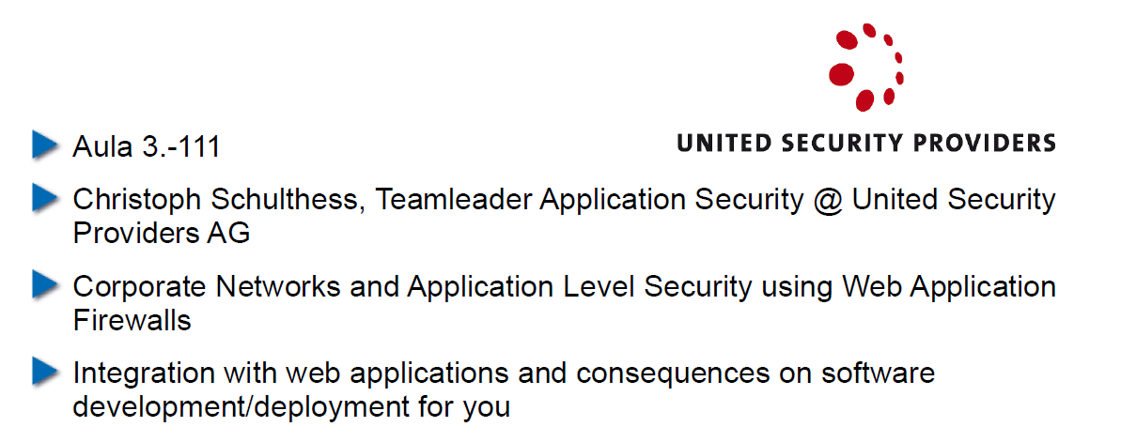

## Agenda

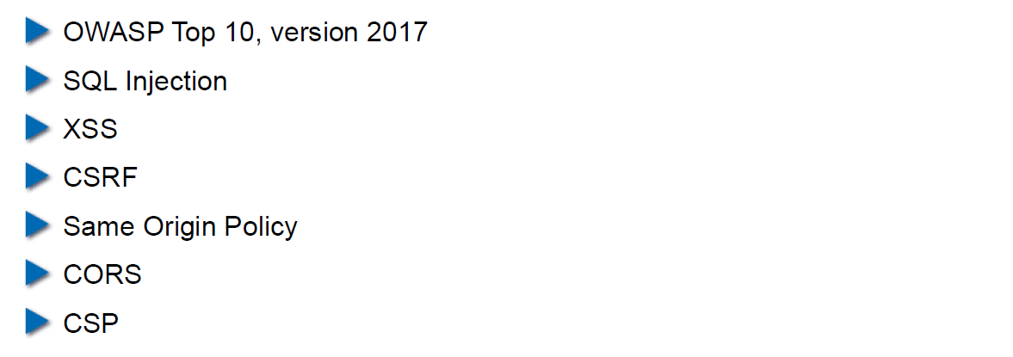

## OWASP – Open Web Application Security Project

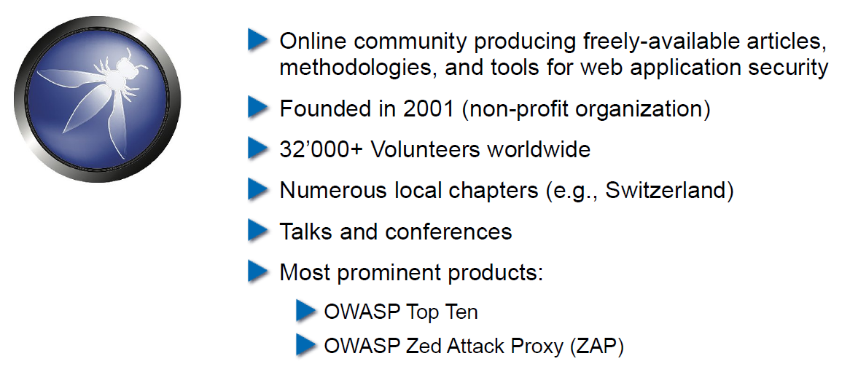

## OWASP Top Ten

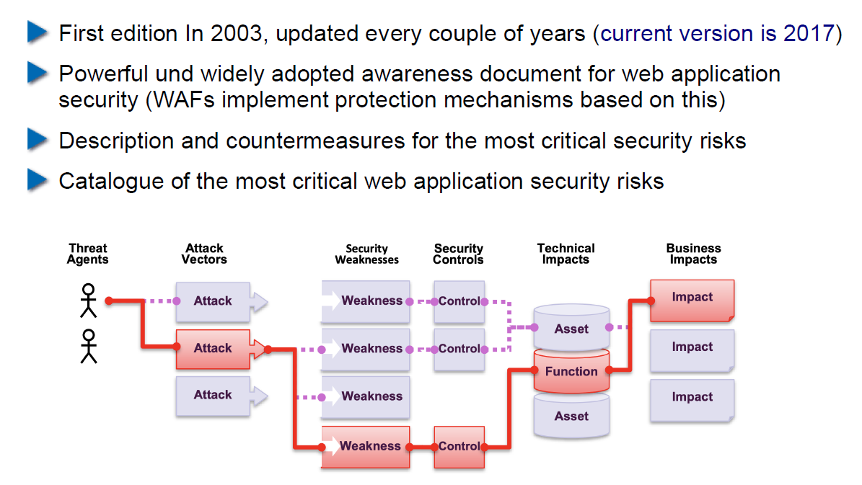

## OWASP Top Ten

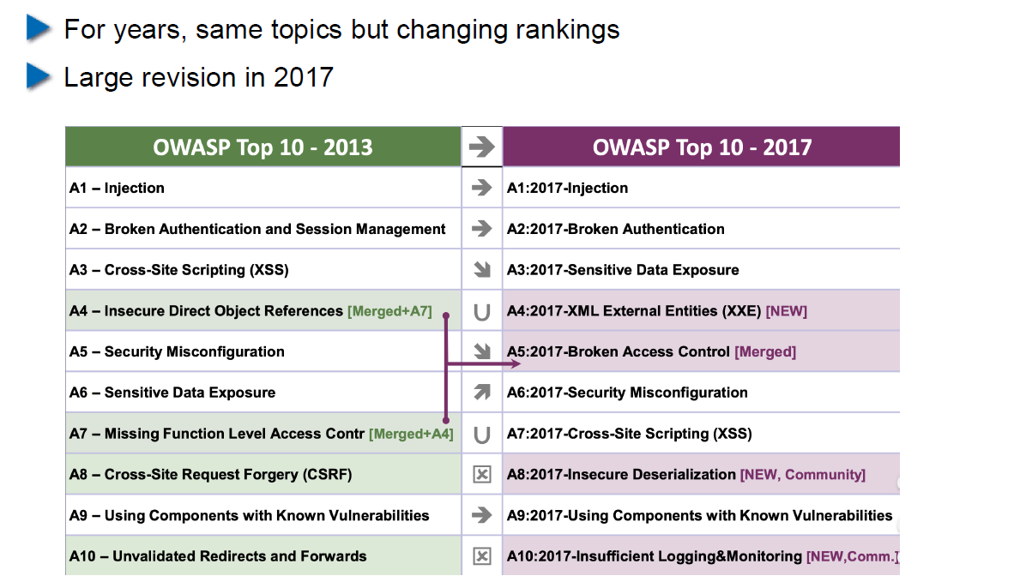

## Cross-Site Scripting (XSS): Cookie Theft

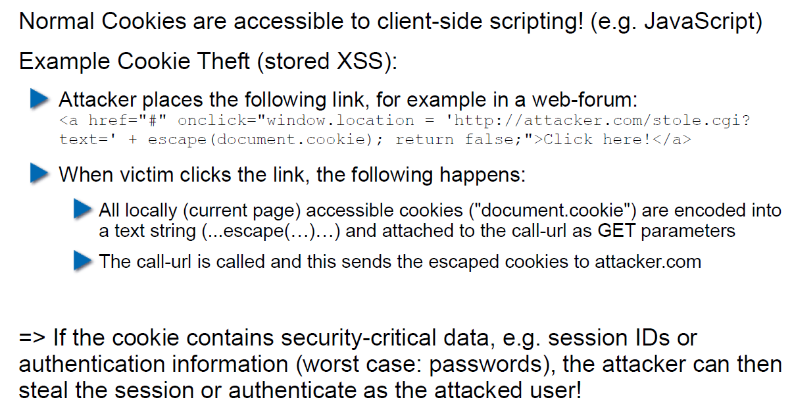

## Stored XSS Countermeasures

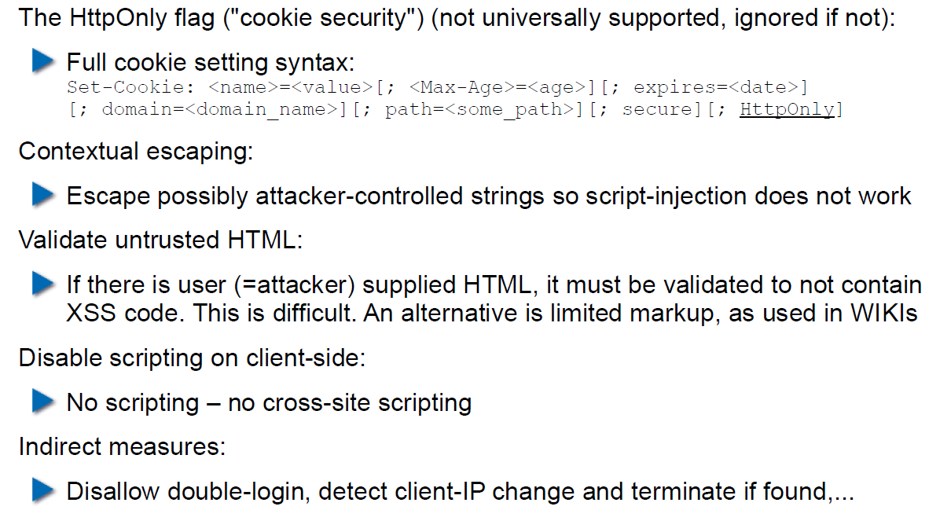

## Reflected XSS

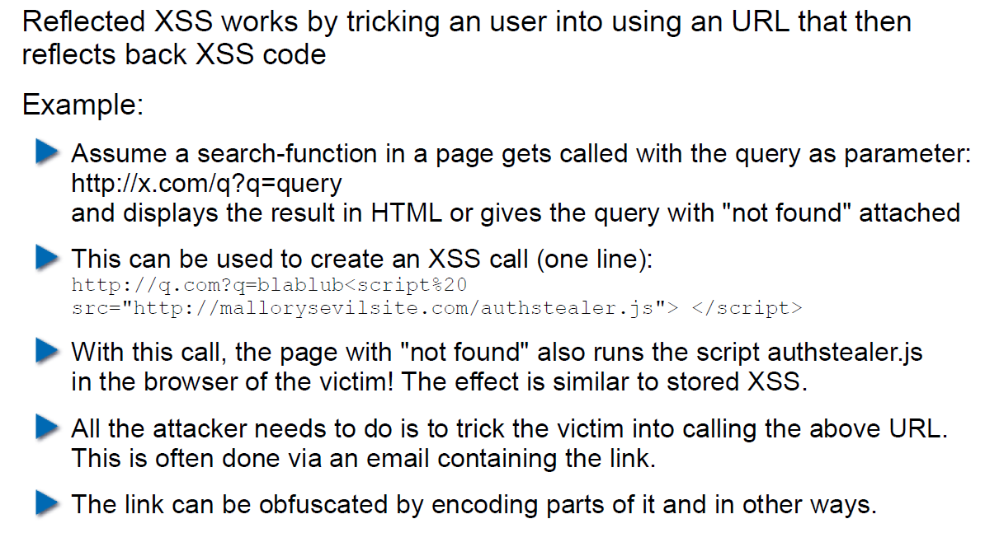

## Defense Against Reflected XSS

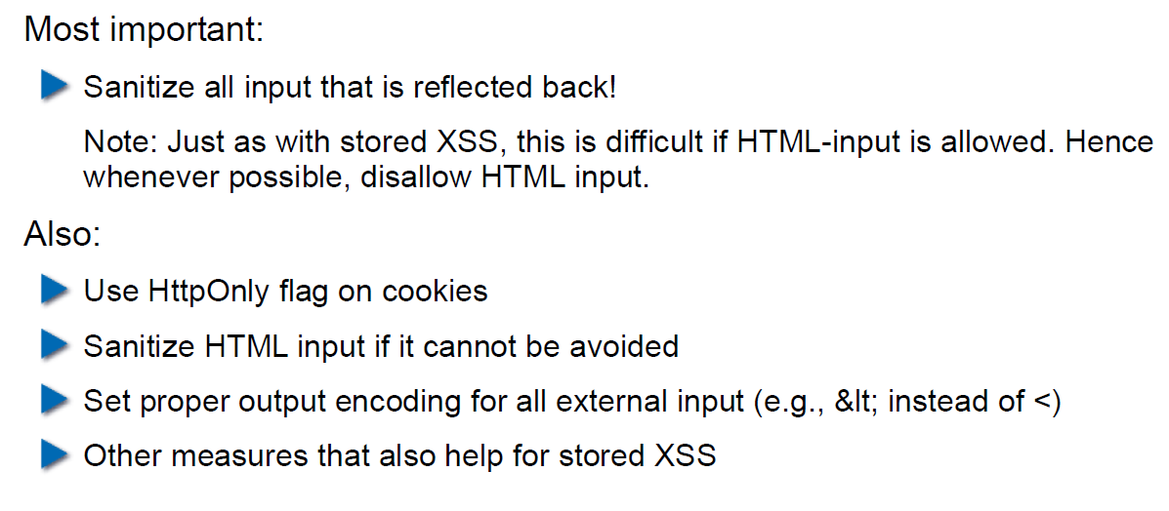

## Cross Site Request Forgery (CRSF)

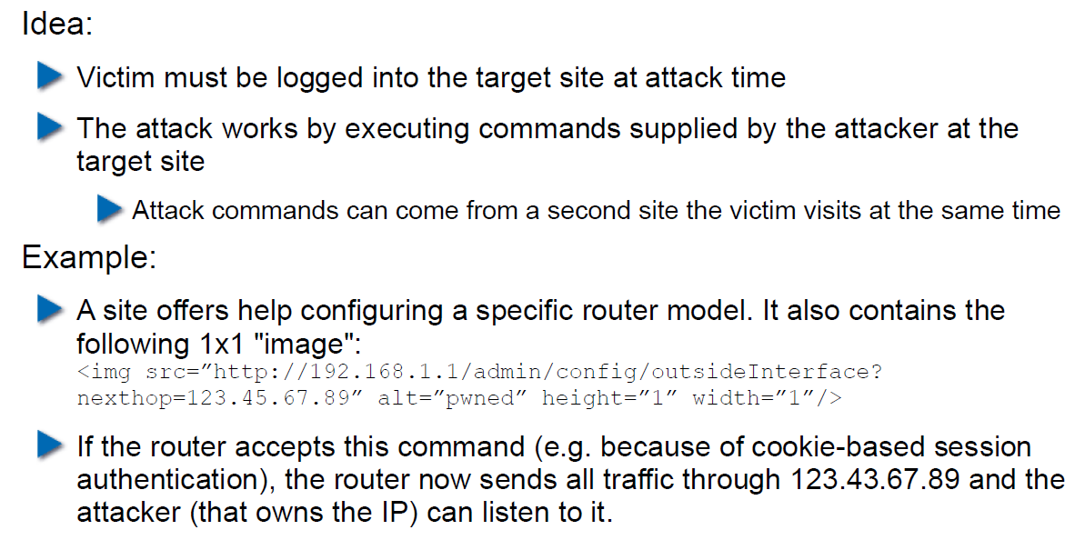

## CRSF Example 2

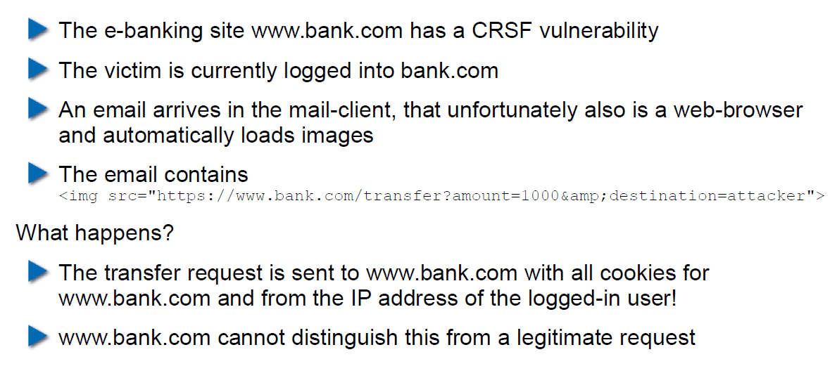

## CRSF Countermeasures

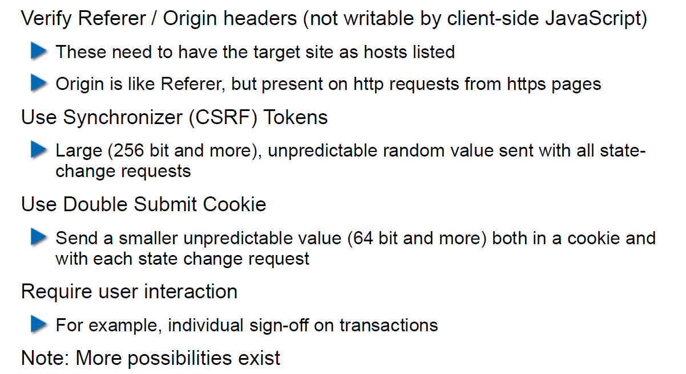

## Same-Origin Policy

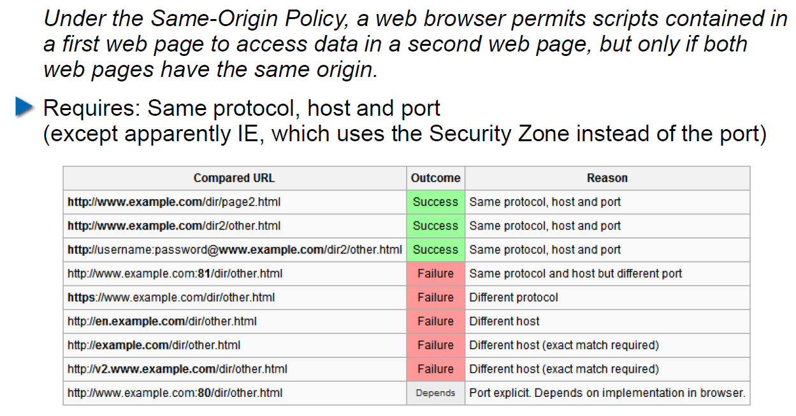

## Cookies and Same Origin

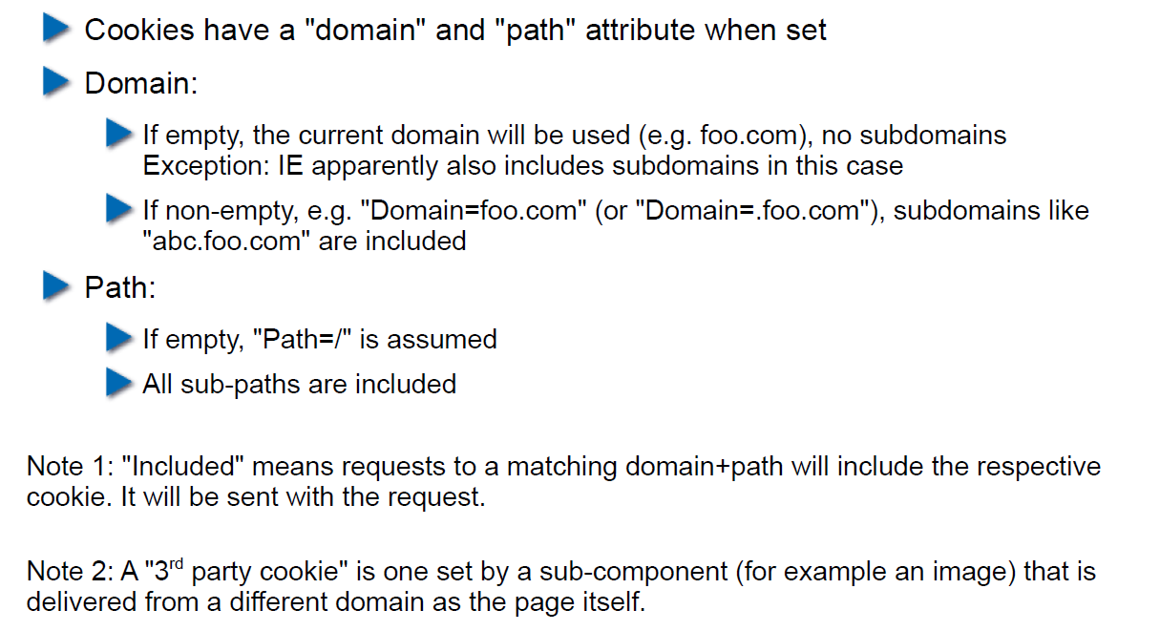

## Same Origin Policy (SOP) and its Limits

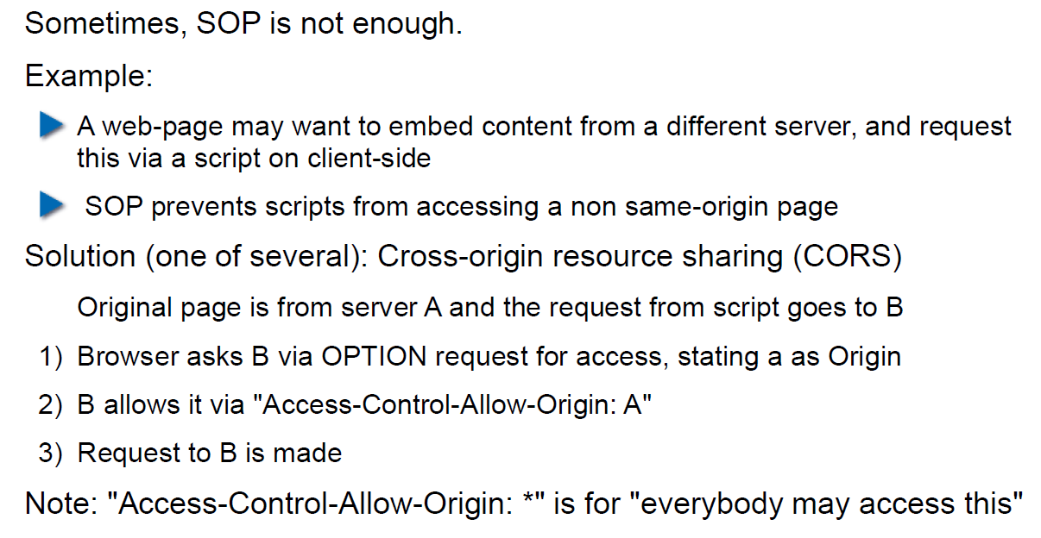

## CORS Overview

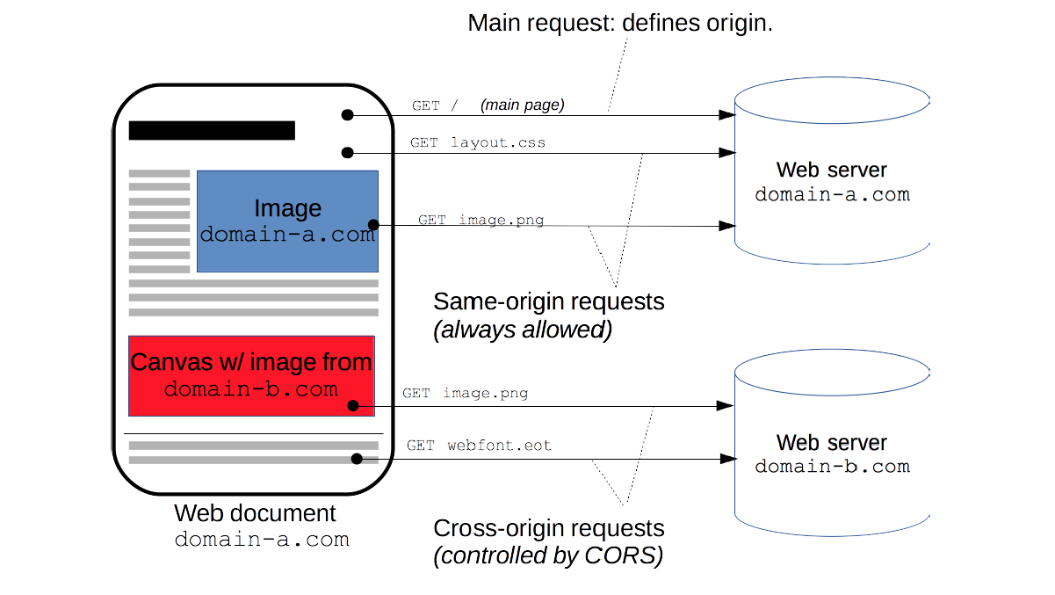

## CORS Preflight Requests

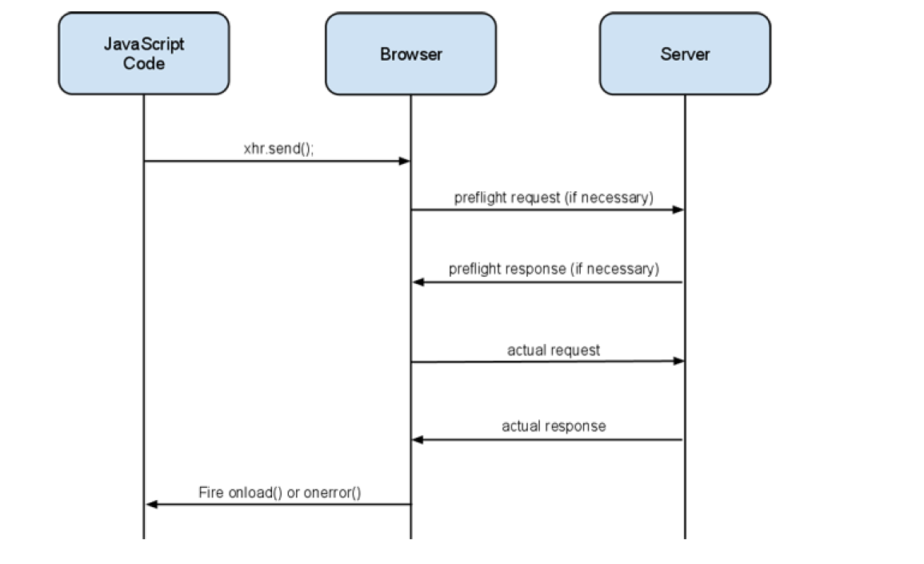

## CORS Example (slightly abbreviated)

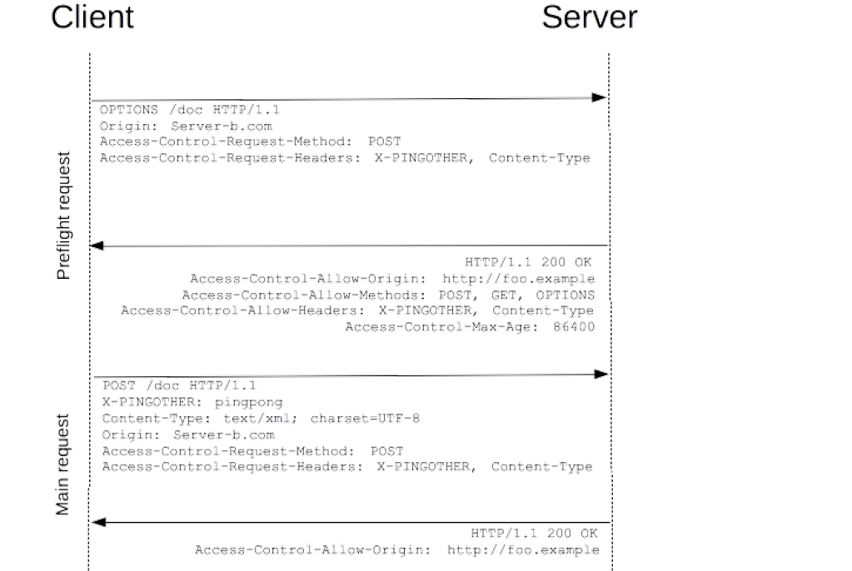

## CORS for Multiple Domains

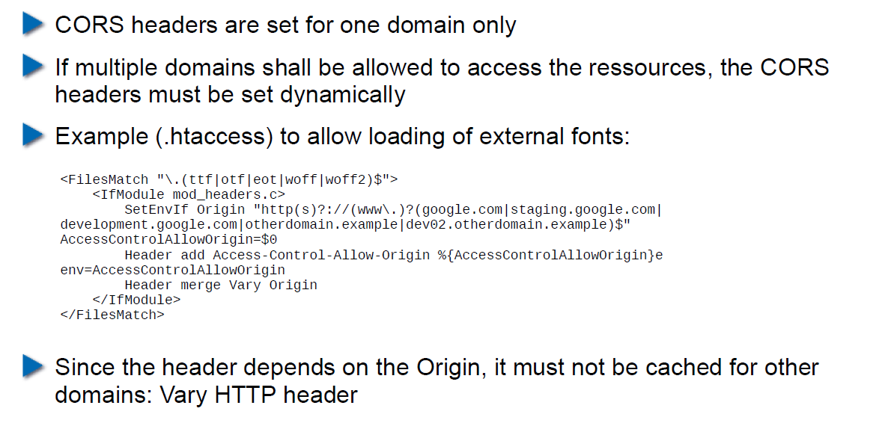

## Content Security Policy (CSP) Headers

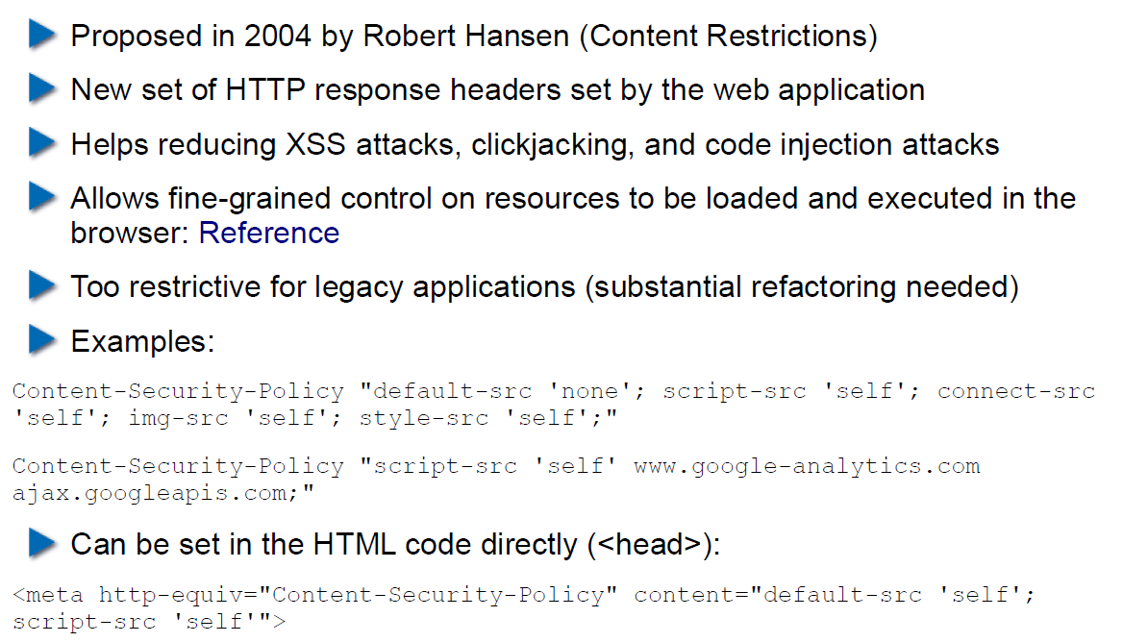

## Overview of Common CSP Options

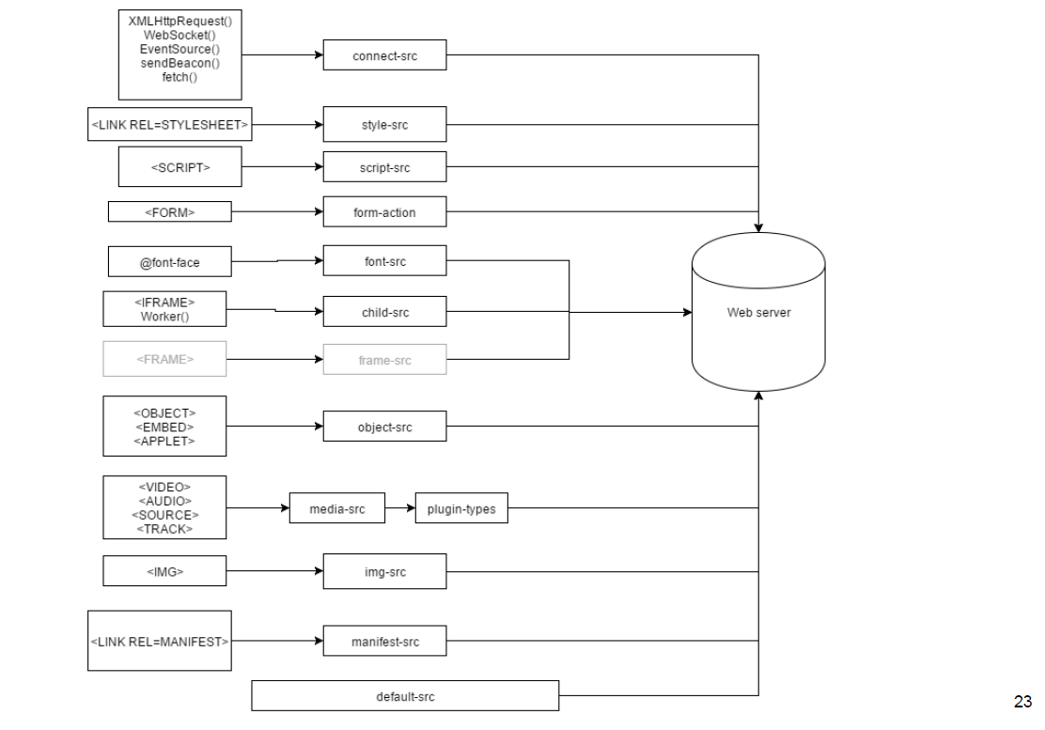

## Exercise: U08

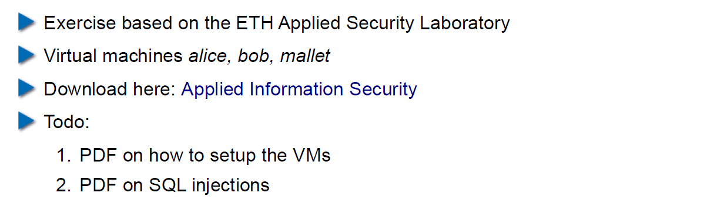

# Woche 9

## Agenda

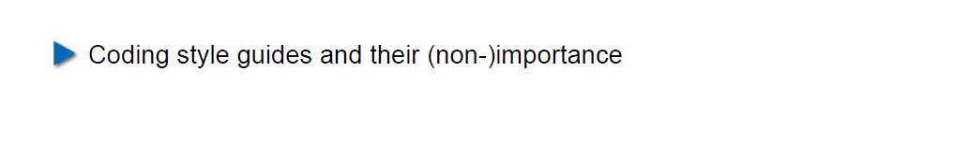

## Coding Style Guides / Coding Standards

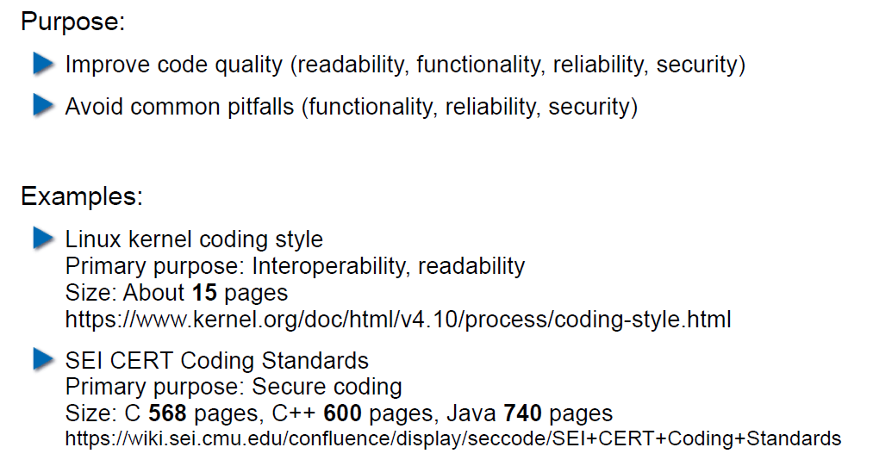

## Linux Kernel Coding Style: Introduction

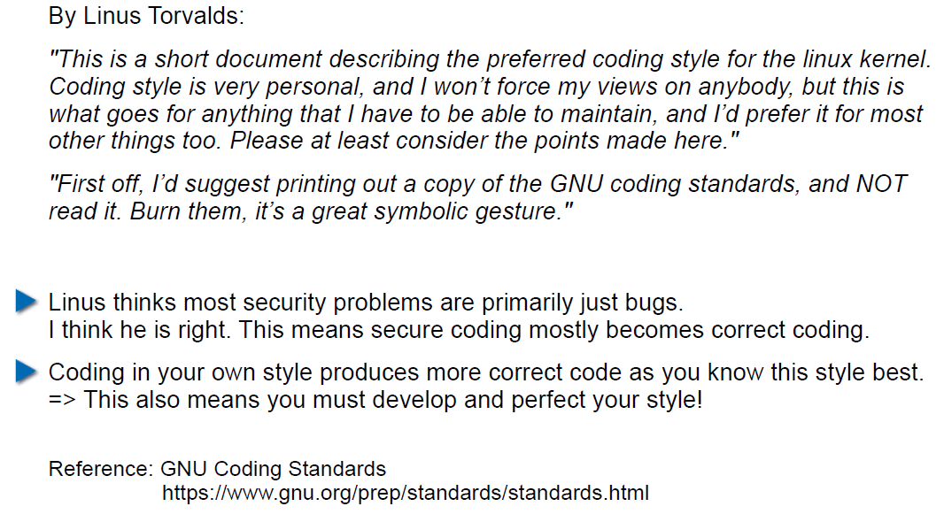

## Linux Kernel Coding Style: Examples (1)

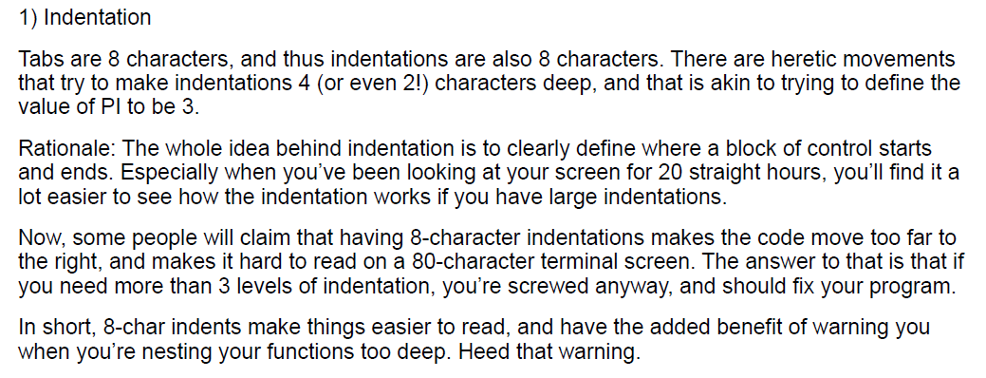

## Linux Kernel Coding Style: Examples (2)

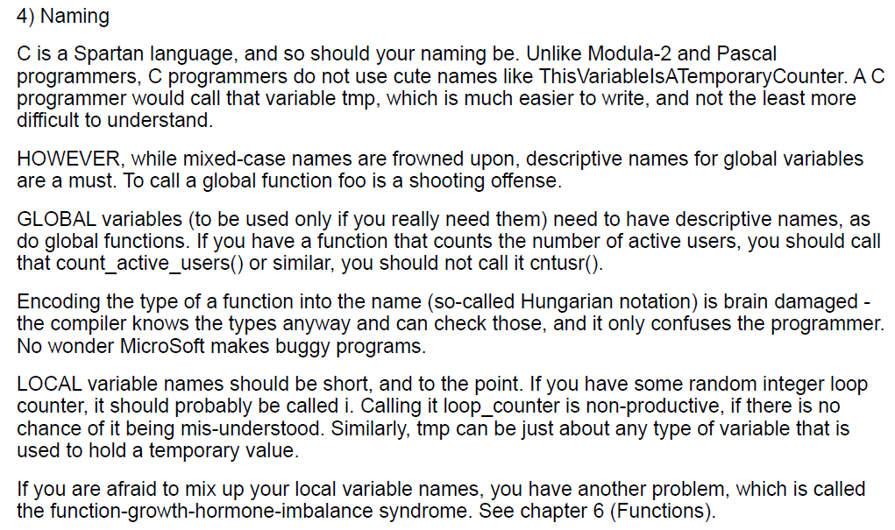

## Linux Kernel Coding Style: Examples (3)

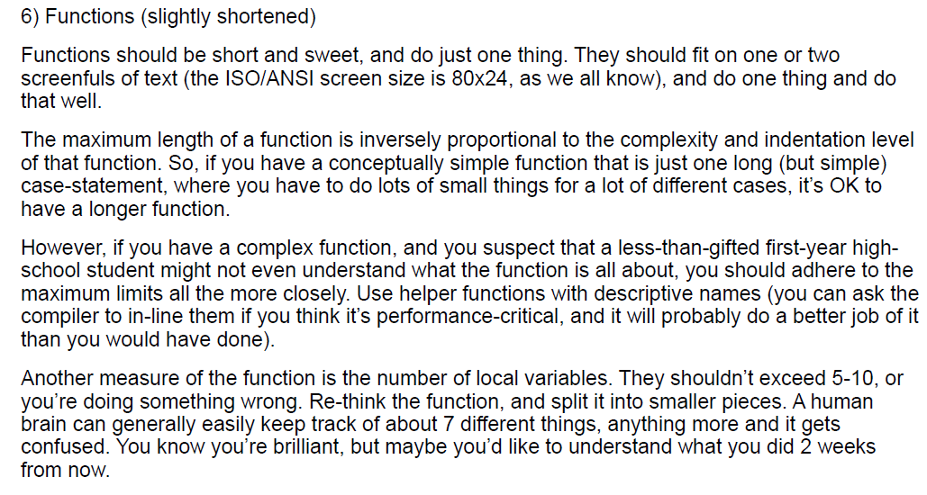

## Linux Kernel Coding Style: Examples (4)

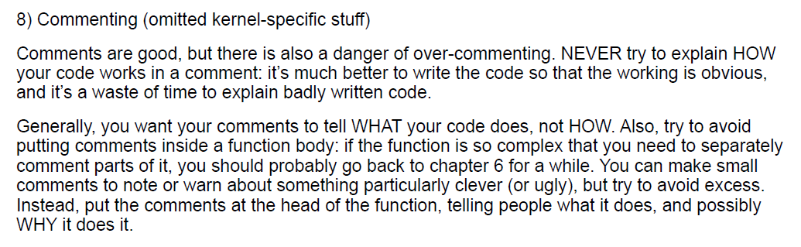

## CERT/SEI Rules and Recommendations

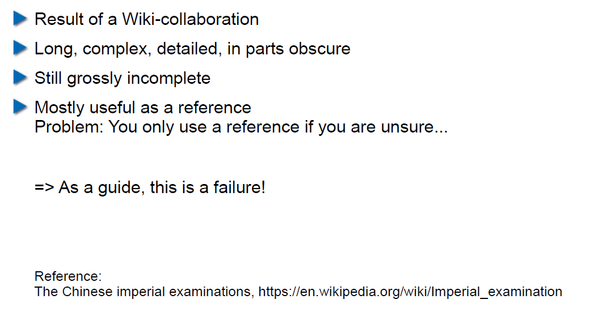

## What do Coding Style Guides Accomplish in Reality?

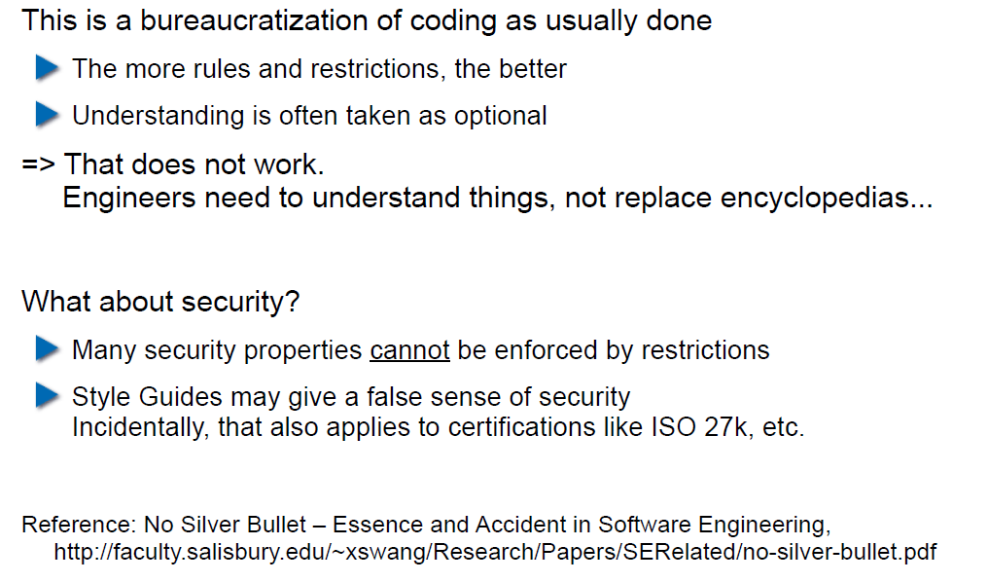

## Problems with Restrictive Coding Environments

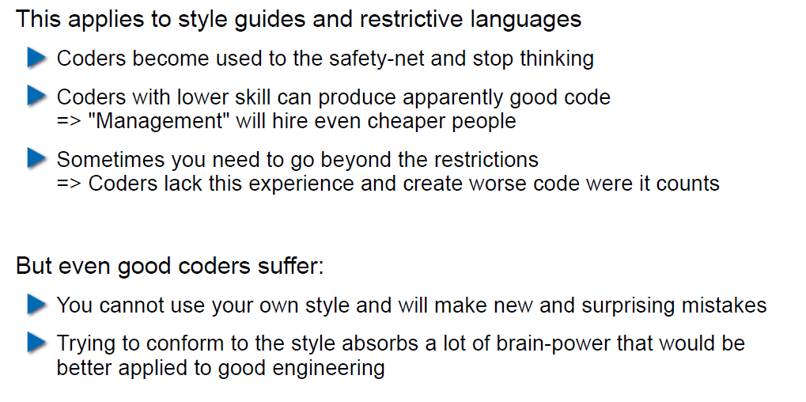

## What About Interfaces and Naming in Them?

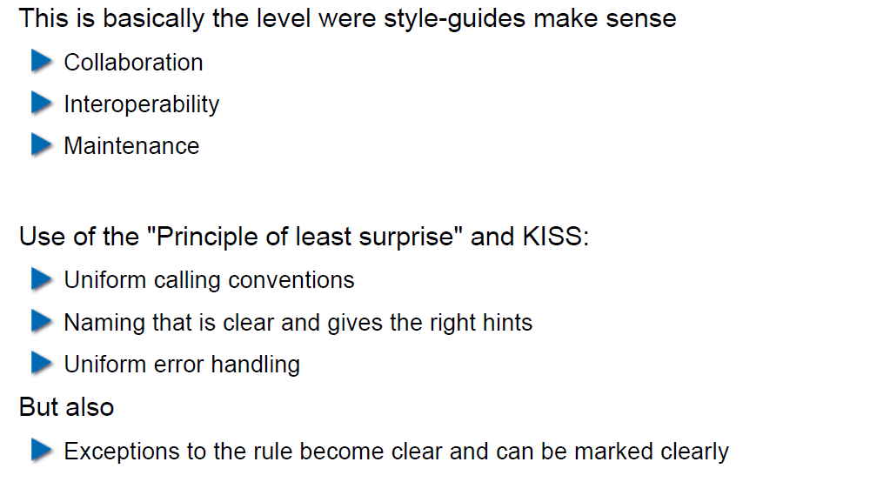

## So use a Style Guide or not?

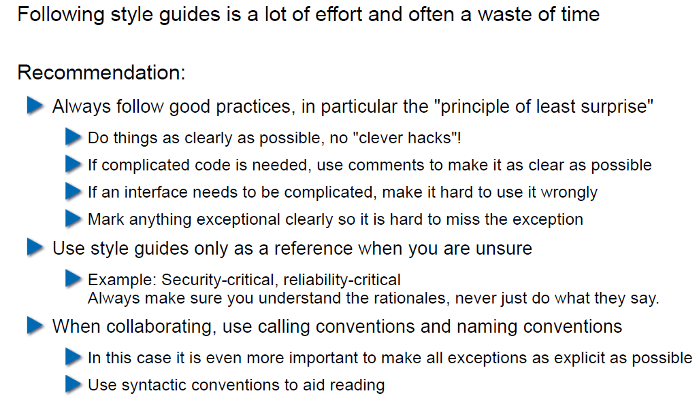

# Woche 10

## Agenda

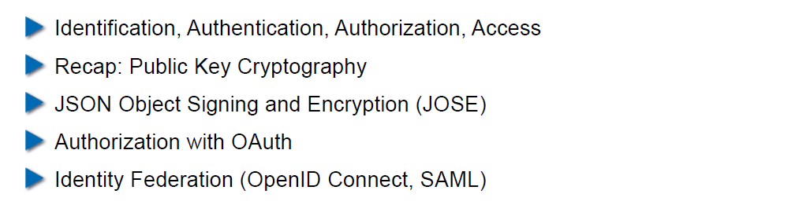

## Authentication

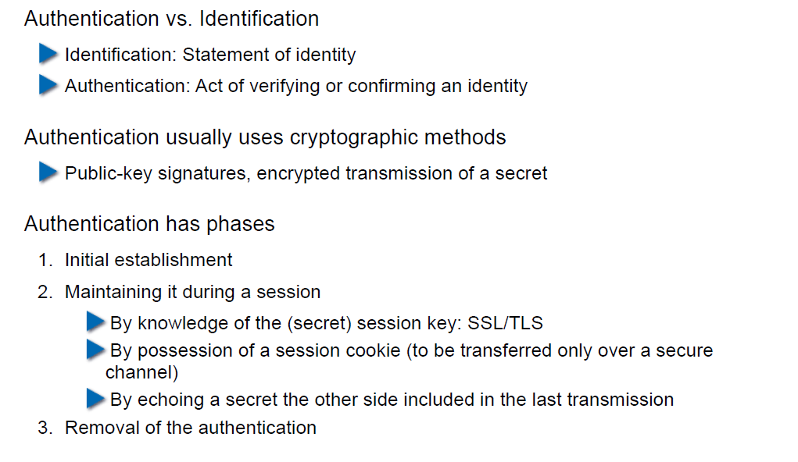

## Authorization

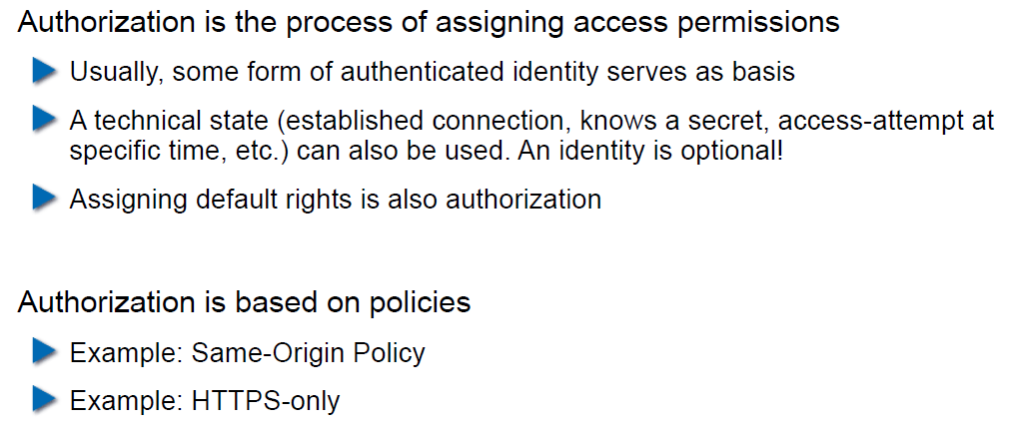

## Access to a Resource

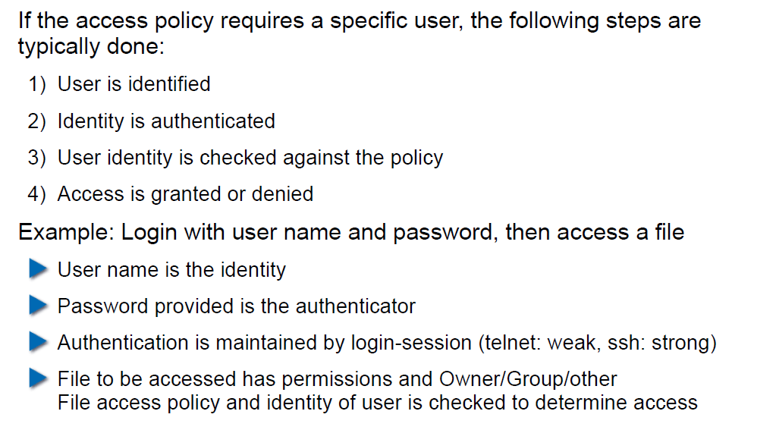

## Recap: Public Key Cryptography

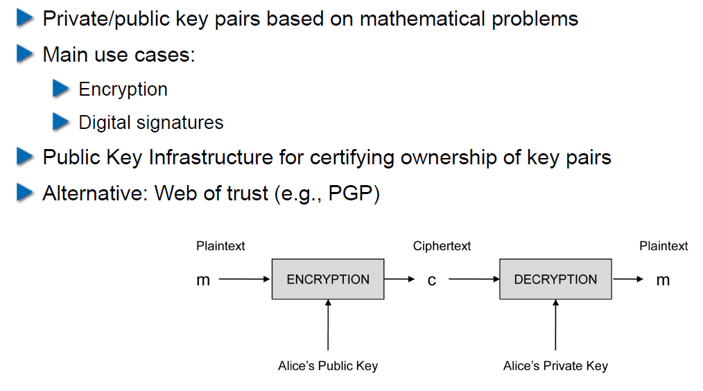

## JSON Object Signing and Encryption (JOSE)

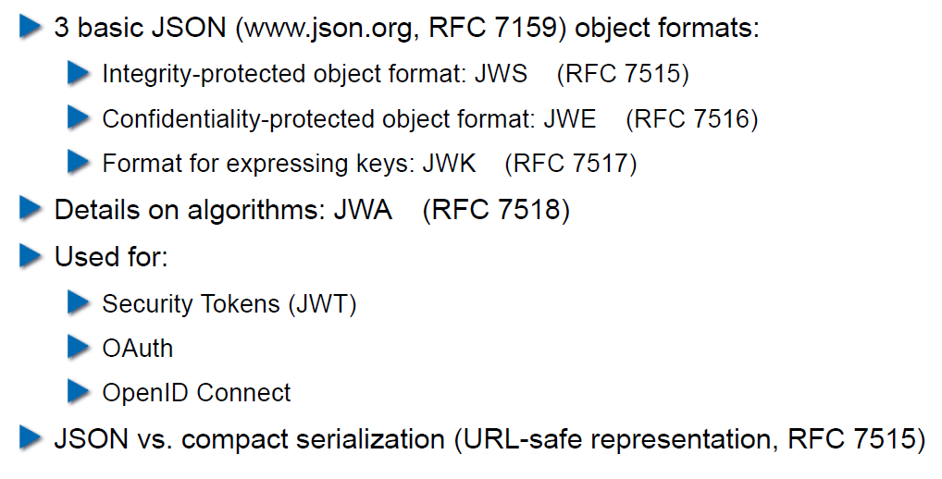

## JSON Web Signatures (JWS)

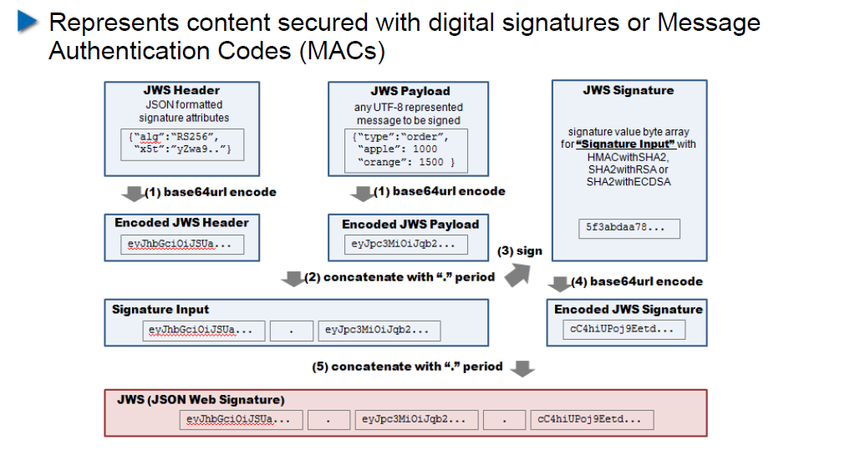

## JSON Web Encryption (JWE)

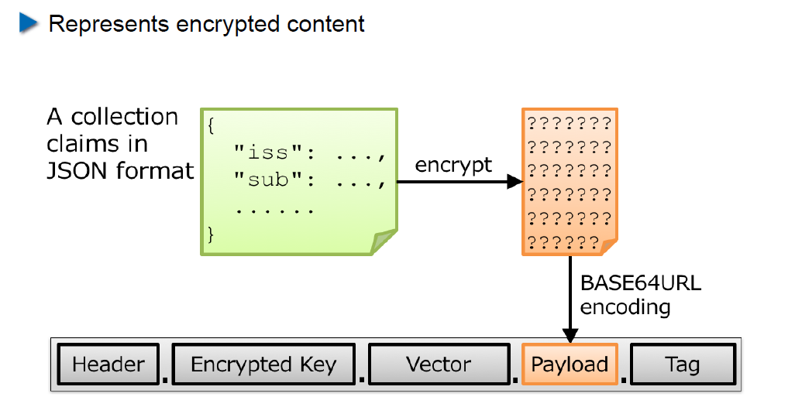

## JSON Web Token (JWT)

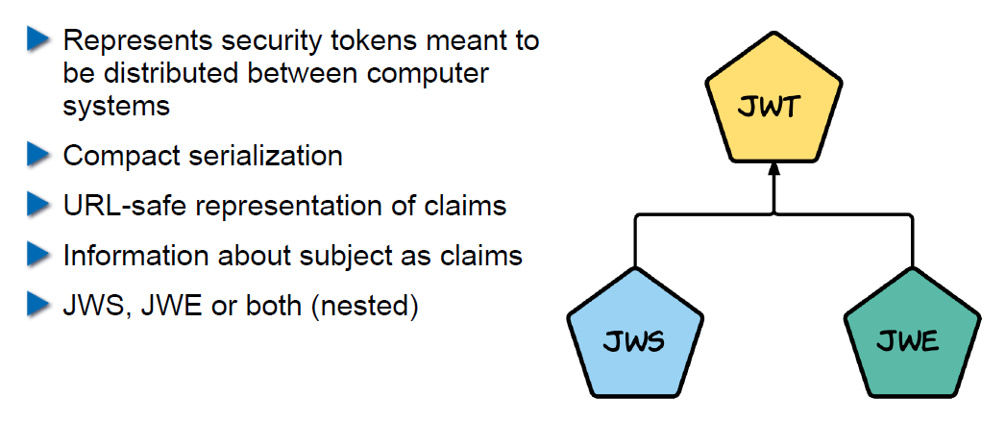

## Nested JWT

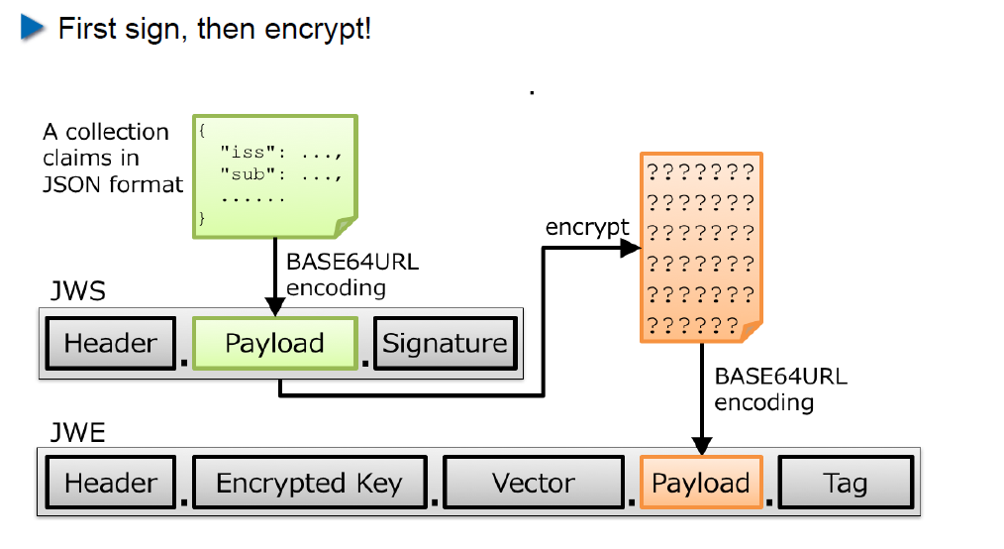

## JOSE Implementation Details

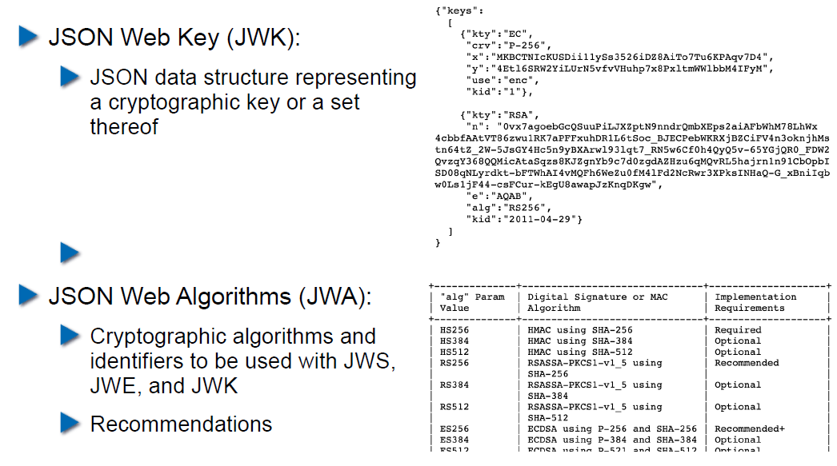

## OAuth 2.0

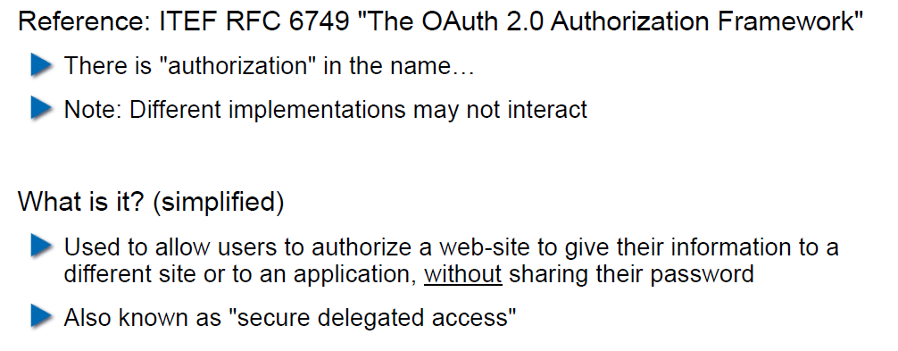

## OAuth Access Flow

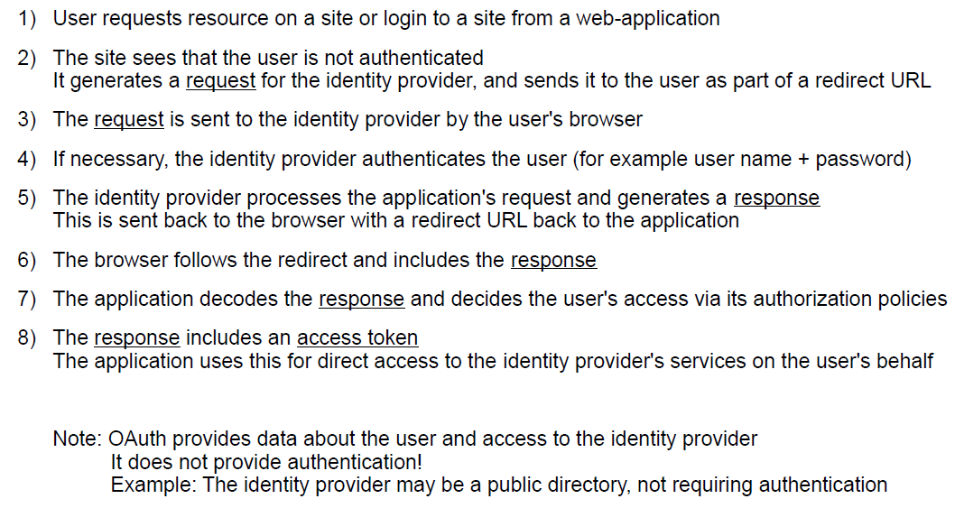

## Identity Federation

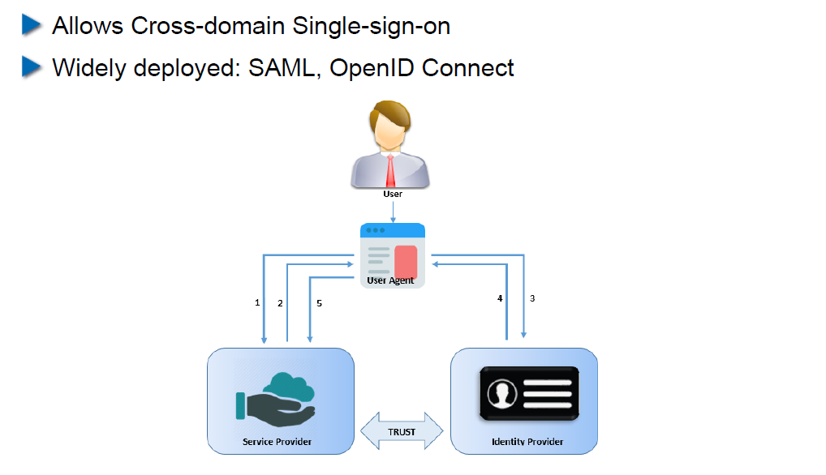

## OpenID Connect

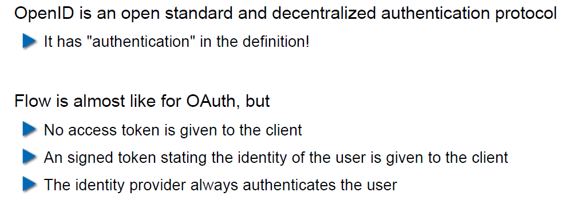

## OAuth vs. OpenID

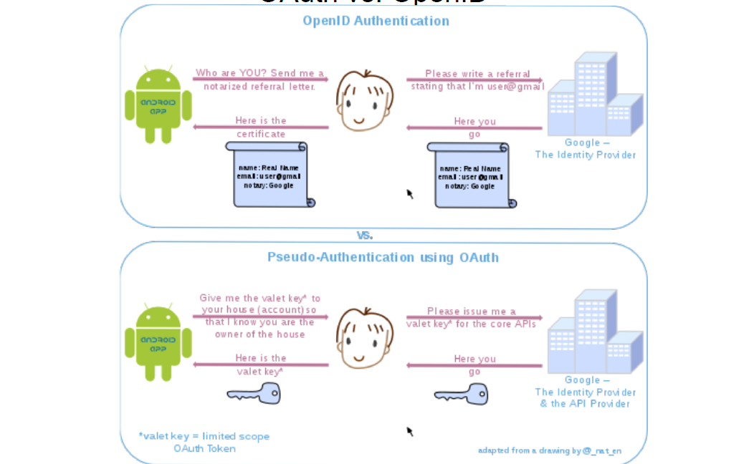

## OpenID Connect

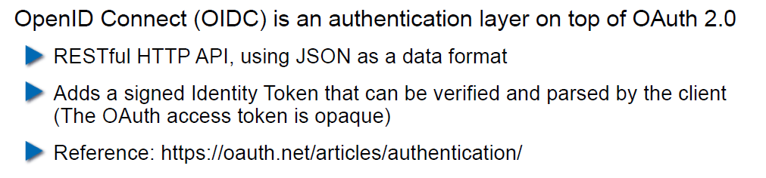

## Recent OAuth 2.0 Flaws

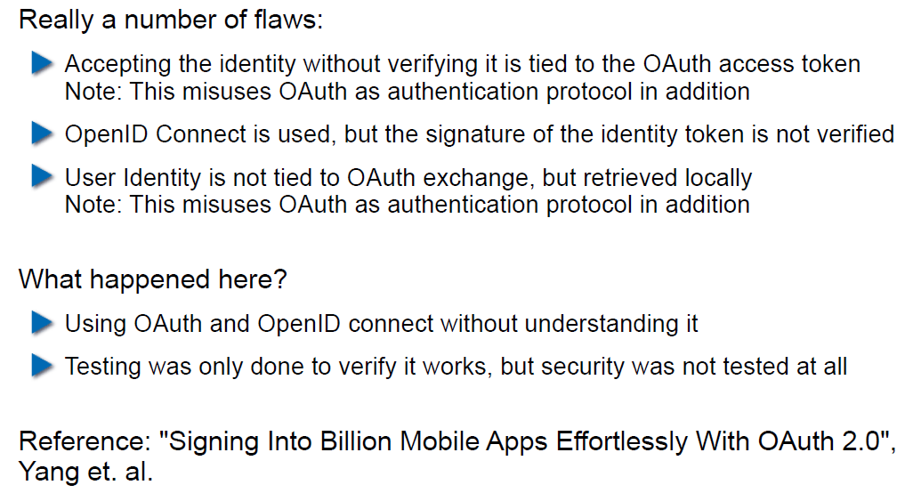

## SAML 2.0

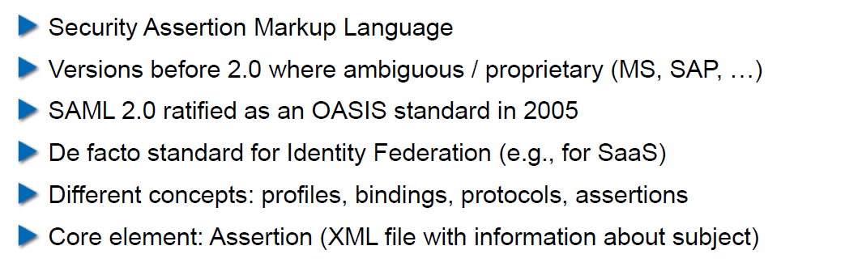

## SAML 2.0

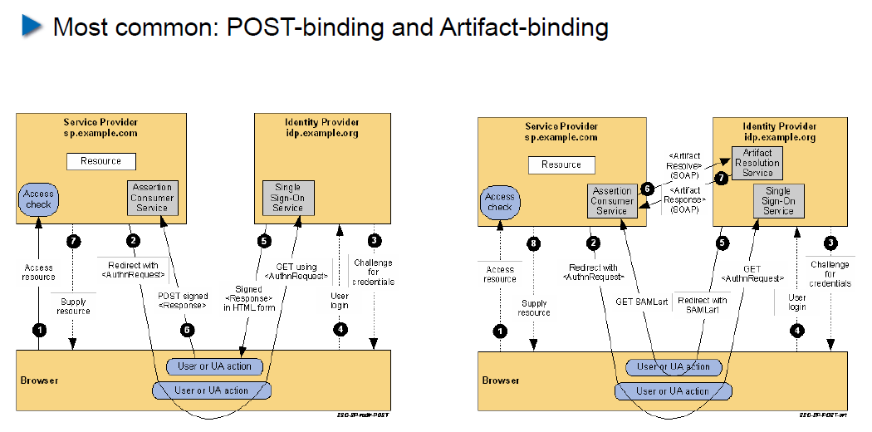

# Woche 11

In Woche 11 fand die Projektwoche statt.

# Woche 12

## Agenda

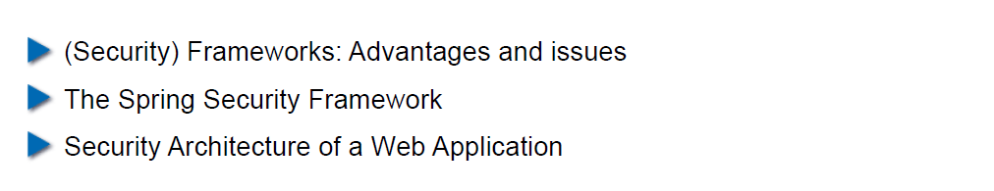

## Why use a Security Framework?

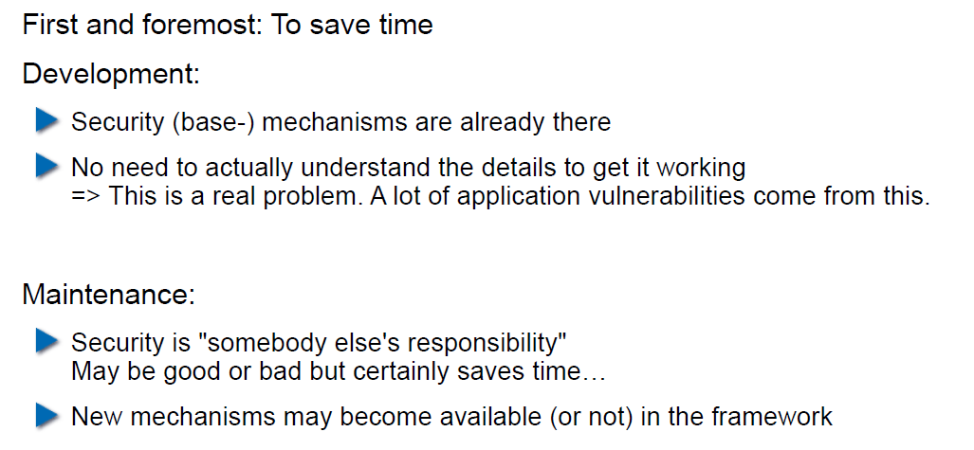

## Bad Reasons to use a (Security-) Framework

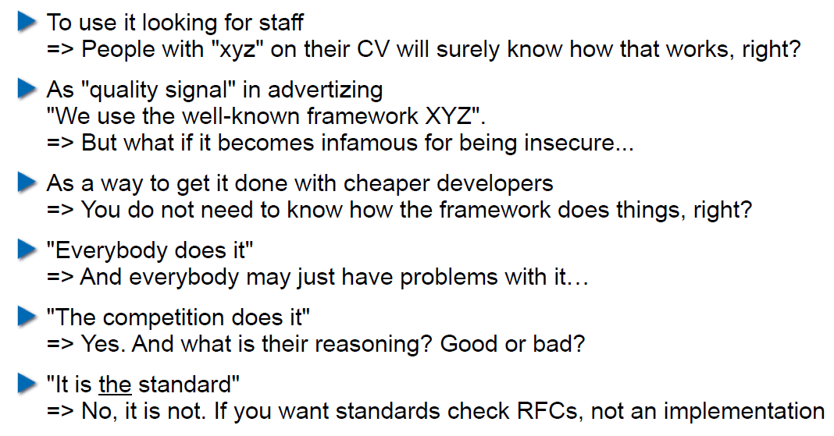

## Problems of Using a Security Framework

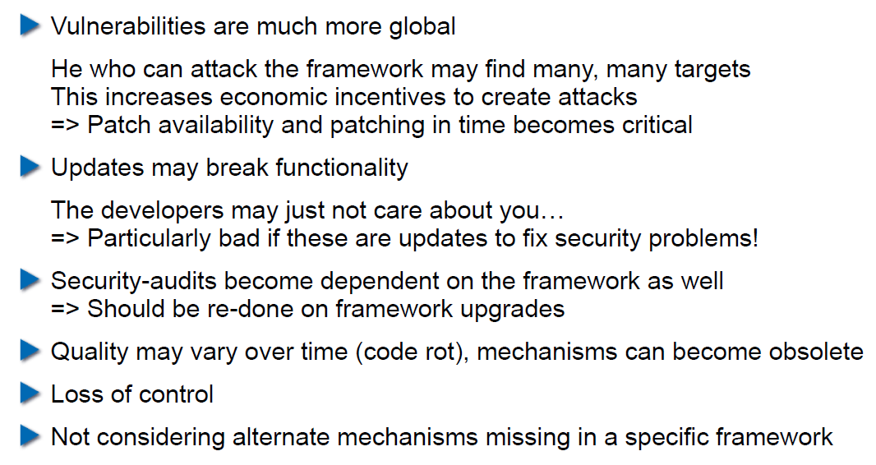

## What if the Framework will not let you go?

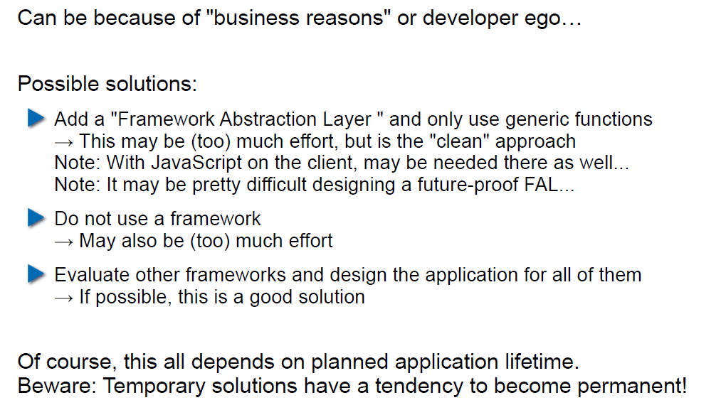

## The Spring Security Framework

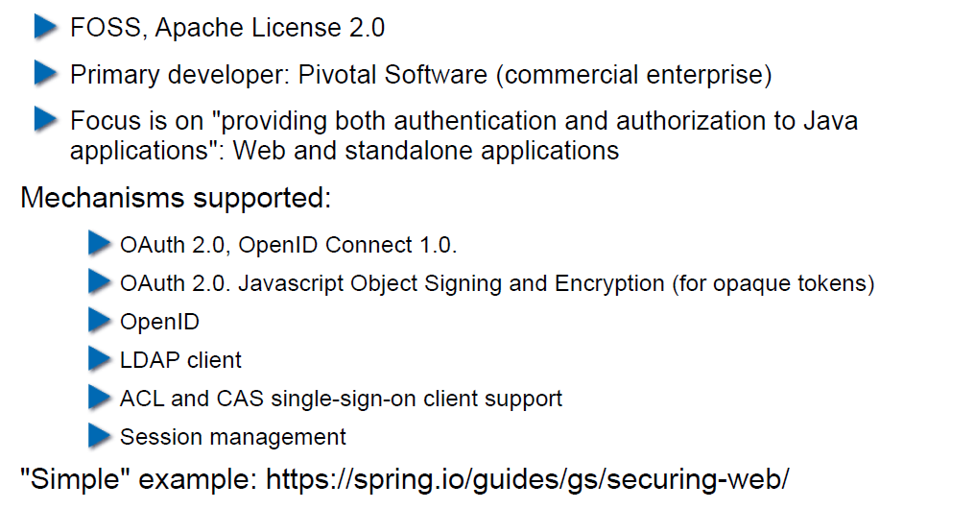

## Project Integration: Maven

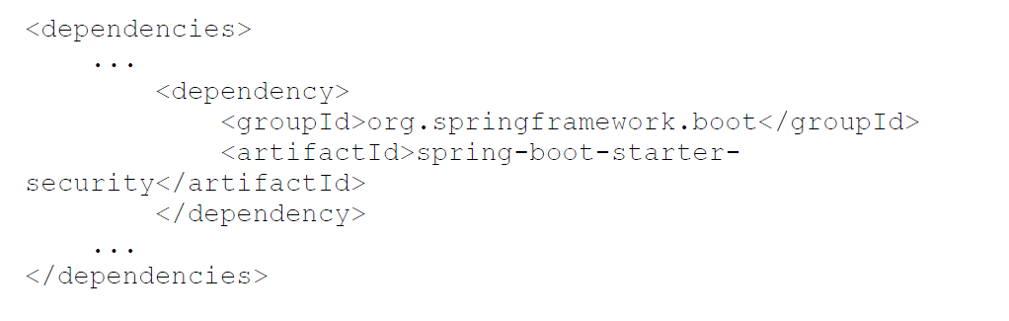

## Project Integration: Gradle

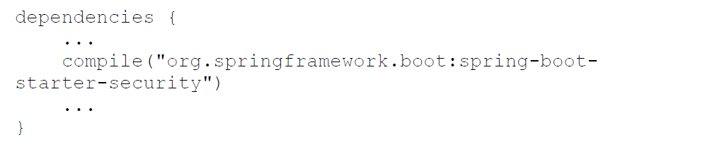

## Characteristics of the External Dependency

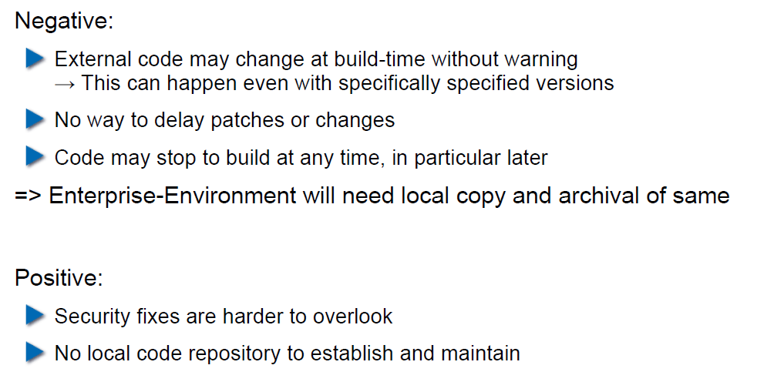

## Attacks Via External Dependency

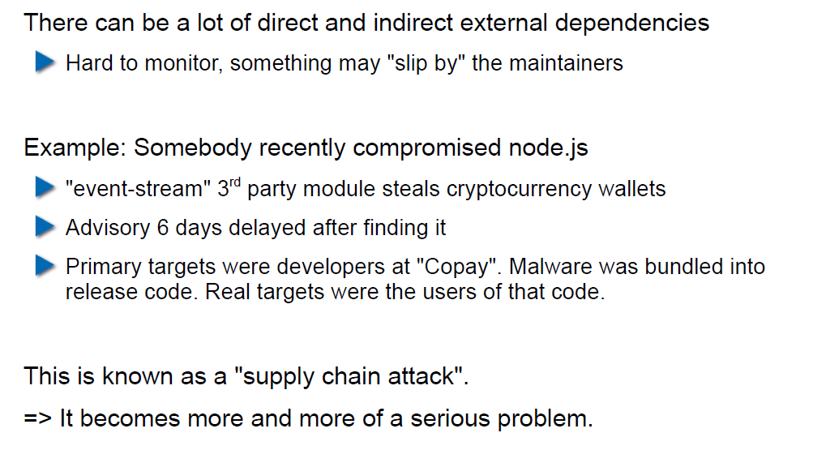

## Attacks Via External Dependency

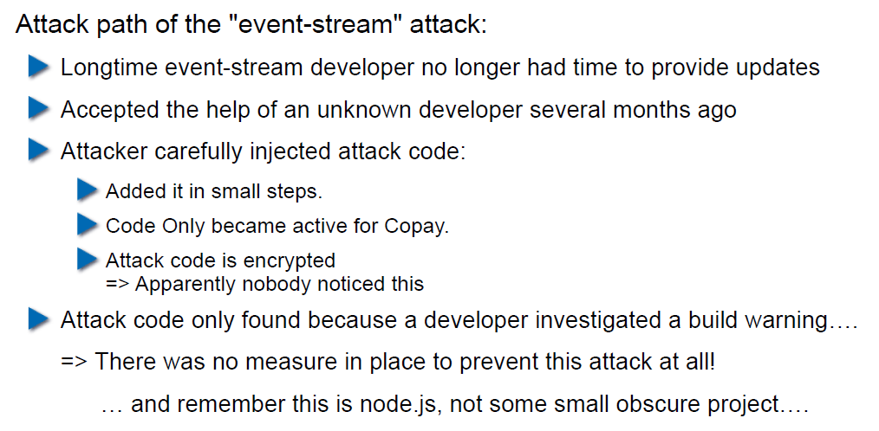

## Security Track-Record of Spring Security

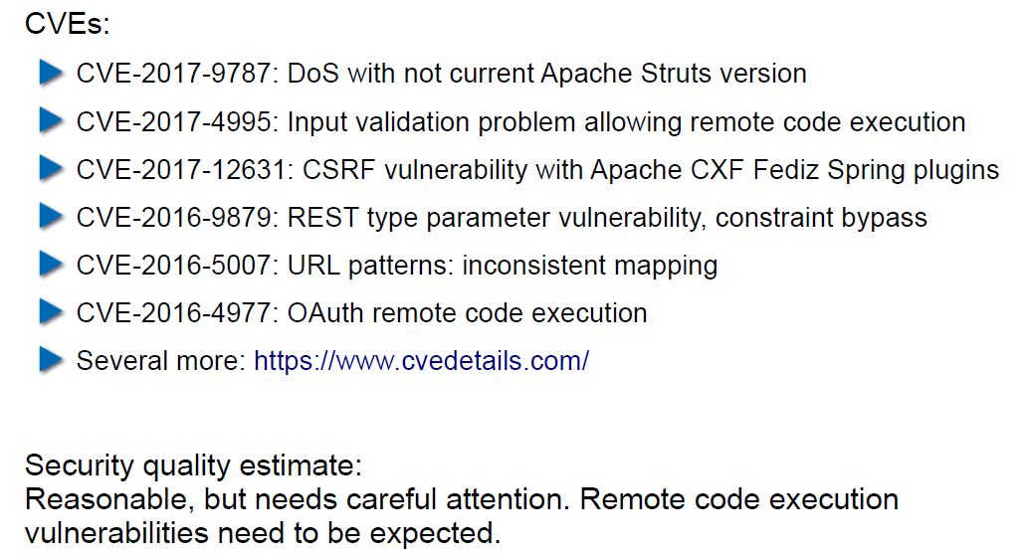

## Security Architecture of a Web Application

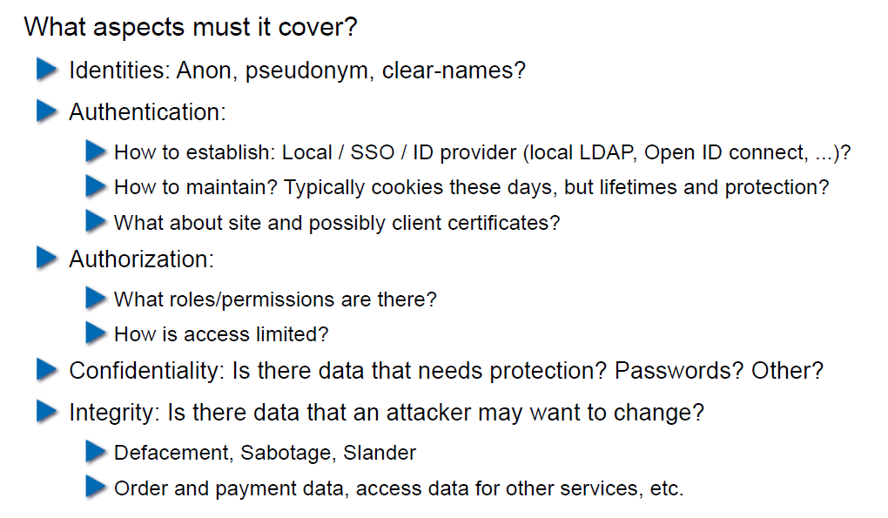

## Security Architecture of a Web Application

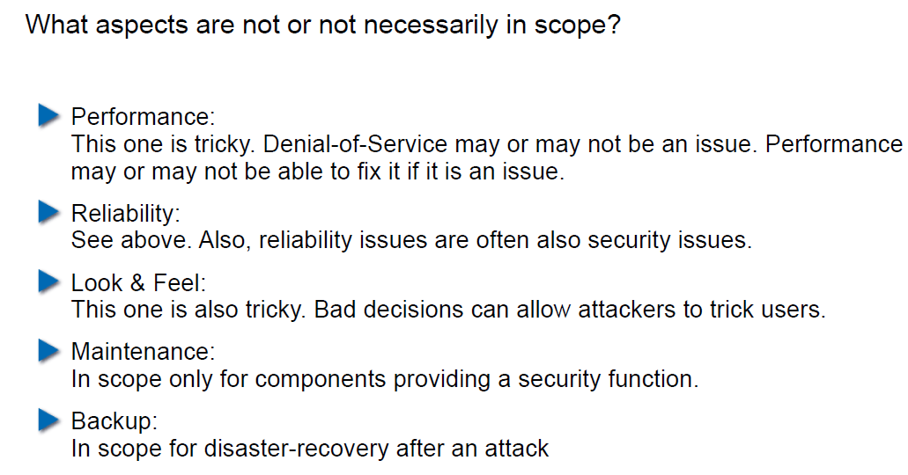

## User States

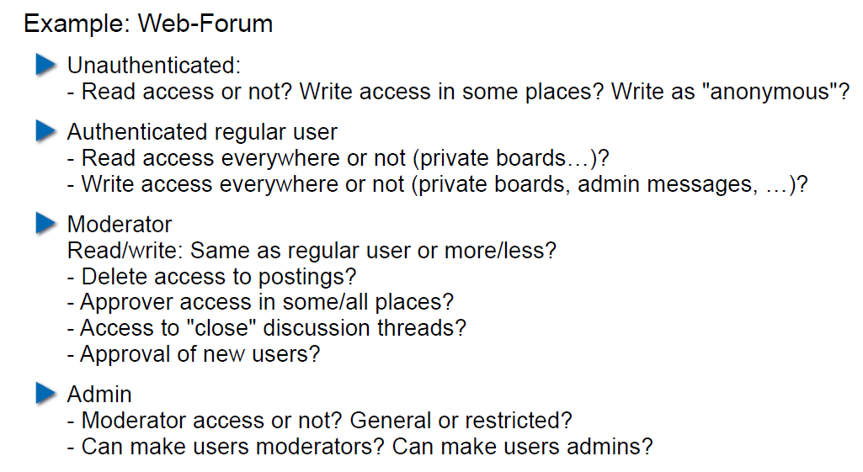

## State Transitions

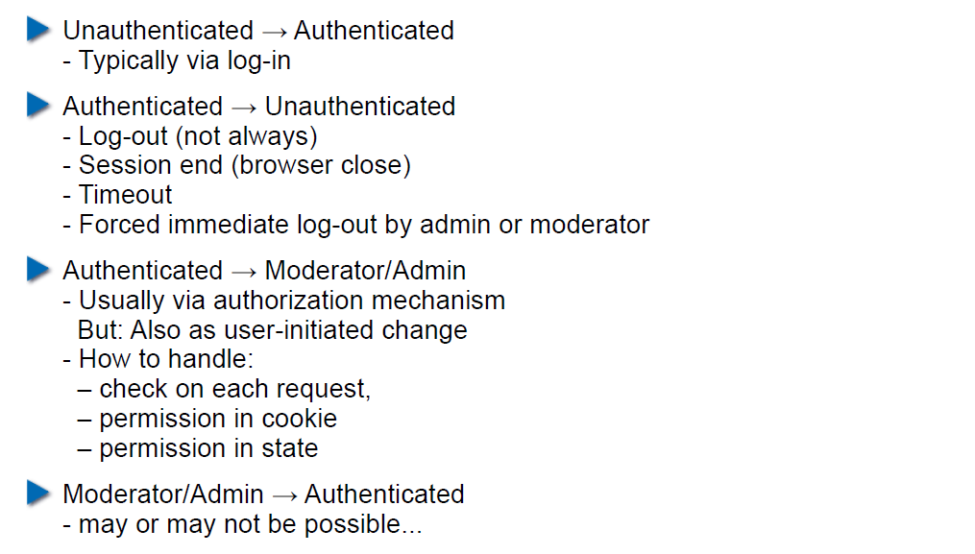

## Content-Based Attacks

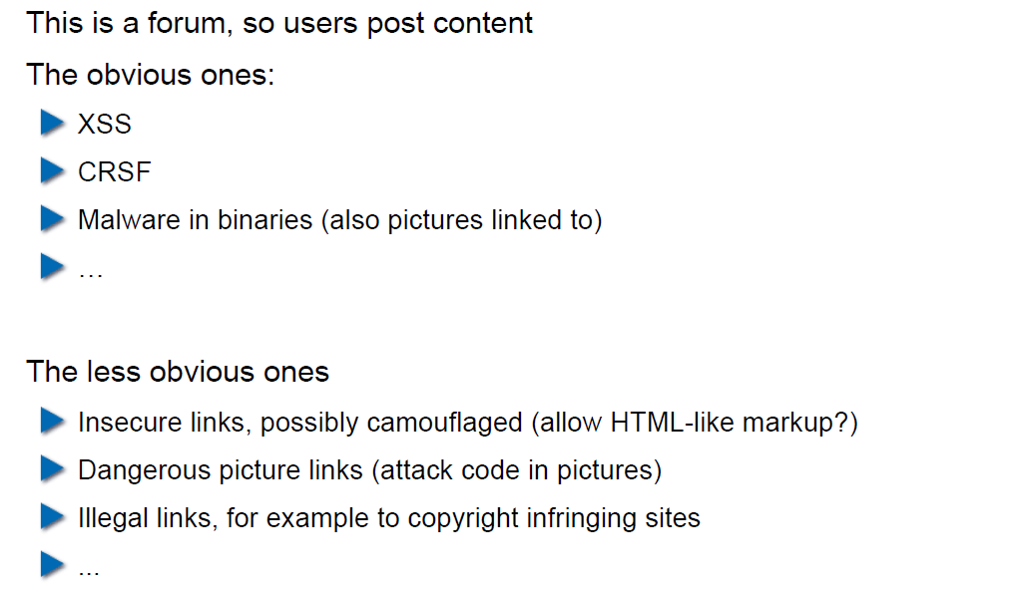

## How to Protect Against User-Generated Content?

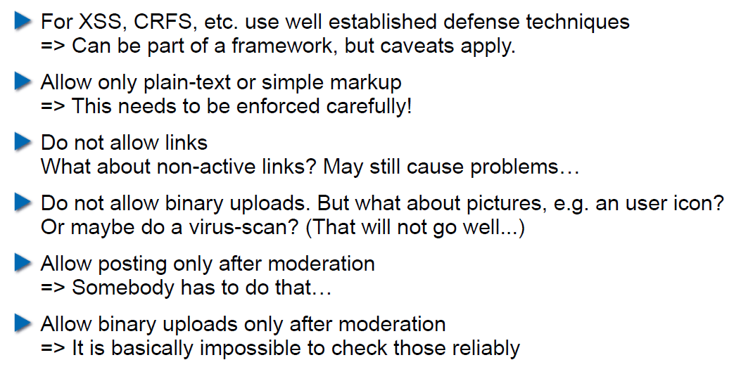

# Woche 13

## Agenda

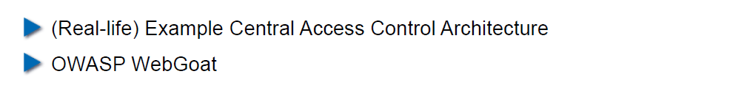

## Example Enterprise Access Control Architecture (simplified)

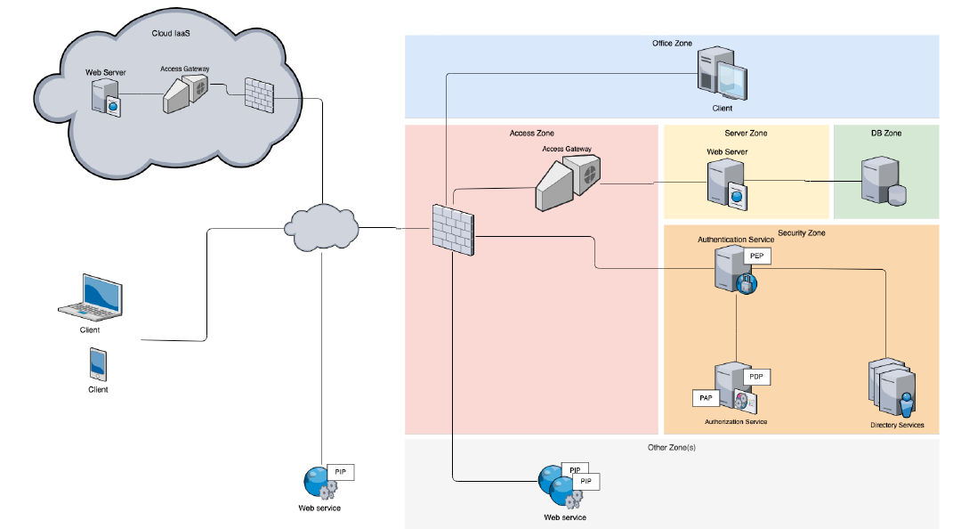

## Decentralized Access Gateways

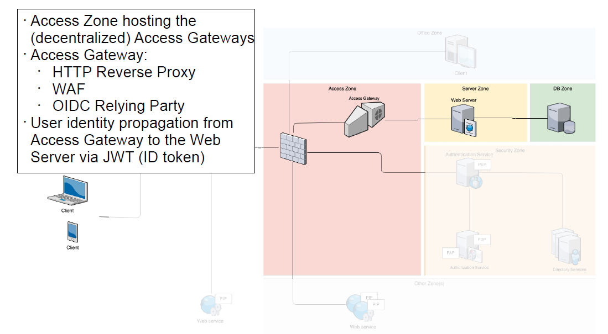

## Federated Authentication and Authorization

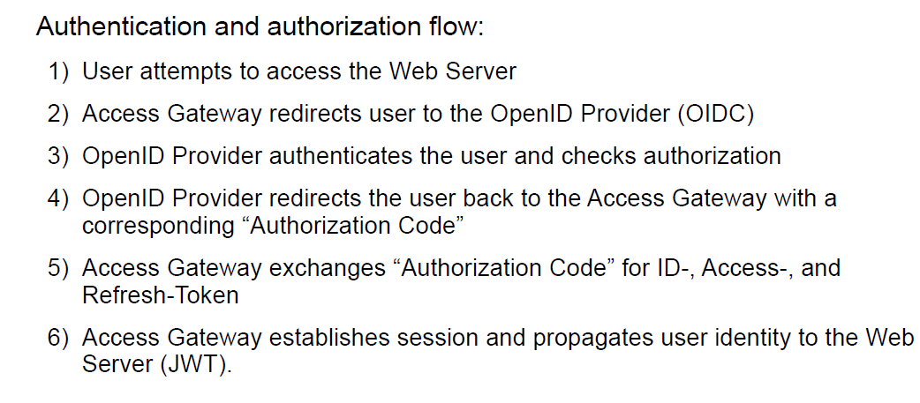

## Central Authentication and Authorization

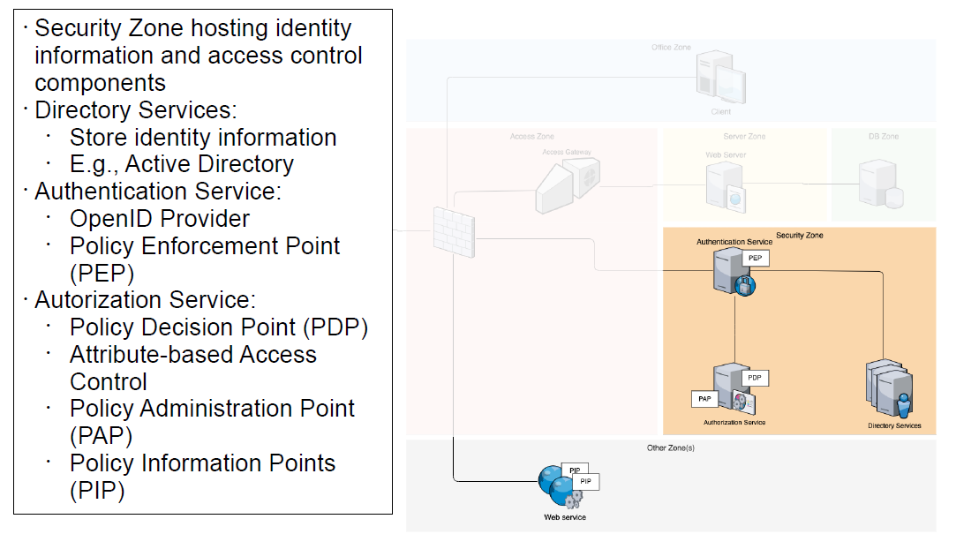

## Externalized Authorization Management

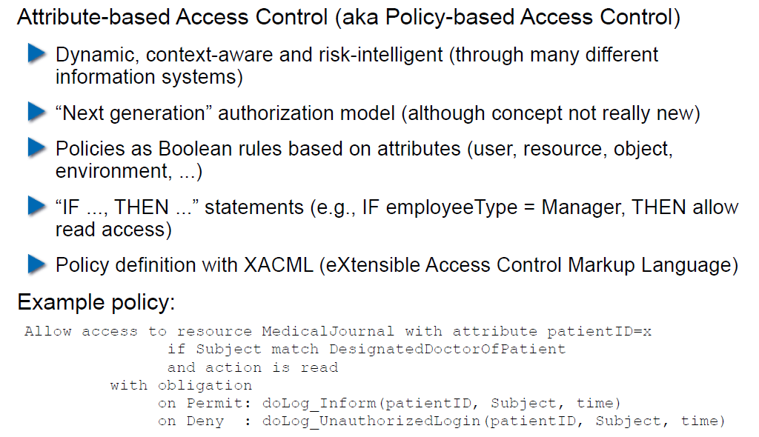

## XACML Architecture and Sample Authorization Flow

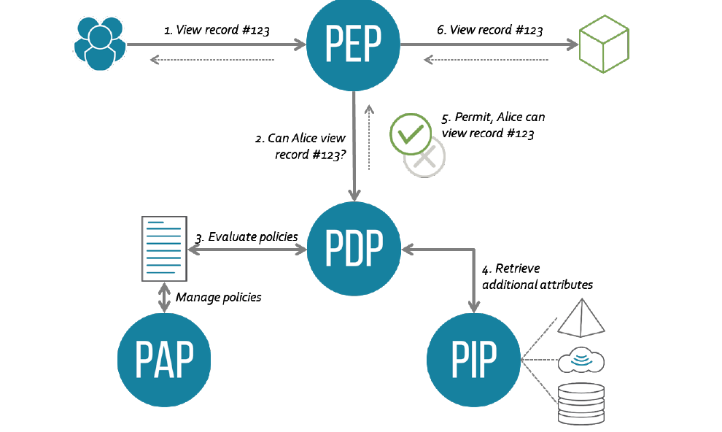

## Unified Hybrid Multi-Cloud Application Deployment

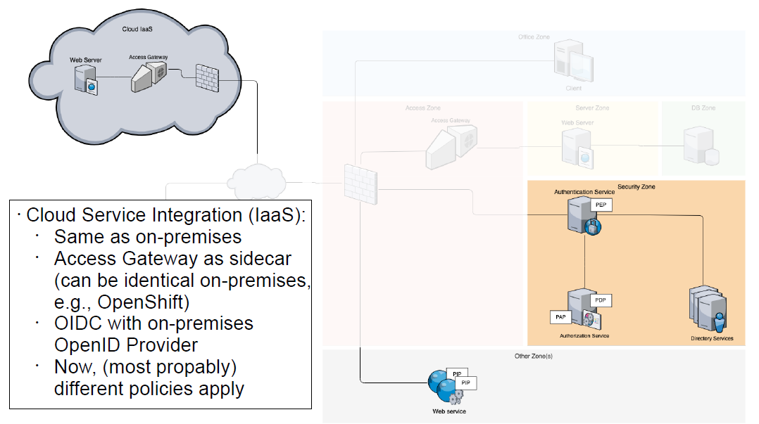

## Access Gateway based on the Sidecar Pattern

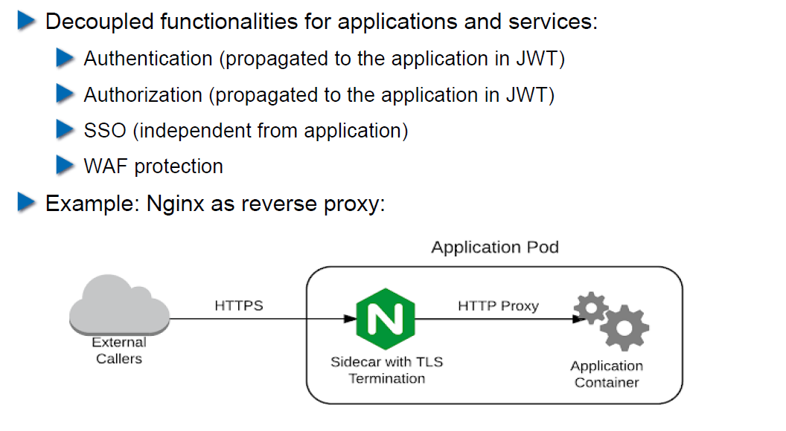

## Central Access Control Summary

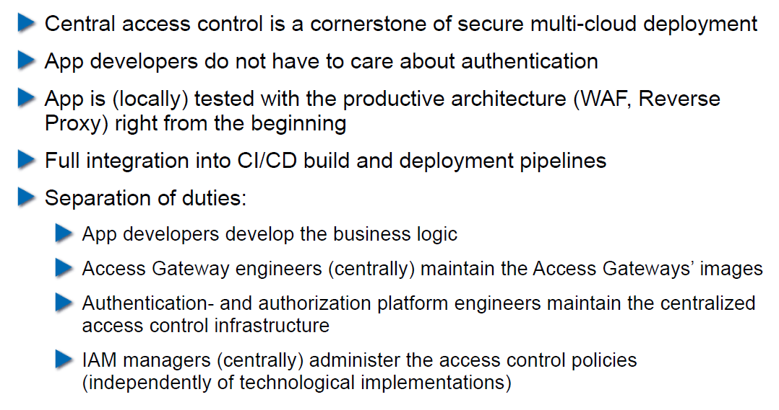

## OWASP WebGoat

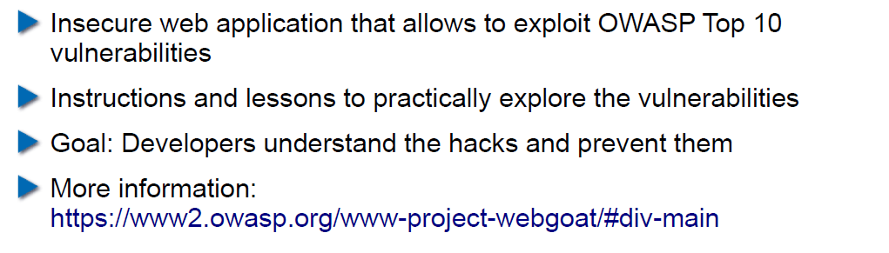

## Setup WebGoat the Simple Way

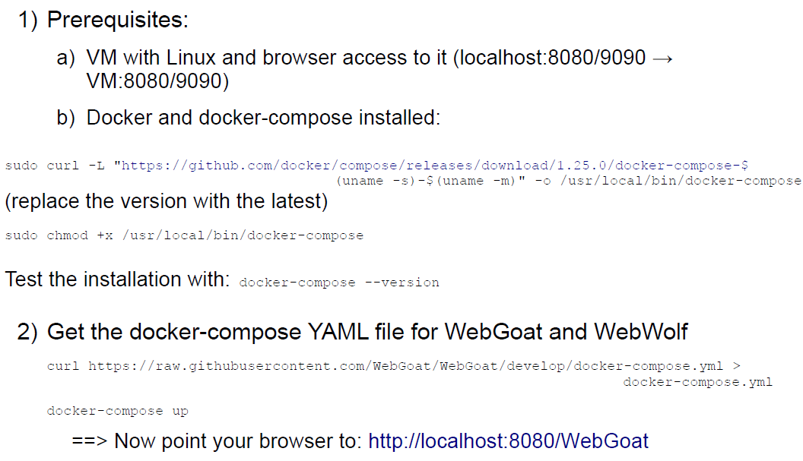

## Setup OWASP Zed Attack Proxy (ZAP)

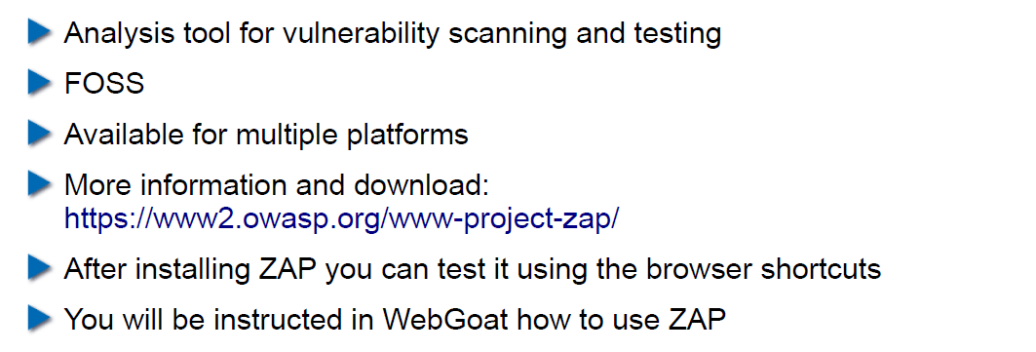

## Using OWASP WebGoat

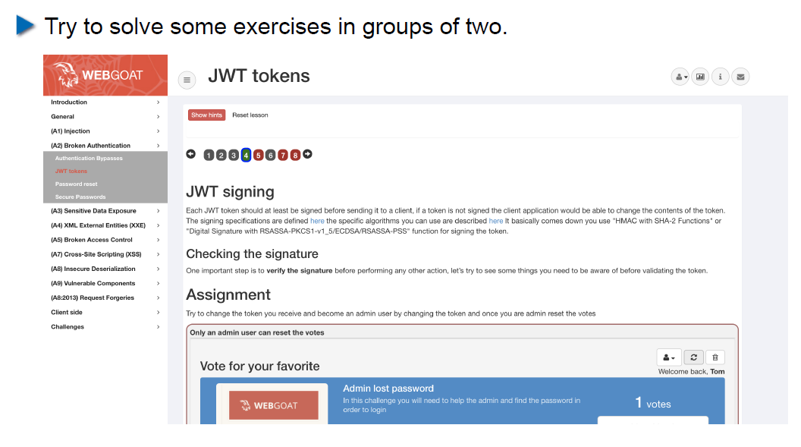

## Homework

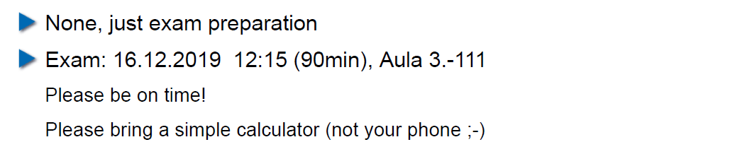

# Woche 14

In Woche 14 fand die Prüfung statt.